Solutions to O Activity Applying Dimensional Analysis

- Convert 1000000 to prefix notation.
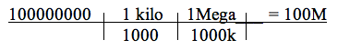

- Convert 0.000000001 to prefix notation.
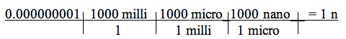

- Convert 900n to .9u and add together.
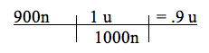

- They are in the same prefix so subtract.

10n – 9.2n = 0.8n

- One is in a prefix and the other is standard form. Multiply and convert the answer to prefix notation.
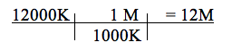

- Since dividing convert both to standard form, divide and then convert back to prefix notation.
