SHINE Lesson:
Skating Get-Up-And-Go
==========================Lesson Header ==========================
Lesson Title: Skating Get-Up-And-Go
Draft Date: June 11, 2012
1st Author (Writer): Patty Niemoth
Associated Business:
Instructional Component Used: Energy and Energy Transfer
Grade Level: 9th grade

Content (what is taught):
- Define Potential Energy
- Define Kinetic Energy
- The Relationship Between Kinetic Energy and Potential Energy
- The Law of Conservation of Energy
- How to Calculate Potential Energy and Kinetic Energy

Context (how it is taught):
- Brainstorming session led by teacher introducing kinetic energy and potential energy
- Computer simulation lab that shows the relationship between potential energy and kinetic energy
- Calculate potential energy and kinetic energy from story problems
Activity Description:
In this lesson, students discuss how energy can look different. Students will use a computer simulation to answer questions about kinetic energy and potential energy. They will discover the relationship between kinetic energy and potential energy. They will complete worksheets showing their ability to calculate kinetic energy and potential energy.

Standards:

Math: MB1, MB2 Science: SB3

Technology: TA3 Engineering: EB5

Materials List:
- Copies of worksheets for the simulation lab
- Copies of worksheets for computing potential energy and kinetic energy
- Computers with Internet access
Asking Questions: (Skating Get-Up-And-Go)

Summary: Brainstorming activity on kinetic energy and potential energy.

Outline:
- Teacher led discussion on kinetic energy and potential energy

Activity: A class discussion about kinetic and potential energy will take place. The class will discuss the differences between kinetic and potential energy and brainstorm answers to the following questions related to kinetic energy and potential energy.

Questions | Answers
What do we need to do work? | energy
How is the energy in gasoline different from the energy of a football player running down the field? | Gasoline stored energy; football player, the energy is in motion
Can they both do work? | yes
What businesses convert potential energy into kinetic energy? What parts possess the potential energy and what parts posses the kinetic energy? | Power plants
Exploring Concepts: (Skating Get-Up-And-Go)

Summary: Students discover the relationship between kinetic energy and potential energy using a computer simulation. They also discover what affects the amount of kinetic and potential energy.

Outline:
- Students discover the relationship between kinetic energy and potential energy using an online PhET simulation
- Students discover how height, mass and gravity affect kinetic energy and potential energy

Activity: Students are guided through a lab using an online PhET simulation of a skate boarder that is interactive. They experiment to see how potential energy is changed to kinetic energy and back. This shows the students that the total energy remains the same. They also discover how height, mass and gravity affect kinetic energy and potential energy. For a detail description of the lab activity see attached file: S144_SHINE_Skating_Get_Up_And_Go_E_Lab.doc


Attachment:
- S144_SHINE_Skating_Get_Up_And_Go_E_Lab.doc

Resource:
- PhET: http://phet.colorado.edu/
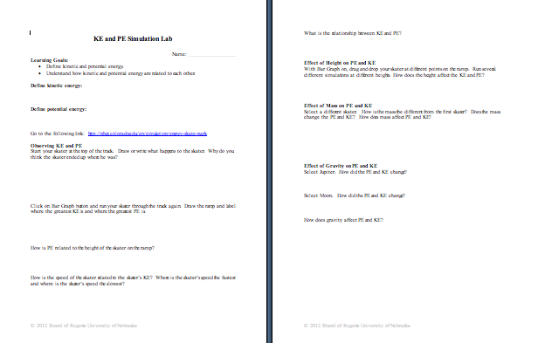
Instructing Concepts: (Skating Get-Up-And-Go)

Energy and Energy Transfer

Definition of Energy: Energy is defined as the capacity to do work that causes physical change within a closed system. In a closed system, energy cannot be created or destroyed only transformed into a different type.

Energy Types: Some scientists state that there are only two types of energy potential and kinetic. Potential energy is stored energy. Kinetic energy is energy resulting from motion. Many forms of energy exist within these two types: mechanical, electrical, thermal, nuclear, wind, chemical, water, geothermal, wave, light, and sound.

Energy Transfer/Conversion: Energy can be converted or transferred from one form to another. The Law of Conservation of Energy from physics says that the total energy in a closed system is constant over time. Most forms of energy can be converted from one form to another with a high degree of efficiency. The exception to the rule is thermal energy: all of the energy in the universe may one day be converted to thermal energy which slowly cools until a very cold equilibrium is reached. Conversion of thermal energy is limited by the second law of thermodynamics. A result of this law is that energy cannot be created or destroyed. It can only be changed from one state to another. Examples where this change in state occurs are:
- Hydroelectric dams: Dammed water (potential), moves through turbines and turns them (kinetic) which causes a generator to create electricity (electrical).
- Electric lamp: Electricity (electrical) makes a light bulb light up (heat and light)
- Microphone: Sound energy converted into electricity.
- Fossil Fuel power plant: Fossil fuels (potential) are burned (thermal) to heat water which in turn moves turbines (kinetic) to create electricity (electrical).
- Friction: Kinetic energy is turned into thermal energy.
- Solar cells: Light energy is turned into electricity (electrical)
This list is far from exhaustive but should point out the many different ways that energy can be transformed.

Energy Costs: The cost of energy is more than the price that you pay for the electricity, gasoline, natural gas, etc. that you use. The financial costs of these items are paid everyday and vary depending on the location where the energy was purchased and the time of year. The use of energy has hidden costs associated with it such as climate and environmental impact.

Energy Efficiency: Energy efficiency is defined as the process of using less energy to provide the same level of service. Creating more efficient products such as higher mileage cars, florescent light bulbs, high efficiency furnace and AC units, or appliances can do this. It can be caused by better insulation or building design.

Energy Conservation: Energy conservation is the effort to reduce the consumption of energy. The goal of conservation is to preserve finite resources and reduce pollution. It can be accomplished by creating more efficient related energy products or simply by creating habits that utilize less energy such as turning off the lights or carpooling.
Organizing Learning: (Skating Get-Up-And-Go)

Summary: Students will complete worksheets related to kinetic energy and potential energy.

Outline:
- Students will calculate kinetic energy and potential energy

Activity: Students will complete worksheets with story problems requiring them to calculate kinetic energy and potential energy.

Attachments:
- S144_SHINE_Skating_Get_Up_And_Go_O_Worksheet1.doc
- S144_SHINE_Skating_Get_Up_And_Go_O_Worksheet2.doc
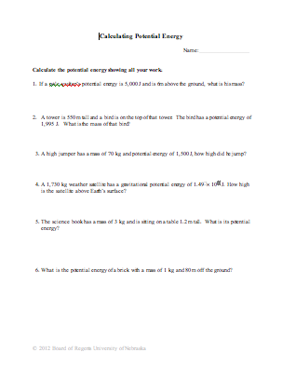
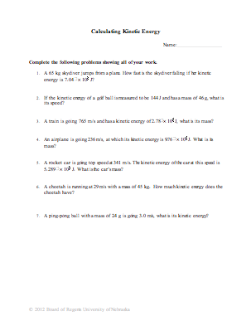
Understanding Learning: (Skating Get-Up-And-Go)

Summary: Students will explain the difference between kinetic energy and potential energy and how they are related to the law of conservation of energy.

Outline:
- Formative Assessment of Energy and Energy Transfer
- Summative Assessment of Energy and Energy Transfer

Activity: Students will complete written and quiz assessments related to energy and energy transfer.

Formative Assessment: As students are engaged in the lesson ask these or similar questions:
- Do they understand the difference between kinetic energy and potential energy?
- Can they calculate kinetic energy and potential energy?
- Can they relate kinetic energy and potential energy with the law of conservation of energy?

Summative Assessment: Students can complete one of the following writing prompts.
- Explain the difference between potential energy and kinetic energy.
- Give examples of objects with potential energy and objects with kinetic energy.

Students can complete the following quiz questions: Calculate the potential energy and kinetic energy of an object.
Example Problems:
- A 2 kg book sitting on a counter that is 3.33 m high, what is its potential energy?
- What is the mass of a book that is sitting on a counter 3.33 m high and has a potential energy of 90 J?
- How much kinetic energy does a runner have who is 54 kg and is running 3.1 m/s?
- How faster is the 54 kg runner going if she has 350 J of kinetic energy?

Alternative Assessment: Students will teach/write out a mini lesson explaining the difference between potential energy and kinetic energy, how to calculate PE and KE, and give examples of objects that have PE and/or KE.

