SHINE 2.0 Lesson:
How Many Horses Are You?
==========================Lesson Header ==========================
Lesson Title: How Many Horses Are You?
This Teacher was mentored by:


www.nppd.com

In partnership with Project SHINE grant funded through the

National Science Foundation
Draft Date: June 16, 2012
1st Author (Writer): Teresa Walters
Associated Business:
Instructional Component Used: Power
Grade Level: 7-12

Content (what is taught):
- Power
- Calculating Horsepower

Context (how it is taught):
- The students will be asked to define power and think of things that might affect power production
- The students will view a video on the Ainsworth Wind Farm and discuss the amount of power produced by a turbine
- The students will calculate their horsepower and compare their power output to the power output of a wind turbine
Activity Description:
The students will be asked to define power and think of things that might affect power production. The students will view a video on the Ainsworth Wind Farm and discuss the power produced by the turbines. The students will calculate their horsepower and compare their power production to the amount of power produced by a wind turbine.

Standards:

Math: ME1 Science: SB2, SB3

Technology: TD3 Engineering: EA1

Materials List:
- Stopwatch
- Calculator
- Meter Stick
- Video on the Ainsworth Wind Farm: http://itsyourpower.org/Wind.html (Click on the link: Ainsworth Wind Energy Facility)
Asking Questions: (How Many Horses Are You?)

Summary: The students will be asked to define power and explain what factors might affect power production.

Outline:
- The students will be asked to define power.
- The students will be asked to think of ways power production might be affected in a business such as Nebraska Public Power (NPPD).

Activity: The students will be asked to define power. Each student will then be paired with another student and asked to think of ways power production in a business, such as Nebraska Public Power District (NPPD), could be affected. The students will then share their ideas with the class.

Questions | Answers
What is the formula for power? | Power = work/time or force x distance/time
How might power production be affected if there is no wind for the wind turbine? | No power produced by turbine, must use other sources.
How might power production be affected if there are several days of very hot weather? | More power needed to run air conditioning.
How might power production be affected if the wind speed is too high? | The wind turbine must be shut down to avoid damage to the turbine, thus they must use other sources.
Exploring Concepts: (How Many Horses Are You?)

Summary: The students will watch a video on the Ainsworth Wind Farm, followed by a discussion of the amount of power produced by a wind turbine.

Outline:
- The students will watch a video on the Ainsworth Wind Farm
- The students will discuss the amount of power produced by a wind turbine

Activity: The students will view a video on the Ainsworth Wind Farm (see link below). After viewing the video, the students will discuss the amount of power produced by a wind turbine. (For example, the Ainsworth wind turbines are rated at 1.65 MW, if it has a capacity factor of 40%, how much power is produced by one turbine? Answer: 1.65 x .40 = .66 MW)

Resource:
- Video of the Ainsworth Wind Farm: http://itsyourpower.org/Wind.html (Click on the link: Ainsworth Wind Energy Facility)
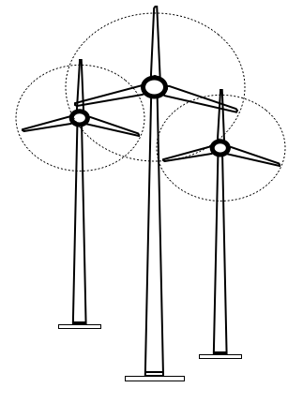
Instructing Concepts: (How Many Horses Are You?)

Power

Putting “Power” in Recognizable Terms: If a person were to walk up the stairs versus run up the stairs, would the person perform the same amount of work? The answer, is yes (same force of weight moving the same distance), but because the running took less time, the person exerted a greater amount of power. Power is the rate at which work is performed determined by how long it takes to perform the work. Since work is related to the amount of energy used, then power can be used to express the change of energy during a time interval.

Putting “Power” in Conceptual Terms: It is apparent that the power present in a situation is dependant on the amount of work done (energy expended) and the time that it takes to do that work. So, if 100 joules (J) of work are done in 10 minutes and 100 joules of work are done in 1 minute then in the second scenario a greater amount of power was experienced. The second scenario is greater by a factor of 10 times.

Putting “Power” in Mathematical Terms: Power can be mathematically represented by the formula P = W / t where “P” is the Power, “W” is the work done, and “t” is time in which the work was done. The SI unit of power is the watt (W), which indicates the rate of 1joule of work per 1 second. Power is then directly proportional to the work done and inversely proportional to the time to do the work.

Remembering that work is force times displacement (W = F*d), you can derive a corollary for the power equation. Substituting this formula into the power equation we get P = F*d/t. Moreover, since velocity is displacement divided by time (v = d/t), we can substitute it into the formula and get the equation Power = Force * velocity (P = F * v). This formula is valid provided the force remains constant.

Putting “Power” in Process Terms: Thus, power is about doing work over time. From the mathematical analysis of this concept it is obvious that a bigger engine has more power because it can do more work in the same amount of time. It is also worth noting that since power = force * velocity something that is both strong (large force) and fast (high velocity) will display more power.

Putting “Power” in Applicable Terms: Power applies in any situation where work is being done. Power is present in mechanical, electrical, pneumatic, and fluidic systems. Basically anywhere work is accomplished the concept of power is discussed.

Related “I” pieces: Work, Force, Hooke’s Law
Organizing Learning: (How Many Horses Are You?)

Summary: The students will be calculating their horsepower and comparing their power output to the power output of a wind turbine.

Outline:
- The students will use a flight of stairs to calculate their horsepower
- The students will compare their power to the power generated by a wind turbine

Activity: The students will measure the height of a flight of stairs in meters (measure the height of each stair and multiply by the number of stairs). Each student will be timed as they run up the stairs. Run five trials for each student then calculate the average time in seconds. The students will calculate their horsepower using the height of the stairs, their average time and their weight in kilograms. (See attached lab to complete calculations.) The students will then compare their power to the power output of a wind turbine. For a detailed description of the lab activity, see attached file: S145_SHINE_How_Many_Horses_Are_You_O_Lab.doc

Attachment:
- Horsepower Lab: S145_SHINE_How_Many_Horses_Are_You_O_Lab.doc
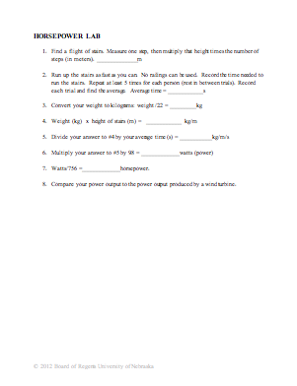
Understanding Learning: (How Many Horses Are You?)

Summary: The students will be asked to define power and explain what factors might affect power production and why that would be important for a business such as Nebraska Public Power District (NPPD).

Outline:
- Formative Assessment of Power
- Summative Assessment of Power

Activity: Students will complete written and quiz assessments of power.

Formative Assessment: As students are engaged in the lesson ask these or similar questions:
- Did the students measure the height of the stairs correctly?
- Did the students run five trials and calculate the average time?
- Did the students do the correct calculations for power?

Summative Assessment: Students can answer on of the following writing prompts.
- What is the formula for power?
- Explain why it would be important for a business such as Nebraska Public Power District (NPPD), to know what factors affect power production?
- How does your power production compare to a wind turbine?

Students can complete the following quiz questions.
- If a person weighs 70 kg and they run up a flight of stairs 10 m high in 9 seconds, how much power is produced?
- If you lift a box that weighs 2 kg from the bottom shelf to the top shelf (a distance of 1m), and it takes you 2 sec to move it, how much power is produced?

