BUMP BOT SQUARE 2 BARRIERS EXAMPLE

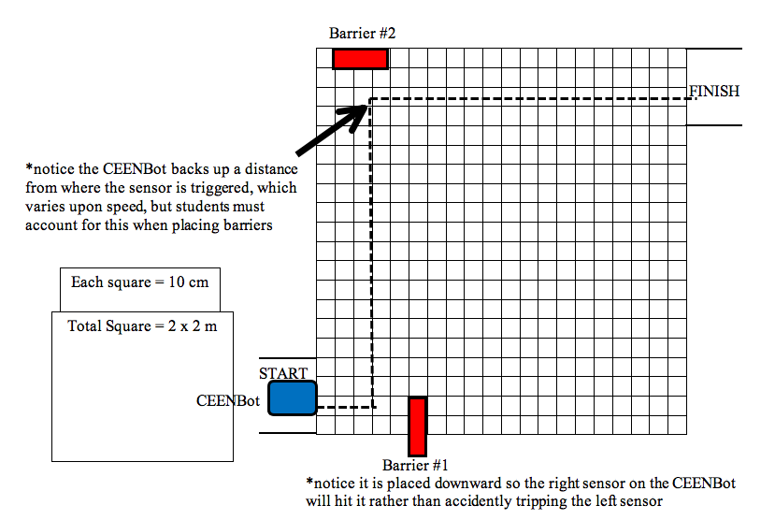

Discussion Questions:

- Does it matter if the first barrier were placed at 0.5 meter, 0.7 meter, 1.5 meter on the x-axis?
Answer: The CEENBOT will turn at a 90˚ angle once the sensor is trigged, so the angle of the barrier only helps in triggering the left or right sensor first.

- Does it matter the angle the barriers are placed (45˚, 90˚, 200˚, etc.)? (Hint: Does is effect the CEENBot?)
Answer: The barrier could be placed farther along the x-axis, so the distance is not a factor other than the 2nd barrier would need to be placed farther back.

- Does it matter the angle at which the CEENBot is placed in the START box?
Answer: Yes, this is critical because the CEENBot only maneuvers at 90˚ after the initial angle, so the initial angle really determines all the following angles.

- How long did it take for the CEENBot to reach the first barrier?
Answer: Students may time this, but lead them to the distance/speed = time equation…0.5 meters/ 0.22 m/s =2.27 seconds.

- If asked to place the first barrier such that it is 2.3 seconds away from the start, but still at a 0˚ angle, how would a person solve for this? Where would it be placed?
Answer: Students may time this, but lead them to the speed*time=distance equation…0.22 m/s*2.3 s =0.506 m (x-axis only) so the coordinates would be (0.506m, 0m).

BUMP BOT SQUARE 1 BARRIER EXAMPLE
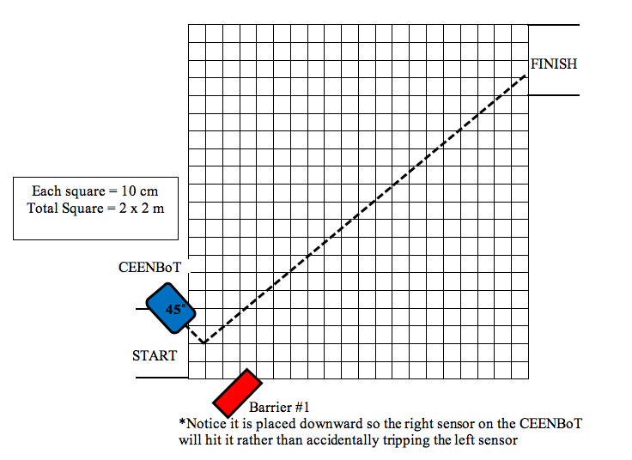

Discussion Questions:

- How far away is the CEENBot from the barrier?
Answer: Students may pull out a ruler to measure this, but it must be exactly at a 45˚ to get correct…lead students to think of a simpler way such as the Pythagorean Theorem. 0.3²m x 0.3²m =√0.18 =0.424 m

- If asked to place the barrier such that it is 0.7 seconds away from the start, but still at a 45˚ angle, how would a person solve for this? Where would it be placed?
Answer: Students may time this, but lead them to the resolving vectors 0.22m/s is the hypotenuse at a 45˚ angle taking sin45*0.22m/s = 0.155m/s in this in both the x and y. Multiply 0.155m/s*0.7s = 0.1085 m in the x and y, so position the CEENBot 0.1085 m down and over from the start position.

- Ask students to position a barrier such that is would be hit in 3 seconds at a 30˚ angle from the start.

