←VE↑CT→OR↓ Lab
CEENBoT Commander Program

To setup for the lab create this program in CEENBoT Commander and download into each lab station robot using the AVRISP In-System programmer.

This program is similar to the Bump Bot program in the CEENBoT firmware, but this program will turn 90 degrees when it encounters a barrier

This program uses a main module to create the forever loop and call the modules to check the left and right proximity sensors to see if a barrier was detected.

NOTE: You will FIRST need to create the modules Barrierleft and Barrierright before they can be selected in the Goto.

Start a CEENBoT Commander project called Vectors
Use Project > Add New Module (or click the green plus [+] sign) to create the modules

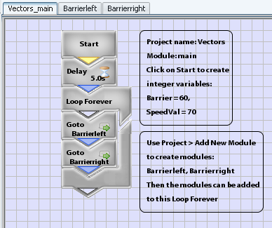

Create the modules to move in freerunning mode unless a barrier is detected
When a barrier is detected the robot will backup and turn in blocking mode

Module: Barrierleft

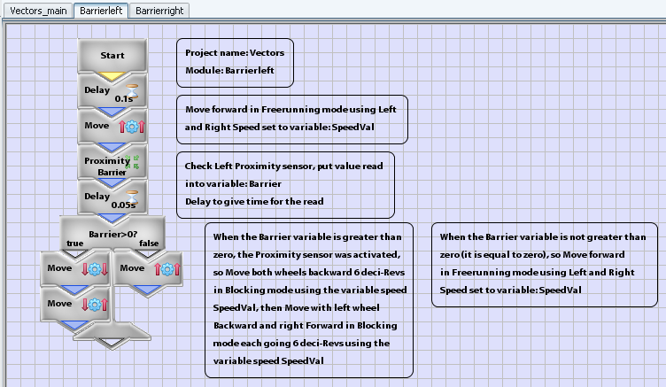

Module: Barrierright

