SHINE 2.0 Lesson:
Balancing Act
==========================Lesson Header ==========================
Lesson Title: Balancing Act
This Teacher was mentored by:


www.loup.com

In partnership with Project SHINE grant funded through the

National Science Foundation

Draft Date: June 1, 2012
1st Author (Writer): Ashley Vandeventer
Associated Business: Loup Power
Instructional Component Used: Force
Grade Level: 9-11 (used in multiple classes)

Content (what is taught):
- Forces are any push or pull on an object
- Forces can be calculated with the formula F = ma
- Forces on the same object can add together and result in a net force
- Forces are considered balanced when the net force is equal to zero

Context (how it is taught):
- Students discuss motion in daily life and also discuss why some objects are stationary when being pushed or pulled
- Students explore opposite pulling forces on a wood dowel, calculate the individual forces (F=ma) and determine net force, experiencing both balanced and unbalanced forces
- Students determine the minimum mass necessary to keep a wood dowel upright when a given amount of mass hangs from one side and the other force is at an angle < 180 degrees
- Students analyze how changing the angle between opposite forces affects both the force and mass necessary for balance

Activity Description:
In this lesson, students will be introduced to force by discussing how various pushes and pulls create motion or keep an object stationary. After then defining force, net force, and practicing how to calculate both, students will explore opposite pulling forces on a wood dowel, calculate the individual forces and determine net force on the dowel, experiencing both balanced and unbalanced forces. Balanced forces are further defined after that activity. Then, students will determine the minimum mass necessary to keep a wood dowel upright when a given amount of mass hangs from one side and the other force is at an angle <180 degrees in another lab activity. By the end students should have a working knowledge of net force and its effect on an object and should be able to analyze how changing the angle between opposite forces affects both the force and mass necessary for balance (as applied electricity companies, keeping electricity poles up).

Standards:
Math: MA2, MB1, MB2, MB3 Science: SB1, SF5

Technology: TA3, TA4, TC4 Engineering: EB5

Materials List:

- Wood dowels (8”-12”, with hole in the top)
- Small buckets with sand
- Uniform books or blocks
- String
- Adjustable angle pulleys with clamps to attach to a table
- Sets of slotted masses and weight hangers
- Lab & activity sheets – see attachment

Asking Questions: (Balancing Act)

Summary: Students will be introduced to the concept of force by discussing forces in terms of pushing and pulling, and will speculate on what makes an object move or remain still.

Outline:
- Guided class discussion about pushing and pulling on objects
- Student leaning activity to demonstrate pushes that result in motion and no motion
- Guiding the students to think about balanced and unbalanced forces, but really want them to come up with the terms

Activity: Students will be asked a series of questions related to motion and forces, in terms of pushes and pulls. Students will be asked why & how objects move and why & how objects stay still, even when pushing or being pulled upon. Does the direction of a push or pull matter?

*A few students will be asked to come up & demonstrate different forces (unbalanced and balanced, but they should determine the vocabulary themselves). Know your students personalities before attempting, so no feelings are accidentally bruised. Watch your wording. Ask a larger student and a smaller student to stand side by side about 12 inches apart. Have them carefully lean against each other. (The distance between students may need to be adjusted, and you may want them standing on one foot for decreased stability). You should see the larger student starting to push the smaller one over. Then have two more, comparable in size students come up and repeat the activity. They should support each other without moving. Have your class compare the differences between the pushing pairs, guiding back to the question. Were the results a fluke?

Questions | Answers
Remember when you learned to ride your bicycle (or rollerblades, skates, skateboard, etc.)? How did you start moving? | Pushed (off the ground, on a pedal- results will vary.)
What direction did you push/pedal? | Opposite the direction you wanted to go.
How did you move forward when you pushed back/down? | You moved in the opposite direction you pushed.
Why didn’t the object you pushed move and you stay still? | Let them think on this awhile before answering, or consider leaving this open to answer during instruction. When you pushed the ground, the ground pushed back.
Do things that are pushed always move? What if they are pulled? Why or why not?  *See activity above before answering. | Guide conversation to different architecture- suspension bridges, stone archways, etc. These stationary objects are both exerting force and are being acted upon by forces, yet don’t move.
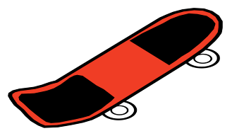
Exploring Concepts: (Balancing Act)

Summary: Students will determine the net force on an object through a series of trials and should determine by the end that forces are balanced when the net force is 0 Newtons.

Outline:
- Students will set up a wood dowel that can be pulled in opposite directions by two strings with slotted weights hanging on the ends (see picture below)
- Students will hang different amounts of weights on each string and record observations
- Students will calculate net force for each trial
- Students will determine which trials had balanced forces

Activity: Students will set up a wooden dowel in a small bucket of sand and attach two strings to the top of the dowel. Each string will be attached to a weight hanger and strung over the top of a pulley at opposite sides of a table; the pulley needs to be at an angle such that each string makes a right angle with the dowel. Students will also need two sets of slotted masses.
With one student holding the dowel in the upright position, another student will put slotted weights on both of the weighted hangers. After letting go of the dowel, the students will record if the dowel moved and what direction if it moved. Students will calculate the force each string applied to the dowel at that time (mass of the weight * acceleration of gravity = force applied by the string on the dowel). Students should have a force of string A and force of string B. Then students will calculate the net force on the dowel for that trial.
Students will repeat the process a number of times with varying amounts of weight on string A and string B, with at least twice where the mass on both strings is equivalent. At the end of the activity, students will be asked to go back determine whether each trial had balanced or unbalanced forces.
For a complete laboratory description see attached file: S153_SHINE_Balancing_Act_E_Net_Forces_Activity.doc

Attachment:
S153_SHINE_Balancing_Act_E_Net_Forces_Activity.doc
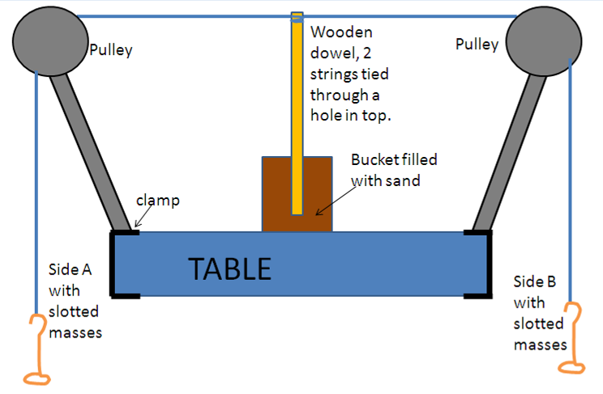
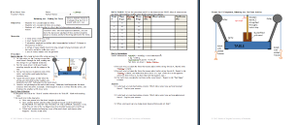
Instructing Concepts: (Balancing Act)

Force

Putting “Force” in Recognizable Terms: Force is a push or pull on an object that may result in an object with mass accelerating. The standard unit of force is a Newton (N) which is the amount of force required to give a 1-kg mass an acceleration of 1 m/sec². Force has both magnitude and direction and therefore it is a vector quantity. Typically directions noted as forward, up, or to the right are chosen as positive vectors, that is, force and acceleration are positive in any of those directions. Therefore, a force or acceleration quantity that is backward, down, or to the left would be considered negative.

Putting “Force” in Conceptual Terms: More than one force can act between objects or on a single object. If forces are balanced, meaning all the forces acting on an object cancel each other out than the object is at rest or in a state of constant motion. When forces on an object are unbalanced, the object’s motion will change or accelerate. Forces fit into two broad categories: contact and “action-at-a-distance”. Contact forces are forces that act directly on an object and might include: Frictional Force, Normal Force, Air Resistance Force, Applied Force, and Spring Force. Typical action-at-a-distance forces include: Gravitational Force, Electrical Force, and Magnetic Force.

Putting “Force” in Mathematical Terms: The force on an object can be calculated by looking at the individual or components of forces that are acting on the object. Newton’s first law states that an object at rest tends to stay at rest and an object in motion tends to stay in motion unless acted on by an unbalanced force. The net force on an object is the sum of all the forces (both contact and action-at-a-distance) acting on the object. If the object is at rest or moving at constant velocity the sum of the forces are balanced and cancel out. If the object is accelerating or decelerating, the forces do not cancel and the direction of the motion change of the object can be determined by the unbalanced force applied to the object using Newton's Second Law: F_{net} = ma where “F_{net}” is net force, “m” is mass, and “a” is acceleration.

Putting “Force” in Process Terms: Thus, the forces affecting an object can be calculated by looking at the sum of the individual forces at work on the object and the resulting movement, if any. By looking at individual forces on an object rather than just whether an object is moving or at rest can help you understand how and why the object is behaving the way it is.

Putting “Force” in Applicable terms: Force is a push on an object that may change its speed and direction as a result of acceleration. It can be thought of as the force required to change the motion of an object in a desired direction or to maintain an object at rest.
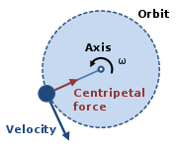
Centripetal Force
The magnitude of the centripetal force on an object of mass m
moving at a speed v along a path with radius of curvature r is:

$$F_{c}={\text{mv}}^{2}/r$$
The direction of the force is toward the center of the circle in which the object is moving, or the osculating circle, the circle that best fits the local path of the object, if the path is not circular.
Organizing Learning: (Balancing Act)

Summary: Students will be determining how much mass it takes to balance a force when the opposing forces are less than 180 degrees apart. Students will determine the effect of different angles on the balancing mass (and resulting force). Students will discuss how this is applied in real life (e.g. electricity poles).

Outline:
- Students will set up a wood dowel that can be pulled in two directions by two strings, one connected to a pulley with hanging slotted masses, and the other connected to a flat disk laying on the table (see picture below)
- Students will determine the minimum mass on the table anchor string needed to keep the dowel upright with 50 g mass hanging on the pulley string
- Students will repeat twice with the anchor string at different angles
- Students will complete a lab write-up that summarizes their data, predicts similar scenarios, and applies their new knowledge to real world construction

Activity: Students will set up a wooden dowel in a small bucket of sand and attach two strings to the top of the dowel. One string will be attached to a weight hanger and strung over the top of a pulley at the end of the table; the pulley needs to be at an angle such that the string makes a right angle with the dowel. The other string (called the anchor) will be attached to a flat disc and placed on the table such that the string is pulled taut. Students will also need a set of slotted masses and three uniform thickness books or blocks. Start the set up with 2 books underneath the sand bucket.
Students will determine the angle between the anchor and wood dowel and record. Working together, they will determine the minimum amount of mass (and calculated force) needed to keep the wood dowel standing straight when 50 g of mass is hanging from the pulley string. Students should find it takes more mass. They will do two more trials, with one book and then three books underneath the sand bucket, each time making sure the anchor line is drawn tight and re-measuring the angle.
Student will draw conclusions from their data. Students will roughly predict how much mass would be needed if a) there were 4 books under the bucket and b) if there were no books under the bucket. Students will also discuss in their lab write-up how this applies to electricity companies when choosing strengths of anchor wires on electricity poles. For a complete laboratory description see attached file.

Attachment:
S153_SHINE_Balancing_Act_O_Balancing_Angled_Forces.doc
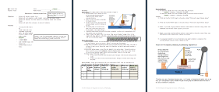
Understanding Learning: (Balancing Act)

Summary: Students will be assessed on their comprehension of net force and balanced/unbalanced forces through lab activity write-ups and a quiz with writing prompts.

Outline:
- Formative Assessment of Force
- Summative Assessment of Force

Activity: Students will complete written and quiz questions related to force.

Formative Assessment: As students are engaged in the lesson ask yourself these or similar questions:
- Are students connecting that a force is a push or a pull on an object?
- Do students understand the change of angle changes the force?
- Do students initially understand that opposite forces (with the same mass) are called balanced forces?
- Are students able to grasp that balanced forces at an angle < 180 degrees will have different masses? Can they explain why?

Summative Assessment: Students can answer the following writing and quiz questions.
- What is the net force on the box?
- Will this box remain still or start moving? How do you know?
- Will the mass at right be less than 100 g, equal to 100 g, or more than 100 g? Justify your answer.

- Calculate the force (in Newtons) applied on the dowel by the 100 g weight.
- Are the forces on the opposing strings equal? Explain your answer. NOTE: Tricky Question-the horizontal component of the left is equal to the force on the right, but the force through the string on the left is larger. You can use simple trigonometry to find the force on the string, but that depends on the math abilities of your students.
- Explain the amount of mass changes to balance the force when there is a less than 180-degree angle between the forces.

