Class Name Here Name ________________________ Period_____
Teacher’s Name Partner Names ____________&______________
Ideally students would be in groups of 3, but 2 or 4 would work well, too.
Balancing Act - Finding Net Force

Objectives: - Students will calculate applied force.
- Students will calculate net force on an object.
- Students will work together to collect detailed observations and analyze results.
Teacher’s note: for a time-squeezed classroom, you can have the pulleys set up ahead of time and have students adjust as needed, and have the strings pre-tied to the wood.

Materials:
- 1 wood dowel with hole in top
- 1 small bucket with sand
- 2 adjustable angle pulleys (either with clamps attached or have 2 C-clamps to hold pulleys to table)
- 2 strings of equal length (need to be long enough to hang over pulley and off the table, and table widths may vary)
- 2 sets of slotted masses with weight hook
Procedure:
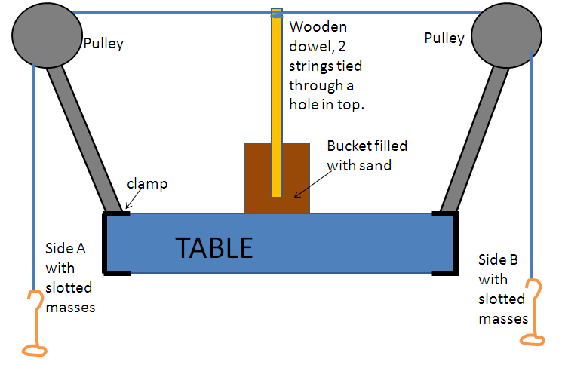
Part 1: Set Up (for a larger picture of the setup see page 3)
- At your table, tie the 2 strings to top of the wood dowel through the hole, making sure the strings will go opposite directions.
- Set the wood dowel in the sand bucket standing straight up with the strings at the top.
- Set up two pulleys on opposite ends of the table, and put the sand bucket halfway between them.
- Adjust the pulley angle so that when the strings are stretched over the top they are perpendicular (90°, right angle) to the wood dowel.
- Attach a weight hanger to the end of each string. Make sure both hangers are the same distance from the dowel. (Example: if the hanger on side A is 50 cm from the dowel, side B should be attached at 50 cm as well.)
Part 2: Data Collection
- Designate one side to be “Side A” and the other side to be “Side B”. Mark with masking tape.
- For each trial in the data table,
  - Have one person hold the dowel straight up and down.
  - Have another person add the correct amount of mass to each weight hanger. REMEMBER TO ADD IN THE WEIGHT OF THE HANGER. (Example- if you need 50 g on side A, the 5 g hanger plus 45 g of slotted masses gets your 50 g.)
  - When both masses are hanging, let go of the wood dowel and observe what happens. Record in data table.
DATA TABLE: Follow the procedure and fill in the observations FIRST. After all observations are done, then continue with the gray shaded calculations columns.
Trial # | Mass A  (g) | Force_{A} (N) | Mass B  (g) | Force_{B} (N) | Observations | Net Force (N)
1 | 20 |  | 60
2 | 40 |  | 60
3 | 60 |  | 60
4 | 75 |  | 60
5 | 75 |  | 50
6 | 75 |  | 25
7 | 50 |  | 50
8 | 48 |  | 50

Part 3: Calculations
Useful information: Force(N) = mass(kg) × acceleration(m/s²)
1 kg = 1000 g
acceleration of gravity = 9.8 m/s²
Net force on dowel = Force_{A} +Force_{B}

- For each trial, calculate the force the masses pulled on the string for side A. Record in the “Force_{A}” column.
- For each trial, calculate the force the masses pulled on the string for side B. Record in the ”Force_{B}” column, and make these forces have a (-) sign. (Force B is in the opposite direction from Force A; we show that with the negative sign.)
- For each trial, calculate the net force on the wood dowel. Record in the “Net Force” column.

Analysis
- Look back at your observations column. Which trials would you say have balanced forces? Explain your answer.

- Look back at your observations column. Which trials would you say have unbalanced forces? Explain your answer.

- What conclusion can you make about balanced forces and net force?

Picture for E Component, Balancing Act, Net Force Activity
