Class Name Here Name ________________________ Period_____
Teacher’s Name Partner Names ____________&______________
Ideally students would be in groups of 3, but 2 or 4 would work well, too.
Balancing Act – Balancing Angled Forces

Objectives: - Students will calculate applied force.
- Students will work together to collect detailed observations and analyze results.
- Students will determine the effect angles have on balancing masses (and resulting forces).
- Students will apply their conclusions to real-world situations.

Materials:

- 1 wood dowel with hole in top
- 1 small bucket with sand
- 1 adjustable angle pulley (either with clamps attached or have a C-clamp to hold pulley to table)
- protractor
Teacher’s note: for a time-squeezed classroom, you can have the pulleys set up ahead of time and have students adjust as needed, and have the strings pre-tied to the wood.
- 1 – 60 cm string
- 1 – 30 cm string
- 2 sets of slotted masses with weight hook
- 3 uniform-sized books or blocks

Procedure:
Part 1: Set Up (for a larger picture of the setup see bottom of page 3)
- At your table, tie the 2 strings to top of the wood dowel through the hole, making sure the strings will go opposite directions.
- Place 2 books on the table underneath the bucket of sand.
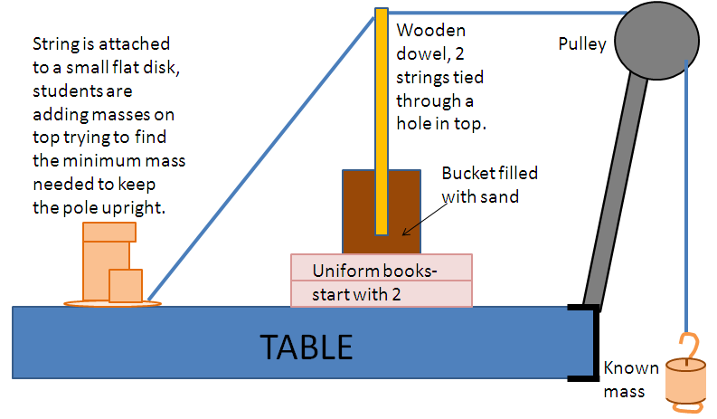
- Set the wood dowel in the sand bucket standing straight up with the strings at the top.
- Set up the pulley on one end of the table, and run the 60 cm string over the top; attach to the weight hanger.
- Adjust the pulley angle so that when the string is stretched over the top it is perpendicular (90°, right angle) to the wood dowel.
- Attach a small, flat weight to the 30 cm string. This is your “anchor” string. Place the flat weight with string attached on the table, opposite the pulley, and pull the string taut to the table with the wood standing straight.
*Step #8: Teacher may give all students the same mass, i.e. 50 grams, to hang from the pulley side, or you may give each group a slightly different weight so each group has different results that lead to the same CONCEPT conclusion.

Part 2: Data Collection
- Have one person hold the wood dowel straight up. Have another person use the protractor and find the angle between the two taut strings. Record in the data table (ON BACK).
- Obtain from your teacher the amount of mass your group will put on the pulley string. This will be different for each group! Record this mass in the data table, and add the appropriate weights to the hanger.
- Slowly start adding masses on top of the disc attached to the anchor string. Using trial and error, figure out with your group the minimum amount of mass needed on the anchor string to keep the wood dowel standing straight without anyone holding it. Record in the data table.
- Repeat steps 7-9 for trials #2 and #3:
  - In trial #2, use one book under the sand bucket. Re-adjust both the anchor string and the pulley.
  - In trial #3, use three books under the sand bucket. Re-adjust both the anchor string and the pulley.

DATA TABLE: Follow the procedure and fill in the observations FIRST. After all observations are done, then continue with the gray shaded calculations columns.
Trial # | Number of books under bucket | Angle between strings | Mass on pulley string (g) | Force on pulley string (N) | Mass on anchor string (g) | Force on anchor string(N)
1
2
3

Part 3: Calculations
- For each trial, calculate the force on the pulley string and record:
Force(N) = (mass(g) ÷ 1000g/kg) × (9.8m/s²)
For each trial, calculate the force the masses pulled on the anchor string and record: Force(N) = (mass(g) ÷ 1000g/kg) × (9.8m/s²)
Analysis
- Which trial had the LEAST weight on the anchor string? What was the angle between strings?

- Which trial had the MOST weight on the anchor string? What was the angle between strings?

- Based on your data, roughly predict the minimum mass needed on the anchor string if there were 4 BOOKS under the sand bucket. Explain your answer.

- Based on your data, roughly predict the minimum mass needed on the anchor string if there were NO BOOKS under the sand bucket. Explain your answer.

- In a paragraph, describe how your observations may apply to electricity companies when choosing strengths of anchor wires on electricity poles.

Picture for O Component, Balancing Act, Balancing Angled Forces
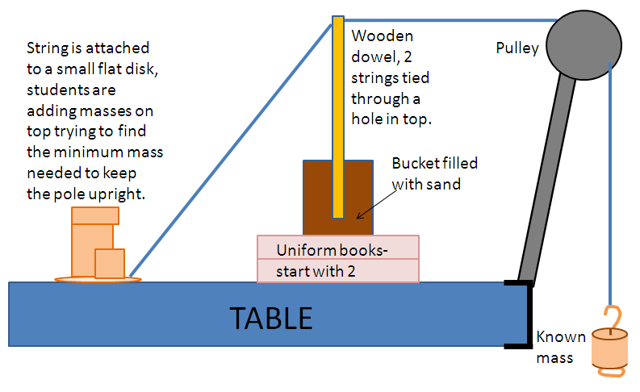
*Teacher may give all students the same mass, i.e. 50 grams, to hang from the pulley side, or you may give each group a slightly different weight so each group has different results that lead to the same CONCEPT conclusion.

