SHINE: Lesson
Have You Seen the Light Yet?
==========================Lesson Header ==========================
Lesson Title: Have you seen the light yet?
Draft Date: July 26, 2012
1st Author (Writer): LaDonna Miles
Associated Business:
Instructional Component Used: Electrical Power Consumption
Grade Level: 9-12

Content (what is taught):
- What is the difference between the two types of light bulbs?
- What is the cost to run each for one year?

Context (how it is taught):
- Research will be done to discover the cost of operating each type light bulb
- Students will prepare a report to determine their cost savings to switch light bulbs
Activity Description:
Students will do research and count light bulbs in their house. They will calculate electrical usage from the counted light bulbs and the cost to run the light bulbs for a year. This information will be charted and presented to the class. To conclude, students will calculate the potential savings if they change all their light bulbs to fluorescent bulbs.

Standards:

Science: SC1 Technology: TC2, TC4, TD3

Engineering: ED3 Math: ME1, ME2

Materials List:

- Pens
- Paper
- White board
- Markers
- Different types of light bulbs (incandescent, CFL, LED, halogen, etc.)

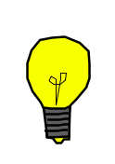
Asking Questions: (Have you seen the light yet?)

Summary: The activity will be a discussion about different types and uses for light bulbs.

Outline:
- Present different sizes and types of light bulbs
- Questions about different light bulbs
- Questions about energy usage of light bulbs

Activity: Provide the students with different light bulbs for them to look at. There needs to be several different types including: incandescent, CFL, halogen, LED, etc. Have students discuss what they know about light bulbs, where light bulbs are used, different types of light bulbs, and the amount of energy used by light bulb. The questions below should be answered in the activity.

Questions | Answers
What do we know about this light bulb? Present each type and ask about it. | Answers will vary
Why are there different types of light bulbs? | Different applications have different needs.
Where have you seen different light bulbs? | Answers vary.
Do different light bulbs draw different amounts of energy? | Yes. It is based on the wattage of the light bulb. Typically larger light bulbs draw more power.

Resources:
- Different types of light bulbs including incandescent, CFL, halogen, LED, etc.
Exploring Concepts: (Have you seen the light yet?)

Summary: Students will research the cost comparison of the amount of energy and cost of using different types of light bulbs.

Outline:
- Divide students into groups with each group being assigned a different type of light bulb
- Report the results of research

Activity: Students will be divided into teams based on the different types of light bulbs. The different groups should be assigned incandescent, LED, CFL, halogen, mercury vapor, etc for their research. As students research, they need to record information about applications (where used) for their bulb, cost to purchase, cost to operate, and history for their light bulb. To conclude, students will write a paper and present to the class their information about their bulb.
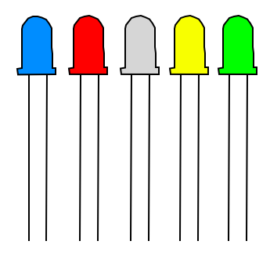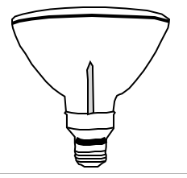
Instructing Concepts: (Have you seen the light yet?)

Electrical Power Consumption

Key Ideas:
- Electricity is the flow of electrons and is a force that can “do work”
- You must have a complete circuit for electricity to do work
- Energy is used by all electronic devices when running
- Modern electrical devices are being engineered to reduce the amount of electricity used while both actively being used and while turned off
- Some devices don’t need to be switched on to still use electricity, these standby losses are often called electrical “vampires”
  - The amount of standby power wasted varies among electronic equipment, but overall, the cost to consumers and businesses for all the electricity lost to vampire power in the US is estimated to be $4 billion annually. Approximately 5%-10% of all household use is this type of loss.

Vocabulary:
- Electricity: a fundamental form of energy observable in positive and negative forms that occurs naturally (as in lightning) or is produced (as in a generator) and that is expressed in terms of the movement and interaction of electrons
- Vampire Power: Wasted Standby Power in Home Electronics and Appliances.
- Watt: a standard unit of measurement for electricity. The wattage of devices provides a means of determining relative electrical consumption.
- The rate at which power is consumed by a device or unit (such as a building) is often expressed in kilowatt-hours.
- Kilowatt Hour (kWh): the basic unit of electric energy equal to 1 kilowatt or 1,000 watts of power used for one hour. The amount of power the customer uses is measured in kilowatt hours (kWh). A 100-Watt light bulb operated for 10 hours uses 1 kWh.
Organizing Learning: (Have you seen the light yet?)

Summary: Students will count the light bulbs in their home and figure out how much they spend per year in energy costs for them based on the number and type of bulbs in their houses.

Outline:
- Students will count the light bulbs in their home
- Students will calculate how much energy light bulbs in their home use in a year
- Students will calculate energy cost for the light bulbs in their home

Activity: Students will be given a checklist to help them count the number of light bulbs in their home (see attached file: S155_SHINE_Have_Seen_Light_Yet_O_Checklist.doc). The next day in class, students will be divided up into groups with each group analyzing the types and amount of light bulbs used in their homes. As a group, students will select a house to calculate the amount of electricity used and cost for a year due to light bulbs. Data that is collected from the home survey will be collated and charts will be completed which show amount and types of light bulbs used, energy consumption and cost. To conclude, students will calculate if all the incandescent light bulbs in the home are changed to CFLs what would be the electrical and cost savings.

Attachment:
- Light Bulb Checklist: S155_SHINE_Have_Seen_Light_Yet_O_Checklist.doc
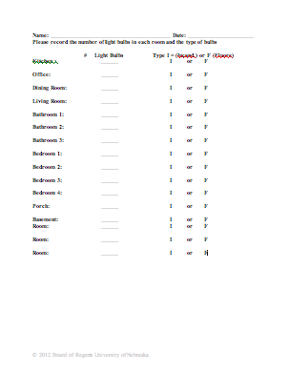
Understanding Learning: (Have you seen the light yet?)

Summary: Students will complete written and quiz questions related to electric power consumption.

Outline:
- Formative Assessment of Electric Power Consumption
- Summative Assessment of Electric Power Consumption

Activity: Student will complete written and quiz questions related to electric power consumption.

Formative Assessment: As students are engaged in the lesson ask these or similar questions:
- Were students able to do the requested research?
- Were they able to complete their checklist?
- Were they able to calculate their savings?

Summative Assessment: Students can complete one of the following writing prompts.
- Describe the electric power consumption in your home. What devices use electricity? What devices use the most electricity? How can we reduce our electricity usage?
- Which bulb is more energy efficient, an incandescent or CFL bulb?

Student can answer the following quiz questions.
- Given a 60-watt incandescent light bulb that runs 8 hours a day. Calculate the cost to run the bulb for a year if electricity costs $0.09/KWH
- Given a 13-watt CFL light bulb that runs 8 hours a day. Calculate the cost to run the bulb for a year if electricity costs $0.09/KWH.

