SHINE Lesson:
“Whose Generation is This?”
==========================Lesson Header ==========================
Lesson Title: Whose Generation is This?
This Teacher was mentored by:


www.nppd.com

In partnership with Project SHINE grant funded through the

National Science Foundation
Draft Date: 6/13/12
1st Author (Writer): Lowell E. Brown
Associated Business:
Instructional Component Used: Power Grid
Grade Level: 12th

Content (what is taught):
- Electrical power generation is based on balancing the electrical grid system (supply/demand)
- Electrical power generation is based on demand verses availability of generation type
- Electrical power is difficult to transfer between grids (Eastern, Western, Texas)

Context (how it is taught):
- Students will research power station locations (type, geography reasons, transmission capability
- Students will understand peak and off-peak electricity demand and cost
- Students will learn the concepts of electrical transmission, peak demand, balance of generation economics, and baseload power generation

Activity Description:
Students will be posed the question, “What is the power grid” to get them thinking about what the production and distribution of electricity. They will identify different sources of electrical power generation and classify them as base-load or auxiliary resource. To conclude, the students will construct a simulated power grid that they will have to keep balanced as demand for electricity changes over time.

Standards:
Math: MD2, MC4 Science: SB3, SE1, SF5

Technology: TA3, TD1, TC3, TD2 Engineering: EA2, EA3, ED1, EF5

Materials List:

- 1-4’x8’ 3/8” exterior grade plywood sheet
- 3-Gencon hand generators
- 20’ of 1/4” dowel rod
- 3- mini light bulb apparatus
- 60 - 4” wire ties
- 50’ of 20 gauge insulated wire
- 3 on/off switches

Asking Questions: (Whose Generation is This?)

Summary: Students will think about different ways to generate electricity. Students will consider the power grid and what are the key components of the power grid.

Outline:
- Different types of power generation
- What is the power grid

Activity: The discussion will begin by having students list different ways to generate power. The concepts of base-load power source and variable resource are introduced with each power source being labeled by the group as one or the other. Next, students will be posed the question, “What is the power grid?” As the question is answered, the thoughts generated should be written on the board for later use. The questions below should be touched on as part of the discussion.

Questions | Answers
What is the power grid? | The entire interconnected system of power plants and transmission lines that extends throughout the United States and into Canada and Mexico
What are the components of the grid? | Generators, transmission lines, load, etc.
How does the grid affect your lives? | Answers vary
Is there only one grid in the US? | No there are three. The eastern interconnect, the western interconnect, and the Texas interconnect.
What happens if the grid fails? | Answers vary
Exploring Concepts: (Whose Generation is This?)

Summary: Students will research NPPD power plants noting location and type. They will consider why they are located in a certain location and what type of load the power plant fulfills.

Outline:
- Students will list NPPD production facilities
- Students will be asked why the facilities located where they are
- Identify if the power plant is base-load or variable resource

Activity: Using NPPD Facilities Map (see link below), students will be assigned to groups and given a NPPD electrical production facility to research. Each group will be responsible for determining the production method for their production facility, how much energy it can produce, where it is located, whether the plant is base-load or variable resource, and why it might be located there. Research results will be reported back to the class as part of a summary discussion.

Resource:
NPPD Facilities Map: http://www.nppd.com/employment/facility-map
Instructing Concepts: (Whose Generation is This?)

The Power Grid

Definition: Power Grid: the entire interconnected system of power plants and transmission lines that extends throughout the United States and into Canada and Mexico. The grid is divided into three "interconnections" that serve all of the consumers in each region. Smaller distribution points within these interconnections make the supply more manageable as it makes its way to consumers.

Key Ideas:
- Power is produced at power plants and transferred to homes via the power grid.
- Generators in plants produce AC power.
- Each generator can only handle a certain load (their peak capacity) before producing brown outs and black outs.
- Power plants often have generating equipment which operates at varying levels of efficiency. The less efficient equipment can be used during periods of peak demand.

Vocabulary:
- Energy is the ability or capacity to do work.
- Generators are machines that convert fossil fuel, nuclear fuel, water, wind, solar, and/or other energy into electricity.
- Circuit(s) - A conductor or a system of conductors through which electric current flows in a complete path. Different configurations of circuits are possible, two of these are parallel and series.
- Alternating Current/AC: the standard form of electricity supplied to consumers in the US. Transformers are used to increase voltages for more efficient transmission.
- Direct Current/DC: a form of electricity in which electrons flow in only one direction—storage batteries use this form of electricity.
- Peak load or demand: the maximum amount of electricity needed during the time of greatest demand.
- Peak capacity: the maximum amount of electricity of which a power plant is capable of producing.
- Kilowatt: 1,000 watts
- Kilowatt hour: the energy of 1,000 watts used for one hour (a 100 watt lightbulb used for ten hours is one kilowatt hour).
- Megawatt: 1,000,000 watts
- Megawatt hour: the energy of 1,000,000 watts used for one hour.

A Final Thought
Society as we know it relies on the power grid for its very existence. The continual demand for more energy will continue to strain the capacity of the power grid. Brownouts or even blackouts will become more common. The current infrastructure will not be sufficient in the near future. We will have to make investments in growing and improving the power grid which costs money, time and resources if we are to meet our growing energy needs.
Organizing Learning: (Whose Generation is This?)

Summary: Students will build a simulated power grid to learn about production and transmission of electricity. Students will compare and contrast the need for base load generation, auxiliary generation, and intermittent generation and their impact on electric grid systems balance.

Outline:
- Students will construct electric production and transmission grid
- Students will manually generate power representing base load, auxiliary load, and intermittent production

Activity: Students will simulate a power grid by building a “transmission table”. The activity is based on a Nebraska Public Power District education activity. The grid will simulate power generation, including base-load and variable resources, transmission, distribution and load on the power grid. Power will be generated manually using “Gencon” generators to represent base load power generation, auxiliary load, and intermittent production to varying loads depend IE light bulbs being turned on. For a detailed activity description and pictures see attached files below.

Materials:
- 20 gauge wire, (2strand 8’ long)
- (2) 12” long 1/4 “ wooden dowels
- (2) 4” long 1/4 “ wooden dowels
- (4) 16” long 1/4 “ wooden dowels
- (6) 6” long 1/4 “ wooden dowels
- (8) Plastic thumb tacks
- (60) 4” sections of wire ties
- (2) 2X2” square wooden blocks with ¼” hole in center
- (2) 2X6” wooden blocks with ¼” holes 1” from each end

Attachments:
- Grid building assignment: S156_SHINE_Whose_Generation_Is_This_O_Assign.pdf
- Grid construction steps: S156_SHINE_Whose_Generation_Is_This_O_Construction_Steps.doc
- Grid circuit layout: S156_SHINE_Whose_Generation_Is_This_O_GridLayoutCircuit.jpg
- Grid rocker switch: S156_SHINE_Whose_Generation_Is_This_O_RockerSwitch.jpg
- Example grid: S156_SHINE_Whose_Generation_Is_This_O_Sample_Grid.jpg
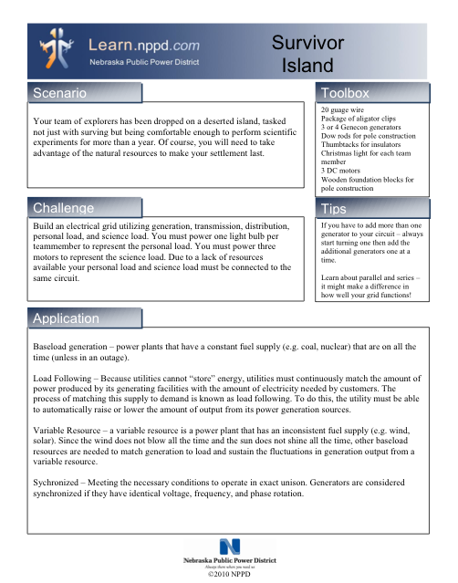
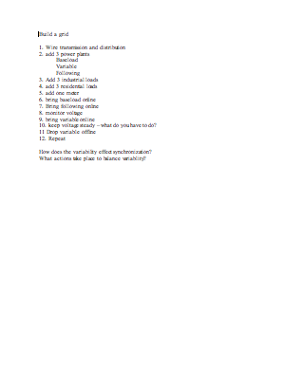
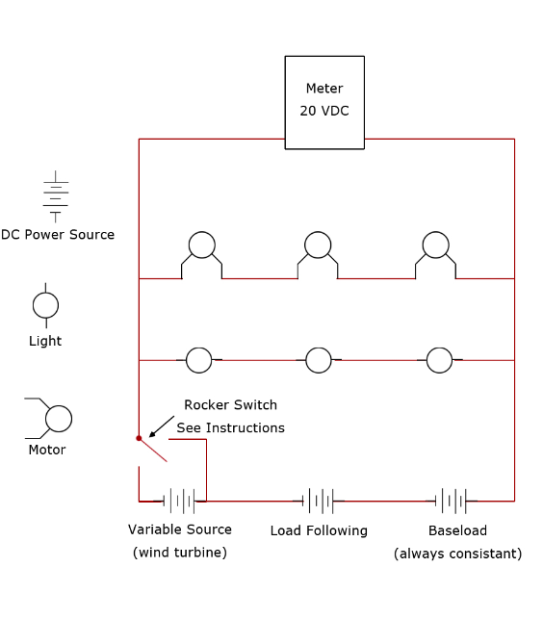
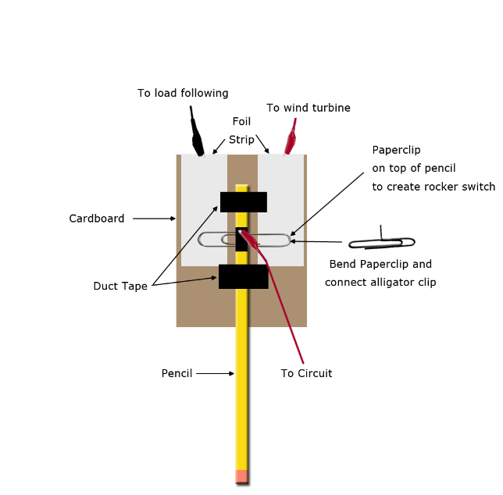
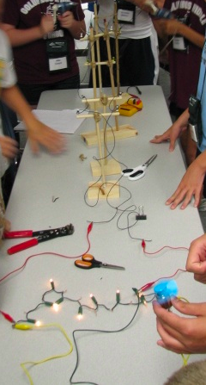
Understanding Learning: (Whose Generation is This?)

Summary: Students will be assessment on their understanding of election power production, transmitting, balance, and load.

Outline:
- Formative Assessment of the Power Grid
- Summative Assessment of the Power Grid

Activity: Students will complete written assessments related to the power grid.

Formative Assessment: As students are engaged in the lesson ask these or similar questions:
- Were students able to recognize base load, auxiliary load, and intermittent load production?
- Were students able to describe the type of production facilities in comparison to the type of electrical production performed?
- Were students able to correctly build and operate the simulated power grid?

Summative Assessment: Students can complete one of the following writing prompts.
- Describe the main part of the power grid and how they are related.
- What is the difference between base-load and auxiliary power resources? Why does a power company need both of these generation methods?
- What is load?
- What do we mean by balance relative to the power grid? Why does the power grid have to be constantly balanced?
- Why is it difficult to share power between the Eastern, Western, and Texas power grids?

