SHINE Lesson:
English or Metric?
==========================Lesson Header ==========================
Lesson Title: English or Metric?
Draft Date: 8/9/2012
Author (Writer): Patty Niemoth
Instructional Component Used: Dimensional Analysis
Grade Level: 9-12

Content (what is taught):
- Using dimensional analysis to convert from English measurements to metric and vice versa

Context (how it is taught):
- Identifying some of the different measurements we come across in our daily lives
- Calculating conversion factors from measurements
- Converting a recipe from English measurements to metric
Activity Description:
In this lesson, students will recognize the different ways measurements are used in their daily lives. They will take measurements in English and metric and find the conversion factors from their measurements. They will convert a recipe from home to metric units.

Standards:

Math: MD1 Science: SF5

Technology: TC2 Engineering: EC1

Materials List:
- Table
- Meter stick
- 100 mL graduated cylinder
- 1 cup liquid measuring cup
- Scale that measures grams and ounces
Asking Questions: (English or Metric?)

Summary: Students will think about and discuss the units of measurement that they encounter in daily life.

Outline:
- Teacher led discussion on what units of measurement are used in society

Activity: Hold a class discussion on different units of measurement students come in contact on a daily basis. Write the units of measurement on the board. This discussion will help students connect why they need to know both systems of measurement and why converting can be a useful skill.

Questions | Answers
When you buy jeans or pants, what units are the sizes in? | inches
What units are used for the sizes of baking pans? | inches
What units are used for parts on machines? | Inches, mm
What units are used for measuring volume on pop bottles? | Ounces and mL
When might you need to convert one unit to another? | When you have only metric tools and the machine you are fixing is in English units.
cm
meters
feet
kilograms
pounds
grams
miles
quarts
liters
yards
inches
Exploring Concepts: (English or Metric?)

Summary: Students will complete a lab to discover how units compare by calculating conversion factors.

Outline:
- Students will measure length, volume, and mass in both English units and metric units
- Students will calculate the conversion factors using their measurements
- Students will use resources to check their conversion factors

Activity: Students will be divided into groups and will complete a laboratory exercise that will have them measure objects in different measurements (both English and metric). From these measurements, conversion factors will be calculated by each group. When the lab is completed, students will check their work by seeing if the conversion factors they calculated are correct by doing research on the Internet or other resources. For a detailed description of the laboratory activity see attached file: S158_SHINE_English_or_Metric_E_Lab_Activity.doc

Attachment:
- Lab Activity: S158_SHINE_English_or_Metric_E_Lab_Activity.doc
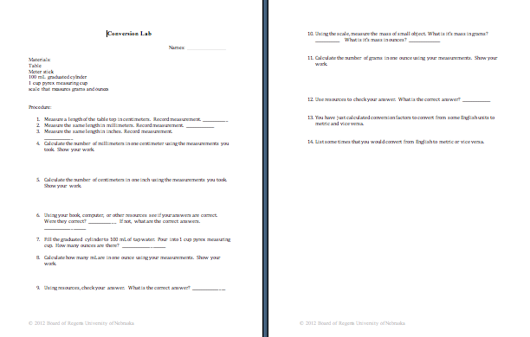
Instructing Concepts: (English or Metric?)

Dimensional Analysis

Putting Dimensional Analysis in Conceptual Terms: Dimensional Analysis (aka Factor-Label Method or Unit Factor Method) is a problem solving technique helpful in converting from one unit of measurement to another. It involves using conversion factors that are multiplied or divided into the original unit’s value to determine the secondary unit’s value.

Putting Dimensional Analysis in Mathematical Terms:
Dimensional analysis begins by determining a conversion factor or setting a unit equal to one in comparison to another unit. Some examples of conversion factors are:
1 foot = 12 inches 1 inch = 2.54 cm 1 mole = 6.022 x 10²³ particles

Note: It would also be correct to write 1 inch = 1/12 (0.83) foot, but often is easier to write the conversion factor making the larger unit equal to one. Then the amount of the other unit is written in a whole number rather than as a fraction or decimal value.

Next the conversion factor is applied to the original unit value either to be multiplied or divided.
Write the conversion factor as a fraction multiplied by the original value. Place the units desired to be eliminated or canceled on the bottom and the secondary unit on top.
Example:
Math component (34 x 1 = 34 … 34 ÷ 12 = 2.83)
Unit component (inches ÷ inches cancel the units
converting them to feet)
Convert 34 inches to feet
1 foot
12 inches
34 inches x = 2.83 ft

If several conversion factors are used to convert the original unit value, they can be written as many fractions multiplied together or in the method shown below. A horizontal line is drawn to represent all the fractions and several conversion factors are written together beginning with the original unit value and ending with the final unit value.
Math component (multiply numbers on top and divide numbers
on bottom)
Top: 5400 x 2.54 x 10 x 1 x 1 = 137160
Bottom: 1317160 ÷ 1 ÷ 1 ÷ 1 ÷ 365 ¼ ÷ 24 ÷ 3600 = 0.00435
Unit component (each one cancels until mm and sec remain)

Example

Convert to
5400 inches 2.54 cm 10 mm 1 year 1 day 1 hour = 0.00435 mm/sec
1 year 1 inch 1 cm 365 ¼ days 24 hours 3600 sec

Putting Dimensional Analysis in Applicable Terms:
Dimensional analysis can be utilized in unit conversion problems found in math and science especially mathematical story problems and chemistry stoichiometry problems as well as numerous other applications not listed here.
Organizing Learning: (English or Metric?)

Summary: Students convert a recipe from home to metric units.

Outline:
- Students will bring a recipe from home
- Students will convert the amounts from English to metric

Activity: Machinists often have to convert from English units to metric units and vice versa. In this activity, students will bring a recipe from home. Using conversion factors and dimensional analysis, they will convert the recipe from English units to metric units. The conversion factors for the most commonly found units in recipe are in the table below.

English Measurement | Metric Measurement
1 teaspoon | 5 mL
1 tablespoon | 15 mL
1 fluid ounce | 30 mL
1 cup | 240 mL
1 ounce weight | 28 g
1 pound | 454 g
Recipe for Chocolate Chip Cookies

2 ¼ cups flour
1 teaspoon baking soda
1 teaspoon salt
1 cup butter
¾ cup sugar
½ cup brown sugar
1 teaspoon vanilla
2 eggs
2 cups chocolate chips
Bake for 10 minutes at 375 degrees.
Understanding Learning: (English or Metric?)

Summary: Students will convert from one metric unit to an English unit and vice versa.

Outline:
- Formative Assessment of Dimensional Analysis
- Summative Assessment of Dimensional Analysis

Activity: Students will complete written and quiz questions using dimensional analysis.

Formative Assessment: As students are engaged in the lesson ask these or similar questions:
- Are students lining up their conversion factors correctly so units are crossed out as they multiply?
- Do they understand how one unit equals a certain number of another unit?
- Do their answers have the correct units?

Summative Assessment: Students can complete the following writing prompt:
Explain what dimensional analysis is and how it can be used to convert between units of measurements.

Students can complete the following quiz questions.
For each problem, find the answer using dimensional analysis.
- How many centimeters equal 6 inches?
- How many mL equal 8 fluid ounces?
- How many grams equal .5 pounds?

