SHINE Lesson:
Radioactive Glow
==========================Lesson Header ==========================
Lesson Title: Radioactive Glow
Draft Date: 8/23/2012
1st Author (Writer): Patty Niemoth
Instructional Component Used: Radioactive Decay
Grade Level: 9th grade

Content (what is taught):
- Define radioactive decay
- Define half-life
- Types of nuclear decay
- Calculation of half-life

Context (how it is taught):
- Brainstorming session to introduce nuclear decay
- Lab simulating nuclear decay
- Worksheets on nuclear equations and half-life
Activity Description:
In this lesson, students will brainstorm what they know about nuclear decay and radiation. Students will conduct a lab that simulates nuclear decay. They will complete worksheets on finding the missing part of a nuclear decay equation and identifying the type of nuclear decay. They will also complete a worksheet of half-life problems.

Standards:

Math: MB2 Science: SB3, SF5

Technology: TA3 Engineering: EB1

Materials List:
- 50 candy pieces with print on only one side per group (i.e. M&M’s, Skittles, etc.)
- Beaker or jar per group
- Graph paper
Asking Questions (Radioactive Glow)

Summary: The class will be led through a discussion about radiation in a brainstorming activity.

Outline:
- Teacher led discussion on nuclear radiation

Activity: A class discussion about nuclear radiation will take place. The class will discuss ways it is useful to us and the types of nuclear decay. Students should think about where radiation comes from, and as many pros and cons that they can list about radiation. The questions below should be addressed in the discussion.

Questions | Answers
What does a nuclear power plant do? | Provide electricity from radioactive material
What happens to the nuclear wastes? | It goes through nuclear decay
What are the types of nuclear decay? | Alpha, beta, and gamma
Name other places where nuclear radiation is used? | medical
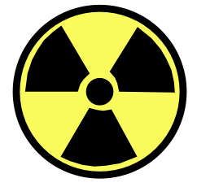
Exploring Concepts (Radioactive Glow)

Summary: Students will discover radioactive decay and half-life through a lab.

Outline:
- Students will simulate radioactive decay and half-life
- Students will compare how different lengths of half-life affect the graph of un-decayed atoms vs. time

Activity: Students will perform a lab simulating radioactive decay. They will use candy pieces with a print on one side or pennies. These will be shaken for a certain length of time and dumped on the table. The pieces with print side up will be considered decayed atoms and be removed. The process is repeated until no more un-decayed atoms are left. Using their data, they will calculate the half-life. For a detailed laboratory explanation see attached file: S160_SHINE_Radioactive_Glow_E_Lab.doc

Attachment:
- Laboratory Activity: S160_SHINE_Radioactive_Glow_E_Lab.doc
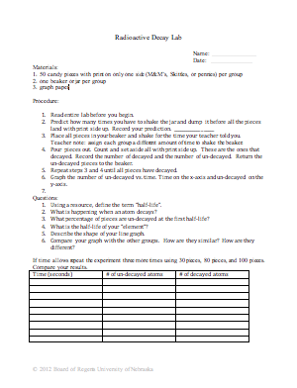
Instructing Concepts (Radioactive Glow)

Radioactive Decay

Radioactive Decay: Radioactive decay is the spontaneous break down of an atom’s nucleus into a slightly lighter nucleus, by emitting particles, releasing energy (electromagnetic), or both.
Cause of Radioactive Decay: The disintegration of an atom’s nucleus occurs due to changes in nucleons. Nucleons are particles within a nucleus. There are two kinds of nucleons: protons are positively charged particles and neutrons are neutrally charged particles. Both are similar in size, but the neutrons have slightly more mass. As protons are positively charged they repel each other. A force known as the “strong force” is used to hold the protons together, but it is only able to overcome the electrical-repulsive force with the aid of the neutrons’ mass.
So, ultimately radioactive decay is governed by the principle of balancing mass with energy or nucleons with the strong force. Nuclides decay by decreasing their mass altering this balance resulting in a release of particles and energy to maintain the mass-energy equilibrium. Nuclides can gain mass as well, but only if an external source of energy is added.
Radioactive Isotopes: Nuclei are unstable and decay in atoms when an unbalanced number of protons to neutrons occur forming radioactive isotopes. Isotopes are forms of the same element that vary in the number of neutrons or mass. Examples of isotope forms for hydrogen include: protium ; deuterium , and tritium each written in the nuclear symbol form, following their name. The subscript identifies the element as hydrogen as it indicates the number of protons or atomic number. The superscript denotes the atomic mass. The mass increases each time a neutron is added. In the case of hydrogen, tritrium has the least stable nucleus and therefore more likely to undergo radioactive decay.
Types of Radioactive Decay: There are several common types of radioactive decay. Two release or emit particles: alpha, and beta. In the case of positron and electron capture, particles within the atom are altered or emitted to convert a neutron into a proton to stabilize the nucleus. All of these differ from gamma ray emissions as those are strictly releases of energy.
Type | Symbol | Charge | Mass (amu) | Emission Description
Alpha particle (ά) |  | 2+ | 4.001 5062 | -two protons and two neutrons bound together, similar to a Helium nucleus
Beta particle (β) |  | 1- | 0.000 5486 | -an electron emitted
Positron |  | 1+ | 0.000 5486 | -particle similar in size to an electron, but positively charged emitted to convert a proton into a neutron
Electron capture |  | 1+ | no change | -an inner orbital electron is taken by a proton in the same atom to create a neutron
Gamma Ray (γ) | γ | 0 | 0 | -differs from the other emissions as it is a high-energy electromagnetic (light) wave emitted when the energy within the nucleus changes
Half-Life: Half-life measures the time of a given radioactive element to reduce half of its nuclei in any sample by radioactive decay. For the radioactive isotope, titrium its half-life is 12.32 years. If a 30 mg sample of tritium was being stored, then in 12.32 years there will be 15 mg of the sample remaining.
Radioactive Decay Detection: There are several means of detecting radioactive decay. Photographic film can be used as it will be exposed in the presence of radiation. However, film can only provide an approximation of exposure. For more accurate measurements a Geiger-Müller counter is used. It detects radiation by counting electric pulses carried by gas ionized by radiation. There are also several other methods: Scintillate Counter, MicroR Meter with Sodium Iodide Detector, Portable Multichannel Analyzer, Ionization (Ion) Chamber, Neutron REM Meter with Proportional Counter, Radon Detectors, Proportional Counter, Multichannel Analyzer System.
For additional diagrams and examples see file: I_Sci_049_Radioactivity_Decay_I_Diagrams.doc
Organizing Learning (Radioactive Glow)

Summary: Students will complete worksheets on balancing nuclear equations and half-life problems.

Outline:
- Students will balance nuclear equations
- Students will solve half-life problems

Activity: Students will complete two different worksheets related to radioactive decay. The first worksheet will be balancing nuclear equations and identifying the type of nuclear decay. The second worksheet will have students calculating half-life.

Attachments:
- Nuclear Equations Worksheet: S160_SHINE_Radioactive_Glow_O_Nuclear_Equations_Wrksht.doc
- Half life worksheet: S160_SHINE_Radioactive_Glow_O_Half_Life_Wrksht.doc
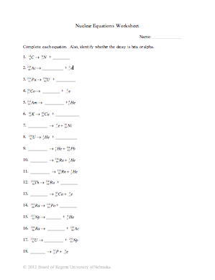
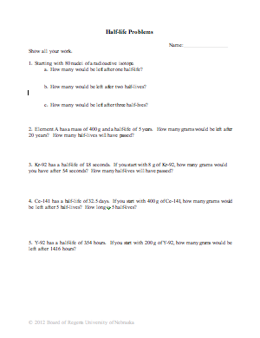
Understanding Learning (Radioactive Glow)

Summary: Students will differentiate between the three types of radioactive decay, understand radioactive decay, be able to calculate half-lives, and determine missing parts in a radioactive decay equation.

Outline:
- Formative Assessment of Radioactive Decay
- Summative Assessment of Radioactive Decay

Activity: Students will complete a written and performance assessment over radioactive decay.

Formative Assessment: As students are engaged in the lesson ask these or similar questions:
- Can students identify the type of radioactive decay from the chemical equation?
- Can students calculate the half-life from data?
- Can students fill in the missing part of a radioactive decay equation?

Summative Assessment: Students can complete the following writing prompt:
- What is radioactive decay?

Students can complete one of the following performance assessments:
- From the following equation, identify the type of radioactive decay and determine the missing part.
${}_{6}^{\text{14}}{}$C → ${}_{7}^{\text{14}}{}$N + ________
- Element A has a mass of 400 g and a half-life of 5 years. How many grams would be left after 20 years? How many half-lives will have passed?

