SHINE Lesson:

Wash Your Hands!

==========================Lesson Header ==========================

Lesson Title: Wash Your Hands!
This Teacher was mentored by:


www.cargill.com

In partnership with Project SHINE grant funded through the

National Science Foundation

Draft Date: 8/10/12

1st Author (Writer): Jess Eckman

Associated Business: Cargill

Instructional Component Used: Microbes

Grade Level: 6-8

Content (what is taught):
- Microbe transmission
- Necessity of microbes
- Harmful nature of microbes

Context (how it is taught):
- Students will view a hand washing video and discuss why it’s important to wash hands
- Students will play a germ game to simulate the transfer of germs by shaking hands
- Student research

Activity Description:

After an introductory game, discussion, and notes, students will research microorganisms and create a poster encouraging other students to wash their hands.

Standards:

Science: SA1, SA2, SC2, SC4 Technology: TC2, TC4, TD3

Engineering: EB1 Math: ME2, MA1, MA3

Materials List:
- Glitter Bill Nye “Germs” video (optional- supplementary use only)
- Poster board and poster supplies
Asking Questions: (Wash Your Hands!)

Summary: Students will view a hand washing video and discuss why it’s important to wash hands.

Outline:
- Students will view “You’d Better Wash Your Hands” on You Tube (link below)
- Students will discuss hand-washing techniques

Activity: Students will watch the “You’d Better Wash Your Hands” music video (to the tune of the Beatles “I Wanna Hold Your Hand”). This can be found at the time of this writing at the You Tube link below or by searching for the title on “Google”. After the video is shown, a question answer session about the video will be conducted. The questions below should be used to help guide the discussion.

Questions | Answers
Why do we wash our hands before we cook or eat? | Hand washing is essential because so many germs can be on our hands! Handling foods with dirty hands can transfer germs to the food and possibly into people’s mouths!
What is a germ? | A small life form that can make us very sick!
How big is a germ? | So small it cannot be seen with the naked eye!
How do germs spread? | Some germs can be spread by touching, eating/drinking, breathing, or even by being bitten

Resources:
- “You’d Better Wash Your Hands” video: http://www.youtube.com/watch?v=AtlcS77LaB0

Exploring Concepts: (Wash Your Hands!)

Summary: Students will play a germ game to simulate the transfer of germs by shaking hands.

Outline:
- Students will be instructed on the germ simulation
- Students will complete the germ simulation
- The class will discuss how germs are spread
- If time allows, students will view extension videos attached

Activity: One in ten students will secretly be given glitter on their hands. Students will mingle around the room shaking hands with each other. After three minutes, students will all stop and look at their hands. Almost all students will have traces of glitter on their hands. A discussion will follow about surfaces students touch at school and home that could transfer germs to their hands. If time allows, the videos listed below can be used as an additional resource

Resources:
- http://www.youtube.com/watch?v=AtlcS77LaB0
- http://www.youtube.com/watch?v=tRLQ-p0PEzU&feature=related
- http://www.gamequarium.org/cgi-bin/search/linfo.cgi?id=7922
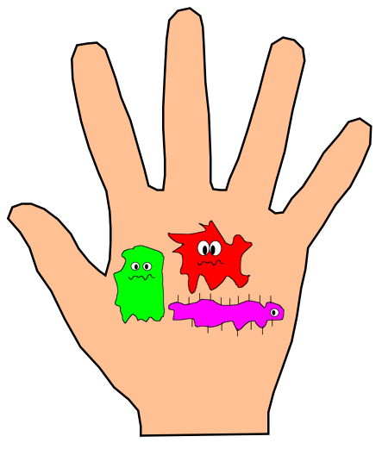

Instructing Concepts: (Wash Your Hands!)

Microbes

Microorganisms: Microorganisms or microbes are living creatures unseen to the naked eye. They can often only be viewed with the assistance of a microscope. Several organisms fall into this classification: bacteria, archaea (archeon), some fungi, and many protists. They tend to be unicellular (single-celled) but no exclusively so.

Types of Microorganisms:

1. Bacteria (Monera) are unicellular, prokaryotic (no nucleus), and are ubiquitous in every habitat or biome on Earth.

2. Archaea are unicellular, prokaryotic, and were originally classified as bacteria known as archaebacteria. However, arachaea differ from bacteria in their lack of organelles, metabolic pathways, and reproduction methods. They are also found in a wide variety of biomes. Some are even referred to as extremophils because of their ability to live in harsh environments like hot springs.

3. Fungi includes two varieties of microscopic organisms: yeast and mold.

A. Yeast are unicellular, eukaryotic (nucleus present), and typically oval or spherical in shape. They are found in soils or as powdery coating on plant material in nature. However, they are important anaerobes fermenting ethyl alcohol for wines and beer as well as producing carbon dioxide used in the raising of bread dough.

B. Mold (includes mildews, rusts, and smuts) are multicelluar, eukaryotic and are filamentous in shape. They often live on the surface of another organisms or food sources and are referred to as saprobes (consumers of dead organic matter).

4. Protists includes some 30-40 dissimilar phyla loosely defined as unicellular or multicellular organisms without specialized tissue. They vary in food cycle types, life cycle types, and mechanisms of movement.

Trophic Modes of Microorganisms: (Energy Usage by Microbes)

Microbes can be autotrophic (produce their own energy) or heterotrophic (receive energy from other organisms or food sources) as well as aerobic (use oxygen to aid in energy production) or anaerobic (do not use oxygen to aid in energy production).

1. Autotrophic microorganisms usually receive their energy from the sun in the process of photosynthesis, which benefits many other organisms by producing oxygen. However there are autotrophic microbes known to use other sources for energy such as hydrogen, carbon dioxide, sulfur, or ammonia.

2. Heterotrophic microorganism can be beneficial or harmful. These tiny organisms are harmful if they are parasitic (use a host as their energy source and cause it harm). There are those that live independent and others that are symbiotic (permanent, close relationship between species without harm) or mutualistic (symbiotic relationship that benefits both species). Many of these are decomposers that break down recycling nutrients to benefit other organisms and aid in the carbon and nitrogen cycles. Others produce beneficial byproducts such as methane or ethanol.

Uses of Microbes:

The properties stated above have led to uses of microbes such as: Biotechnology, Biochemistry, Molecular Biology, Genetics, Genetic Engineering, Digestion, Ethanol fermentation, Methane Fermentation, Wastewater Treatment, Traditional food and beverage preparation.

Organizing Learning: (Wash Your Hands!)

Summary: Students will complete a research project in groups about Microbes to present to the class.

Outline:
- Students will form groups of 3-4 members
- Groups will research microorganisms, the diseases and sickness transmitted by microorganisms, the importance of hand washing, and proper hand washing technique
- Groups will create posters to display above sinks around the school building, encouraging students to wash their hands
- Groups will present their posters to the class and around the school

Activity: Students will form groups of 3-4 members with each group researching microorganisms, the diseases and sickness transmitted by microorganisms, the importance of hand washing, and proper hand washing technique. Groups will create posters to display above sinks around the school building, encouraging students to wash their hands. (See attached project requirements page). Groups will present their posters to the class and students will hang posters above sinks around the school.

Discussion topics:

*Germs may be present but not seen on hands

*Hand washing is arguably the best way to prevent illness and infectious disease

*Hand washing is important as a society- what would change if EVERYONE washed their hands?

Attachments:
- Activity requirements: S161_SHINE_Wash_Your_Hands_O_Project.doc
- Rubric: S161_SHINE_Wash_Your_Hands_O_Project_Rubric.doc
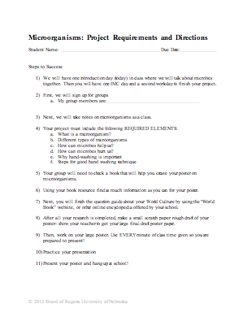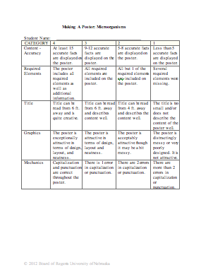
Understanding Learning: (Wash Your Hands!)

Summary: Students will demonstrate understanding of microbes.

Outline:
- Formative Assessment of Microbes
- Summative Assessment of Microbes

Activity: Students will complete written assessments related to microbes.

Formative Assessment: As students are engaged in the lesson ask these or similar questions:
- Are students engaged in viewing the “You’d Better Wash Your Hands” video clip?
- Do students understand how the glitter game relates to real life germs being spread?
- Are groups actively engaged in discussion about germs?
- Are students actively engaged in research? Are students asking questions about their research?

Summative Assessment: Students can complete one of the following writing prompts:
- Explain how germs can be spread through different mechanisms.
- What are different types of microorganisms?
- How are microbes beneficial to us?
- How are microbes harmful to us?

