SPIRIT 2.0 Lessons:
How am I the Same or Different?

==============================Lesson Header===============================
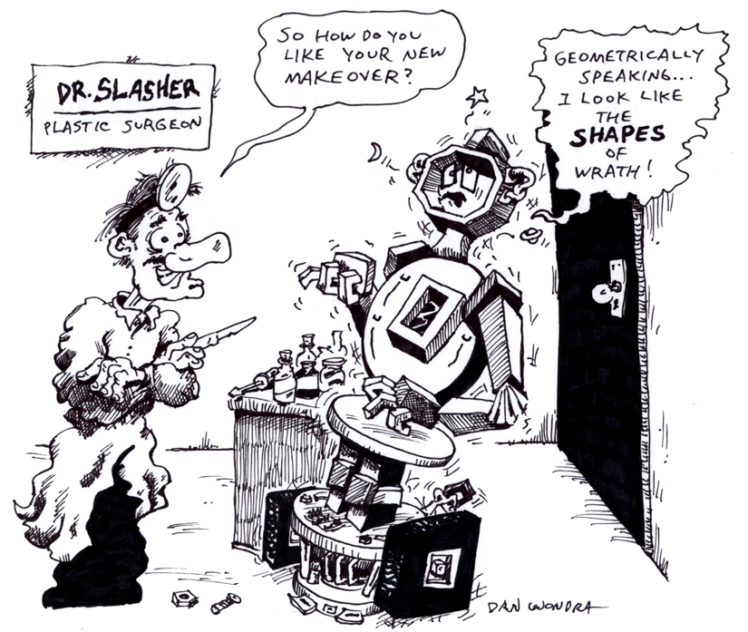
Lesson Title: How am I the Same or Different?
Draft Date: July 18, 2008
1st Author (Writer): Lynn Behounek
Algebra Topic: Attributes/Patterns
Grade Level: Primary

Content (what is taught):
- Compare attributes in geometrical shapes to create a pattern
- Record information
Context (how it is taught):
- Manipulating attribute blocks

Activity Description:
Students will use the CEENBoT to explore the idea that geometric figures have different attributes.

Standards:
- Math—C1, B2, C4
- Science—A1
- Technology—A3

Materials List:
- Attribute blocks
- Markers/Crayons
- Paper for attribute notebook
- Computer
- Internet connection
- Seven Blind Mice by Ed Young

ASKING Questions (How am I the Same or Different?)

Summary:
Students explore similarities and differences in a storybook, in everyday objects, and on the CEENBoT.

Outline:
- Read literature.
- Compare shapes of CEENBoT.
- Compare shapes of attribute blocks.

Activity:
With K-1 students, read Seven Blind Mice by Ed Young. Have a class discussion about the similarities and differences of what the elephant represents.

Questions | Possible Answers
How are a wheel and a washer similar? How are they different? | Both the wheel and washer are round but the tire is thicker than the washer is.
What different shapes do you see on the CEENBoT? | Square, circle, rectangle, hexagon
How are the circles (square, rectangle, and hexagon) different on the CEENBoT? | Size, thickness, color, and materials of which they are made
Do you see some of those same shapes in the classroom? How are they different? | Students will say yes and explain how they are different.
What are the four differences that can be seen with attribute blocks? | Size, shape, thickness, and color

EXPLORING Concepts (How am I the Same or Different?)

Summary:
Students explore different shapes while driving the CEENBoT.

Outline:
- Identify differences (shape, color and size) in geometric figures

Activity 1:
To prepare for this activity, cut out large shapes from different colors of construction paper. Tape the shapes to the floor. Students will use the CEENBoT to drive from one shape to another and explain how shapes are different based on size, shape, or color.

Activity 2:
Ask each student to select a block from a class set of attribute blocks. Ask each student to describe the block that she/he selected. Instruct the next student to select a block that is different in only one way. Ask the student to explain the one way it is different from the previous block. When the group agrees that there is only one difference, place the second block next to the first one. The next student takes a turn and so on. The pattern created can be put on a document reader so all students may see the pattern being created.

Game: Each student is given the same number of blocks and the directions above are followed. If the student does not have a block that qualifies when it is his turn the play, he passes to the next person. The student who uses all of his blocks first is the winner.

Extensions:
Students can experiment with and use online attribute blocks problems at the following website:
http://mathforum.org/varnelle/kalgstudent.html

Additional online activities using attribute blocks can be found at:
http://www.kindergarten-lessons.com/attribute-blocks.html
INSTRUCTING Concepts (How am I the Same or Different?)

Problem Solving Process:
The problem solving process is teachable and students will become better problem solvers with guidance and practice. Since there are many problem solving models, it depends on who you talk to about which model is best. George Polya first outlined one of the best-known problem solving processes. This instructional piece will focus on Polya’s work.

Step One: Understand the Problem
This step involves the very beginning of the problem solving process. Students are asked to analyze carefully the problem paying particular attention to these questions.
- Are all the words in the problem known to you?
- What are you supposed to find, solve for, show, or prove?
- Is it possible to restate the problem in your own words?
- Is there a picture, graph, or diagram that can help you understand the problem?
- Is there enough information to solve the problem?

Step Two: Devise a Plan
This step involves deciding how students are going to solve the problem and creating a plan that will lead to that solution. Below are some possible strategies that students might want to consider.
- Guess and check, look for a pattern, draw a picture, make a list.
- Solve a simpler problem.
- Think about problems that are similar and that you might have solved before.
- Compare and contrast.
- Use a model.
- Solve an equation or work backward.

This list of strategies is not all-inclusive. One of the most important strategies is to be creative and think outside the box to try to devise new and different ideas that may apply.
Step Three: Carry out the Plan
Students must work carefully and diligently to attempt the plan they have devised. If their plan does not work, have them go back to step two and use the knowledge they have gained to think of something else. Often students (as well as the rest of us!) learn more from a failure than by solving a problem correctly the first time.

Step Four: Looking Back
This step is very important to becoming better problem solvers. It is the analysis of what worked and what did not work that allows the students to apply knowledge in similar situations and in less familiar areas. Have students think about where they might use the method again and think about how they could improve their strategy. The analysis of what happened in this exercise will make problem solving easier in the future.
ORGANIZING Learning (How am I the Same or Different?)

Summary:
Students record patterns in attribute notebook using words and pictures.

Outline:
- Create pattern
- Record pattern
- Explain pattern

Activity:
Students will go to centers in the classroom that have sets of shapes. The shapes will be different sizes and colors. Students will be asked to create patterns based on shape, color, and size. These patterns will be recorded in their attribute notebook. In their notebook, students will sketch a drawing of each pattern and include a description.

Example:

Large yellow square Large blue square Large blue circle Small blue circle

Understanding Learning (How am I the Same or Different?)

Summary:
Students will be assessed on pattern recognition and creating patterns.

Outline:
- Formative assessment of pattern recognition and creation
- Summative assessment of pattern recognition and creation

Activity:
Formative Assessment
As students are engaged in learning activities, ask yourself or your students these types of questions:
1. Were the students able to locate similarities and differences between the robot and the given shapes?
2. Can students locate and explain a pattern?
3. Can students properly record the patterns that they locate?

Summative Assessment
- Present students with patterns and have them explain the pattern in words. Also, have students explain what shape, size, and color would come next. For example:

?

_________

?

_________

2. Students can take turns driving the robot to different shapes on the floor. As each student drives the robot, other students record the shapes on the worksheet. The student driving will stop before the last shape in the pattern. Students will predict the last shape. The driver will drive to the last shape in the pattern and students will check their work.

What's My Pattern?

