SPIRIT 2.0 Lesson:
Circuitly Speaking

===============================Lesson Header==============================
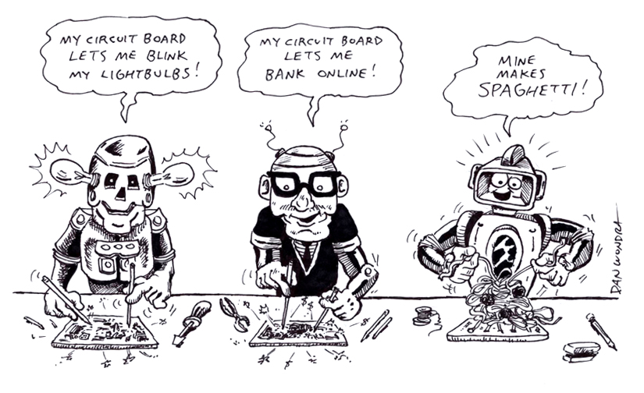
Lesson Title: Circuitly Speaking
Draft Date: July 20, 2008
1st Author (Writer): Davina Faimon
STEM Topic: processing systems of robots and humans
Grade Level: Middle and Secondary

Content (what is taught):
- Processing systems of humans and machines
- Different parts of robot circuitry and the human brain

Context (how it is taught):
- Students will compare the processing systems of humans and machines.
- Students will define and compare the different parts of robot circuitry and the human brain.
- Students will write analogies comparing the two systems.

Activity Description:
In this lesson (series of inquiry activities), students will experiment with the robot and
become familiar with its various functions, make observations of the robot’s circuit boards, and discuss its processing abilities.

Extension project:
- Consider teaching programming.
- Competition: Man vs. Robot in a maze. Program the robot to complete the maze and prepare a plan for the human to complete the maze. Find out which records the better time for accuracy, speed, consistency, and creativity.
- Debate: Which is better: human or robot?
- Extend the comparison to include animal brains or further different kinds of animals, insects etc.

Standards:
- Math— B1, B3, D1, D2, E3
- Science—A1, A2, C1, C3, E1, E2, F1, F4, F5, G1
- Technology—A3, B4, C1, C2, C3, C4, D3, E2, E3, E4, F1, F3, F4

Materials List:

- Robot
- Model of the human brain
- Notebook
- Computer
- Circuit boards

ASKING Questions (Circuitly Speaking)

Summary:
Students are asked to compare the processing systems of robots and humans.

Outline:
- Observe the robot in both controlled and ‘bumper’ mode.
- Examine the circuit boards.
- Watch an educational video or read about the brain.
- Determine corresponding parts of circuitry and brain.

Activity:
Demonstrate how the robot works in both modes (controlled with a remote and ‘bumper’ mode). Write a set of instructions (e.g., go forward one foot, turn right 90 degrees, walk forward 5 feet). At the same time, have a student control the robot through the set of instructions while another student follows the same set of instructions by walking. Take the remote off the robot and try to have the robot follow the instructions in ‘bumper’ mode.

Questions | Possible Answers
How does the robot know how to move? | The robot knows how to move by the programming of the circuits, by the human controller, or by the designer who tells the robot what to do.
How does a human know how to move? | The brain tells the human how to move. The cells makes the brain do things a certain way.
What are the parts of the robot and human brain? | The parts of the robot are the circuits and connectors. The parts of the human brain are the synapses and dendrites.
What makes the robot carry out the requested movement? | The circuits are pathways for the commands to translate into action.
What is it that actually flows through the processing mechanisms in robots and the human brain? | Electricity
How easy was it for the robot to follow the set of instructions? The human? Could the movement of the robot and the human ever be the same? | It took the robot a little longer to follow the instructions because the person controlling the robot had to process the movement and then move the controller the correct way. The human only had to read the instruction and then move. More advanced robots could probably move quicker and maybe just as well as a human.
I am programmed to make the robot move.
I coordinate sensation, intelligence, and nervous activity for humans.
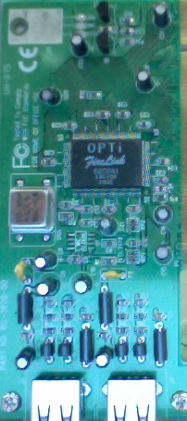

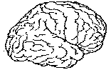

EXPLORING Concepts (Circuitly Speaking)

Summary:
Students explore the different functions of the various components of the circuit board.

Outline:
- Individual circuit board parts will be labeled and functions will be defined.
- Students will consider what would happen if a certain part of the circuitry was removed.
- View video clips of robots with altered circuitry and humans with impaired brain function.
- Students will examine circuit boards with missing parts and predict what the robot will and will not be able to do without those pieces.

Activity:
Students will move from station to station or be provided with direct instruction that will explain the function of certain parts of the circuit board. Along with each component, the brain’s counterparts will be identified and defined. Students will predict what would happen to the robot’s performance if certain parts of the circuitry were omitted or modified.
To provide formative assessments as students are exploring these concepts, ask students these questions:
- What functions will be impacted with the removal of the _____________ in the robot? (In the human brain?)
- Which functions might appear to be intact, but when brought into a linear progression will be shown to be non-functional? (What parts are dependent upon other parts for certain functions in the robot? In the human brain?)
- Does this information give you a better understanding of the electronics used in your daily life? How could this information help you fix your own electrical problems?
- How is this troubleshooting similar to the kind of problem solving that doctors do? How is it different? How could educational robots help people prepare for a career in medicine?
- Do you think that the brain is complex?
- Why is it important to know how to use the engineering, scientific, or future problem solving methods?

INSTRUCTING Concepts (Circuitly Speaking)

Scientific Inquiry

Scientific Inquiry Process
Scientific Inquiry is a very systematic process that scientist use to understand phenomena that are present in the world. The process must be followed exactly without any deviation; otherwise, any of the results that are obtained might not be valid. There are six basic steps to the scientific inquiry process.

Step One: Ask a question.
In this step you ask a question that you want answered about something that you have observed. If scientific inquiry is to provide an answer, the question must be framed in such a way that it can be measured, preferably with a number.

Step Two: Make observations regarding the phenomenon being studied.
The scientist will observe the phenomenon that is being studied without out any bias. It is important that the phenomena be researched in addition to observing it so that past information will be noted and past mistakes will not be repeated.

Step Three: Form a hypothesis that might explain the observations.
The hypothesis should be framed in a format like “If I do this, then this will happen”. This hypothesis must be measurable and should help you answer your original question.

Step Four: Test your hypothesis by doing an experiment.
You will conduct an experiment that will prove your hypothesis true or false. It is important that the experiment be unbiased and fair. To do this, you can only change one variable at a time and keep everything else the same. Doing this insures that any change observed will be as a result of your experiment and not some other factor.

Step Five: Analyze your data and draw conclusions.
Once your experiment is done you need to analyze your measurements and see if your hypothesis is true or false. If your hypothesis is false (a common occurrence), you should start the entire process again with a new hypothesis. Even if you find your hypothesis to be true you may want to devise another experiment to test your hypothesis again. Multiple experiments that validate your hypothesis make your conclusion stronger.

Step Six: Communicate your results.
If your hypothesis stands up to multiple tests you should report your results in a final report. This might take the form of a journal article in a professional or scientific journal.

ORGANIZING Learning (Circuitly Speaking)

Summary:
Students use an engineering notebook to list and define the parts, observe the functions, and possible malfunctions (as well as solutions) for both the robot circuitry and the human brain.

Outline:
- Sketch a picture of the parts of the circuit / brain.
- Write observations of the functions of each part of the circuit / brain.
- Record video observations of malfunctions for each part.
- Predict / create solutions for malfunctions.
- Write analogies comparing the robot’s circuitry to the brain’s inner-workings.

Activity:
Students will record their observations and critical thinking by completing a chart outlining their analysis for each of the components listed.

Worksheet: Brain Circuit

UNDERSTANDING Learning (Circuitly Speaking)

Summary:
Students will choose the level of understanding they would like to demonstrate upon completion of this inquiry lesson.

Outline:
- Formative assessment: Analogies demonstrating understanding of robot circuitry and brain function
- Summative assessment: Conclusions derived from inquiry. Where did this inquiry take each student? The result will be different for each of them if they participated in true inquiry.
- Summative assessment: Circuit and human brain function

Activity:
With a partner, students will write analogies comparing the parts and functions of the robot and human brains. Having students work together increases the depth and complexity of the observations and analogies.

Formative Assessment
Collect analogies from students and check for correct understandings. If any misconceptions are identified, make a note or visit with students to get them back on track.

Summative Assessment
Students will complete an essay on scientific inquiry. What did this inquiry project help you learn? What conclusions have you drawn from this study? The answers to these questions will give you a good idea about each student’s depth of understanding. For example, if a student talks about testing things and trying to figure out their function you will know that the first student is analytical but concrete. If a second students talks about testing and function but also the big picture of preparing doctors for medical careers, the second student is analytical but also has the ability to apply knowledge to a broader concept in a more abstract manner.

Students will complete an identification and prediction lab form. Show students a piece of the circuitry or a part of the brain. Students will identify the part, explain its function, possible malfunction, solutions for correcting malfunction, and name an analogous part from the other system.

