SPIRIT 2.0 Lesson:
Obnoxious Obstacles
==========================Lesson Header ==========================
Lesson Title: Obnoxious Obstacles … or Are They?
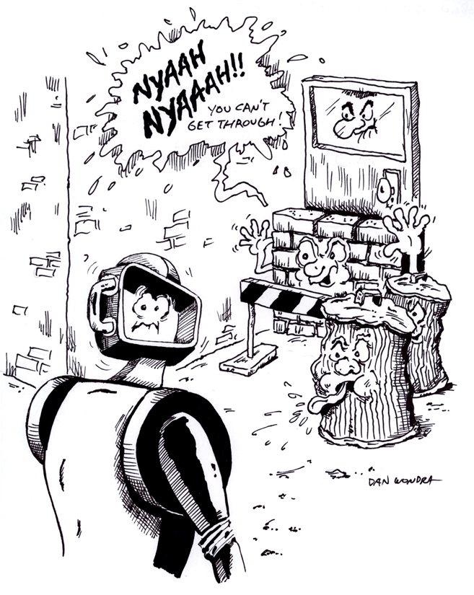
1st Author (Writer): Janet Larson
2nd Author (Editor/Resource Finder):
Technology Topic: Infrared technology
Grade Level: 6 - 8

Outline of Lesson

Content (what is taught):
How infrared light works and is used by technology such as remotes

Context (how it is taught):
- Scientific inquiry in a laboratory setting
Activity Description:
Students will investigate how obstacles placed in front of a wireless remote affect the movement of a robot by recording the effect of various materials on the infrared remotes that are used to control the robots. They will use scientific inquiry to test the effects of these different materials by placing them in the path of the infrared signal. Their data will be recorded into a chart and reported later in the activity. In addition, students would be using the materials to discover whether the infrared waves can reflect off the surface of the given media.

Standards:

Math: E3 Science: A1, A2, E2

Technology: A3, B1, C1, C4

Materials List:

- 1 Robot per group with wireless remote capabilities
- 1 sheet of notebook paper
- 1 sheet of black construction paper
- 1 notebook
- mirror
- glass (tape the edges)
- Student Lab Sheets (1 per student)

Asking Questions (Obnoxious Obstacles)

Summary: Students will be asked to consider how an infrared remote works. They will explore the concept of infrared and make hypotheses about what will happen given a situation.

Outline:
- Students will be asked a series of questions about how an infrared remote works.
- Students will create hypotheses about the questions that can be tested.

Activity:
The teacher should have a student “drive” a robot using an infrared remote. After students see that the robot does indeed move, ask them the following questions to get them thinking about how the remote works. Record their answers as hypotheses that will be tested later.

Questions | Answers
1) How do obstacles placed in front of a wireless remote affect the movement of a robot? | 1) It depends on the object. Opaque objects stop movement. Transparent objects have no effect.
2) How does the robot “know” to move when I push the remote? | 2) There is a sensor on the robot that picks up infrared light.
3) How does it receive that information? | 3) It receives a coded signal that it translates into directions.
4) How do infrared waves travel from the remote to the robot? | 4) The remote creates them and they travel through the air to the sensor on the robot.
5) Can infrared waves reflect off a surface and travel to the robot’s sensor? | 5) Yes. Infrared waves can be reflected like visible light.

Exploring Concepts (Obnoxious Obstacles)

Summary: Students will drive the robot without any media (obstacles). Then, media (obstacles) will be added to block the infrared waves see the effect on the robot. Observations will be made and recorded.

Outline:
- Students will “drive” the robot using a wireless IR remote
- Media (obstacles) will be placed between the IR remote and the robot
- Observations will be recorded.

Activity:
Students will use an infrared wireless remote to operate the robot. Once students are successful with basic driving maneuvers, they will place different media (obstacles) in front of the remote to see if infrared waves can pass through different media. Some examples include construction paper, plastic, cling wrap, etc. Data will be recorded into a chart and reported later in the activity. In addition, students will use the materials provided to discover whether the infrared waves can reflect off a surface and then be directed to control the robot.

Student Worksheet:
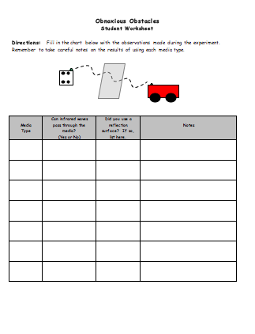

Light Waves
Putting “Light Waves” in Recognizable terms: Light is a form of electromagnetic waves. There are 7 types of electromagnetic or light waves listed in order from longest to shortest wavelength: radio waves, microwaves, infrared waves, visible light, ultraviolet, x-rays, and gamma rays. Most are familiar with visible light: red, orange, yellow, green, blue, indigo, and violet. The colors are listed in this particular order not only because they are viewed in this order in a rainbow, but due to their wavelength differences, red being the longest and violet being the shortest. The band of light “below red” in frequency is known as infrared, conversely the band of light “above violet” in frequency is known as ultraviolet.

Putting “Light Waves” in Conceptual terms: Each light wave varies in the following characteristics: wavelength, frequency, and energy carried. Wavelength measures the distance between two equivalent wave parts that is two successive points that are in-phase. Frequency measures the number of wavelengths that pass in one unit of time or 1 Hertz (waves per second). Electromagnetic waves with a higher frequency carry a higher amount of energy.

Putting “Light Waves” in Mathematical terms: Light waves do vary in all their characteristics except one; speed. The speed of any light wave in a vacuum is 3 x 10⁸ m/s or 1.86 x 10⁵ mile/s. Speed is calculated by using the formula Speed = frequency * wavelength (s=f*λ). For light waves the larger the wavelength the smaller the frequency or vice versa, so if a radio wave has a wavelength of 100 meter and frequency of 3x10⁶ Hz then 100 m * 3,000,000 Hz = 3 x 10⁸ m/s. However, a gamma ray has a wavelength of 1 x 10⁻¹⁰ m and frequency of 3 x 10¹⁸ Hz, then 1 x 10⁻¹⁰ m*3 x 10¹⁸ Hz = 3 x 10⁸ m/s.

Putting “Light Waves” in Process terms: Even though the speed may be the same for all forms of light waves, the energy carried varies. Ultraviolet through gamma rays carry the greatest amount of energy, and are considered the most harmful to humans.

Putting “Light Waves” in Applicable terms: The application focus will be on radio waves and infrared waves. For many years, communication signals have been transmitted using light waves. Most commonly radio waves transmitted “radio” sound waves, TV signals, and other communication signals. More recently infrared is being used for communications. There are three different classifications of infrared (IR): near, mid and far. The near infrared is closest to visible light with the shortest wavelength and the far infrared is closest to microwaves with the longest wavelength. This is of importance because the IR spectrum is best known as the spectrum of light that provides heat, but not all IR waves are thermal in nature. The longer wavelength or “far” infrared provides heat, but the “near” infrared does not. This portion of the spectrum can send signals used to control electronic devices such as between a TV and TV remote control. The waves are sent in rapid predetermined patterns absorbed by a receiver and decoded telling the device what to do.
IR (infrared) remote controllers must be held at specific angles and shorter distances, emit detectable purple light, and cannot go through walls. RF (radio frequency) remote controllers are can be used at any angle over longer distances, emit no detectable light, and can go through walls. For this reason, highly classified information is sent only using infrared.

Attachments:
I_Sci_012_Light_Waves_I_Diagrams.doc
Organizing Learning (Obnoxious Obstacles)

Summary: New media (obstacles) will be presented to the group. Using the skills learned, students will make hypotheses about how the media will affect the remote’s control of the robot. The possibility of reflecting the infrared waves should also be explored.

Outline:
- The teacher provides media (obstacles) not previously used. Examples include aluminum foil, opaque glass, etc.
- Students will make predictions about the effects on robot control based on their knowledge acquired about infrared waves.
- Students will then test their predictions.

Activity:
The teacher will provide media (obstacles) that have not been tested to see its affect on robot control. Students will work in cooperative learning groups to make and test their predictions. Each student is responsible for collecting and recording the data from the activity on his/her own lab sheet.

During the activity, it works well to have:
- 1 person operating the remote
- 1 person holding the media (obstacle) in front of the remote
- 1 person recording.

The student groups will make predictions about how the media (obstacle) provided will affect robot control. Students will record their prediction based on the knowledge acquired about infrared waves. Students will then test their predictions to see if they are correct.

Student Worksheet:
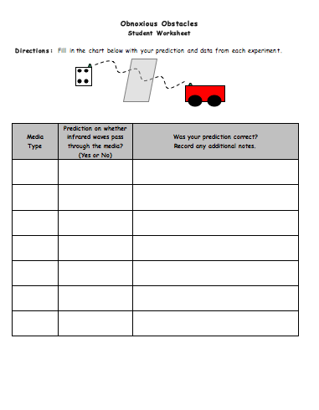

Understanding Learning (Obnoxious Obstacles)

Summary: Assessment for student learning could occur through the use of their completed lab report and informal observations throughout the lesson. In addition, students could demonstrate understanding of these concepts through a performance assessment. For example, students could use a television and remote to predict whether an obstacle would allow the signal to travel.

Outline:
- Formative assessment of infrared waves.
- Summative assessment of infrared waves.

Activity:
Formative Assessment
As students are engaged in the lesson ask these or similar questions:
- Are students able to drive the robot under normal situations?
- Are students thinking about how and why the provided media affects robot control?
- Can students make generalizations about why certain media affects the robot and others do not?
Summative Assessment
Students will write a formal lab write-up including the procedure, data, and conclusions.
Students can answer the following quiz questions:
- Was the wireless remote effective in transmitting a signal through all of the media? Why or why not?
- If the wireless signal was received and the robot moved, what can you infer about the material of the obstacle? Use your knowledge of electromagnetic waves to defend your response.
- Were there any materials that the infrared waves could not pass through that reflected infrared waves? Why did that occur?
- Did you notice a change in speed or sound produced by the robot while using the wireless remote?

Possible Lesson Extensions
A. One possible extension would be to mount a laser pointer to the robot. Using the laser pointer, students would manipulate mirrors to “hit” a designated target. This would further enhance students’ exploration of reflection of light waves.

B. Students could also investigate and research other sensors that are used in daily life, aside from infrared sensors in remotes. They could apply their learning from what they did with the robot to their own television set at home. This may serve as a good opportunity to collaborate with parents.

C. Proficient or Beyond Proficient Students: Conduct independent research—a topic that may appeal to them would be researching how the “Wii” controller works and other video game devices that are tethered to a central location.

D. Younger Students: Review the materials box and reinforce vocabulary: translucent, opaque, or transparent using materials such as tissue paper, glass, and an overhead transparency sheet.

