SPIRIT 2.0 Lesson:
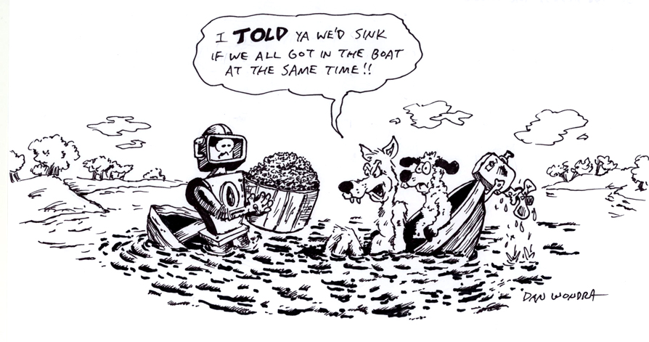
Getting across the River
==========================Lesson Header ==========================
Lesson Title: The wolf, sheep and a bushel of grain
Draft Date: 6/23/09
1st Author (Writer): Betsy Rall
2nd Author (Editor/Resource Finder):
Instructional Component Used: Problem Solving
Grade Level: Middle and High School
Cartoon Illustration Idea: Maybe something with a wolf, sheep, bushel of grain, boat and a farmer

Outline of Lesson
A farmer needs to move a wolf, a sheep and a bushel of grain across a river. He can only take one item at a time in the boat. When the man is not around, the wolf will eat the sheep and the sheep will eat the grain. How can the farmer move all three of these across the river?

Content (what is taught):
- Problem Solving
- Communication
- Teamwork
- Use of manipulatives

Activity Description:
Students will use the CEENBoT to represent the boat as it carries the wolf, sheep and bushel of grain across the river. The students should make representations of the farmer, boat, wolf, sheep and bushel of grain to be used as manipulatives that can be attached to the classroom robot. In the classroom, a length of blue paper can be taped to the floor representing the river.

Standards:

Math - MB2 Science

Technology - TD2, TD3, TD4 Engineering - EA2, ED3

Materials List:
Classroom robot
Representations of the boat, farmer, wolf, sheep and bushel of grain to be used as manupulatives.

Asking Questions (Getting across the River)

Summary: Students will discuss the problem to make sure they understand it.

Outline:
• Students will begin the problem solving process by analyzing the problem
• Students will try to find some of the possible difficulties in this problem
• Students will try to apply previous experience to the problem

The Problem: A farmer needs to move a wolf, a sheep and a bushel of grain across a river. He can only take one item at a time in the boat. When the man is not around, the wolf will eat the sheep and the sheep will eat the grain. How can the farmer move all three of these across the river?

Activity: The team members will discuss the problem. What must occur for the problem to be solved?

Questions | Answers
Do you understand the problem?
Can you state the problem in your own words?
What are you trying to find or do?
What information do you need?
What information is given?
Is there too much information?
Is there a picture, graph or diagram that can help you understand the problem?
Understand the Problem
Devise a Plan
Carry out the Plan
Looking Back

Exploring Concepts (Getting across the River)

Summary: In order to solve the problem, the team must make decisions. They will assign roles to the team members and tasks to be completed. The team will discuss different strategies for solving the problem.

The Problem: A farmer needs to move a wolf, a sheep and a bushel of grain across a river. He can only take one item at a time in the boat. When the man is not around, the wolf will eat the sheep and the sheep will eat the grain. How can the farmer move all three of these across the river?

Activity: The team will discuss strategies for solving the problem. These strategies could include but not be limited to:
- draw a diagram
- guess and check
- look for a pattern
- make a model
- make an organized list
- make a table
- solve a simpler similar problem
- write an equation
- use a graph
- use a Venn diagram
- use logical reasoning
- work backward
The team should estimate what the answer should be. After discussion, the team should select a strategy for solving the problem.


Instructing Concepts (Getting across the River)

Problem Solving

Problem Solving Process
The problem solving process is teachable and students will become better problem solvers with guidance and practice. Since there are many problem solving models, it depends who you talk to about which model is best. George Polya first outlined one of the best-known problem solving processes. This instructional piece will focus on Polya’s work.

Step one: Understand the problem
This step involves the very beginning of the problem solving process. Students are asked to carefully analyze the problem paying particular attention to these questions.
• Are all the words in the problem known to you?
• What are you supposed to find, solve for, show, or prove?
• Is it possible to restate the problem in your own words?
• Is there a picture, graph or diagram that can help you understand the problem?
• Is there enough information to solve the problem?

Step two: Devise a plan
This step involves the process of deciding how you are going to solve the problem and creation of a plan that will lead to that solution. Below are some possible strategies that students might want to consider.
• Guess and check, look for a pattern, draw a picture, make a list
• Solve a simpler problem
• Think about problems that are similar you might have solved before
• Compare and contrast
• Use a model
• Solve an equation or work backward
This list of strategies is not all-inclusive. One of the most important strategies is to be creative and think “outside” the box to try to devise new and different ideas that may apply.

Step three: Carry out the plan
This step is easier than step two because you just have to stick to the plan you created. Work carefully and diligently to attempt the plan you have devised. If your plan doesn’t work go back to step two and use the knowledge you have gained to think of something else. Often we learn more from a failure than by solving a problem correctly the first time.

Step four: Looking back
This step is very important to becoming better problem solvers. It is this analysis of what worked and what didn’t work that lets you apply knowledge in similar situations and extend into the less familiar. You should think about where you might use the method again and think about how your strategy could be improved upon. This analysis of what happened will make problem solving easier in the future.
Organizing Learning (Getting across the River)

Summary: Students will use their chosen strategy to solve the problem.

Outline:
• Students will “act” out their solution using the CEENBoT as the boat
• Students will keep records of their progress
• Students will adapt their plan if it doesn’t work.

The Problem: A farmer needs to move a wolf, a sheep and a bushel of grain across a river. He can only take one item at a time in the boat. When the man is not around, the wolf will eat the sheep and the sheep will eat the grain. How can the farmer move all three of these across the river?

Activity: First students will attempt to solve the problem by using the plan/strategy that they formulated. The robot will serve as the boat while carrying out the devised plan. As this process unfolds it is critical that accurate records of the steps and results be taken so that problems and successes can be noted. As the plan unfolds, it is important that students check the results at each step in the plan. If the plan does not work, the group will need to come up with another plan and repeat the process.

Worksheet: Problem Worksheet

Understanding Learning (Getting across the River)

Summary: Students will create and submit a report showing the use of the problem solving method. The report should contain the following:
- A list of the team members, their roles and assigned tasks
- A list of strategies along with a reason for choosing the strategy used to solve the problem
- A step by step description of the solving process including any difficulties encountered
- Any sketches used in the problem solution
- A symbolic representation of the solution
- A written representation of the solution

Outline:
- Formative assessment of the Problem Solving method
- Summative assessment of the Problem Solving method

Activity:
Formative Assessment
As students are engaged in the lesson ask these or similar questions:
What are you trying to do?
What are the responsibilities of each team member?
What strategies do you have for solving the problem?
What other similar problems have you solved? How did you solve them?
What is your estimate of the answer?
How does your answer compare to your estimate?
Does your answer make sense?

Summative Assessment
First, students will be asked to fill out a rubric grading each member and themselves on their group problem solving work.

Second, another problem to solve will be given to each student. The student does not necessarily need to solve the problem but should be able to describe the steps to solving the problem.

