SPIRIT 2.0 Lesson:
The Tortoise and the CEENBoT
============================Lesson Header ============================
Lesson Title: The Tortoise and the CEENBoT
Draft Date: 6/24/09
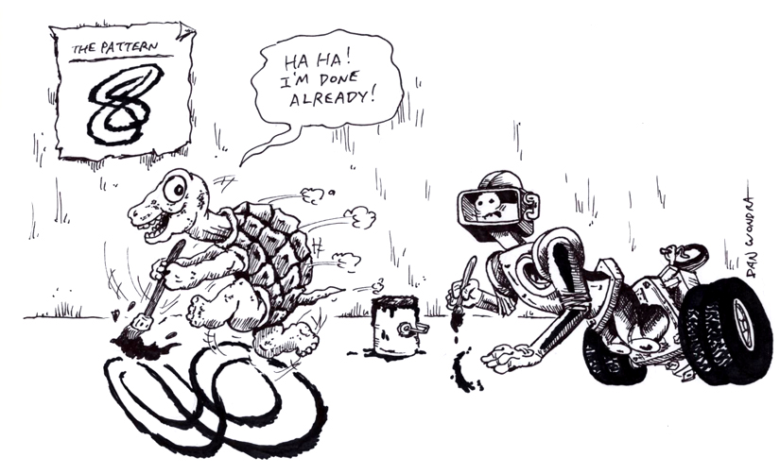
1st Author (Writer): Georgia Tucker
Instructional Component Used: Technology - Problem Solving
Grade Level: Middle School

Outline of Lesson

Content (what is taught):
- Applying a computer program application
- Applying proportional conversions
- Technology - Problem Solving

Context (how it is taught):
- Students use WebTurtle (or other software) to design and then test navigation patterns with the CEENBoT.

Activity Description: Using WebTurtle, design a geometric pattern in a small scale that can be converted to a scale large enough to repeat the pattern utilizing the CEENBoT. Pattern repetition must be proportional to the original design.

Standards:

Science Technology
SA2 TA1, TD2, TF2

Engineering Math
EB5, EC1 MA1, MA3

Materials List:
Robot
Computer with WebTurtle and/or internet access to the program (or similar program)
Meter stick or tape measure
Large protractor
Transparency of robot picture or graphic
Asking Questions (The Tortoise and the CEENBoT)

Summary: Students will practice enlarging using proportional measurement.

Outline:
- Given a small cartoon or picture of the CEENBoT, students will determine how to enlarge the graphic.

Activity:
Using a transparency of a CEENBoT or other small cartoon, demonstrate how graphic size can be increased or decreased using an overhead projector or a moveable digital projector. Discuss how proportion of the projected image relates to the actual image size. Review equivalent fractions and ratios as necessary.
Give each student a CEENBoT graphic to enlarge onto graph paper. Students should be able to determine the proportion of original:enlarged.

Questions | Answers
What happens to individual image measurements as image size is increased? | Should include a reference to all parts of the image enlarging at the same rate or scale.
Is there a way to increase image size unevenly? | Answers will vary.
What happens to the proportions if the image size is increased unevenly? | Proportions will not be consistent and may not be duplicable.
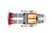

Exploring Concepts (The Tortoise and the CEENBoT)

Summary: Students will explore enlarging clipart through a computer program (one dimension vs. two dimension enlargement) and explore drawing with WebTurtle.

Outline:
- Have students select some clipart images to practice enlarging and reducing the image. This could be a graphic of the CEENBoT or other robot.
- Use WebTurtle to generate unique geometric designs.

Activity:
Students should have the opportunity to practice image enlargements, estimate proportions, or actually print and measure proportions. WebTurtle or another program can be used for students to generate unique geometric designs. Throughout the exploration/practice process encouraging discussion of proportional and distorted images will deepen understanding.
Students should take notes (individual or guided) to explain their understanding of using a computer program to manipulate images.



Instructing Concepts (The Tortoise and the CEENBoT)

Problem Solving

Problem Solving Process
The problem solving process is teachable and students will become better problem solvers with guidance and practice. Since there are many problem solving models, it depends who you talk to about which model is best. George Polya first outlined one of the best-known problem solving processes. This instructional piece will focus on Polya’s work.

Step one: Understand the problem
This step involves the very beginning of the problem solving process. Students are asked to carefully analyze the problem paying particular attention to these questions.
• Are all the words in the problem known to you?
• What are you supposed to find, solve for, show, or prove?
• Is it possible to restate the problem in your own words?
• Is there a picture, graph or diagram that can help you understand the problem?
• Is there enough information to solve the problem?

Step two: Devise a plan
This step involves the process of deciding how you are going to solve the problem and creation of a plan that will lead to that solution. Below are some possible strategies that students might want to consider.
• Guess and check, look for a pattern, draw a picture, make a list
• Solve a simpler problem
• Think about problems that are similar you might have solved before
• Compare and contrast
• Use a model
• Solve an equation or work backward
This list of strategies is not all-inclusive. One of the most important strategies is to be creative and think “outside” the box to try to devise new and different ideas that may apply.

Step three: Carry out the plan
This step is easier than step two because you just have to stick to the plan you created. Work carefully and diligently to attempt the plan you have devised. If your plan doesn’t work go back to step two and use the knowledge you have gained to think of something else. Often we learn more from a failure than by solving a problem correctly the first time.

Step four: Looking back
This step is very important to becoming better problem solvers. It is this analysis of what worked and what didn’t work that lets you apply knowledge in similar situations and extend into the less familiar. You should think about where you might use the method again and think about how your strategy could be improved upon. This analysis of what happened will make problem solving easier in the future.
Organizing Learning (The Tortoise and the CEENBoT)

Summary: Given the problem of converting a small geometric design to a proportion drivable by the robot, students will document their problem solving process.

Outline:
- Using WebTurtle or other graphics program, students create a unique geometric design.
- Determine the size of graphic required for the robot to drive the design.
- Record information to document their problem solving process.

Activity: Alone or in small groups, students design a simple geometric graphic. Students then need to determine how large the graphic components must be in order for the robot to “drive” the graphic. Students need to record driving directions using specific angles and line measurements, practice with the robot as needed and finalize a list of driving directions. The final list should include the original graphic, proportion of original:robot size, and marked starting and end points.
Tip: Attaching a marker to the robot may aid in student trouble shooting of their design and driving directions. Groups exchanging directions provides peer review prior to finalization. Increase the difficulty of the process by requiring specific graphic components or a theme (example: two 45° angles; design a house; include one S curve).
Extended learning: Translate driving directions to graphing calculator programming commands.

Examples of possible student designs:

Understanding Learning (The Tortoise and the CEENBoT)

Summary: Students apply the problem solving process to the robot proportionally recreating a given shape.

Outline:
- Formative assessment of applying proportion and ratios.
- Summative assessment of implementing the problem solving process.

Activity:
Formative Assessment
As students are engaged in the lesson ask these or similar questions:
- Were students able to determine proportions of original:enlarged designs?
- Were students able to determine proportions required for the robot to be able to recreate the design?

Summative Assessment
Students will be given a geometric graphic approximately 3” x 3”. Their objective is to determine a proportion which the robot could recreate. Students then need to apply the problem solving process, writing and reflecting on their use of measurement, mathematics and robot movement parameters needed to solve the problem of proportional enlargement.

