SPIRIT 2.0 Lesson:
Two Blind Bots
============================Lesson Header ============================
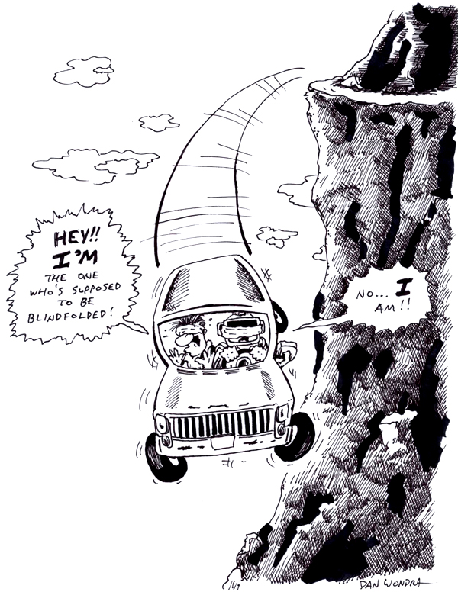
Lesson Title: Two Blind Bots
Draft Date: 6/23/09
1st Author (Writer): Betsy Rall and Matt Bills
Instructional Component Used: Problem Solving
Grade Level: Any

Outline of Lesson
This is a game where two sets of partners race through an obstacle course to a finish. One partner is the driver and the other is the navigator. The trick is that the driver must be turned away from the course and cannot watch the robot drive through the course. The navigator must communicate either verbally or nonverbally with the driver to get the robot through the course successfully and beat the other team to the finish.

Content (what is taught):
- Problem solving
- Communication (verbal and nonverbal)
- Teamwork
- Competition
- Navigation
Context (how it is taught):
- The driver must figure out how to operate the robot without watching it.
- The navigator must effectively communicate to the driver.
- The team must complete the course using group effort.

Activity Description:
Any obstacle course can be set up that will allow robots to race. A sample course can be shown. Teams of two people will race. One person will be the driver and the other will be the navigator. The driver may not look at the robot while it is moving through the course. The navigator will communicate with the driver directions for the robot. The first robot to successfully reach the finish wins.

Standards:

Math - MC4 Science - SB2

Technology - TD2, TD3, TD4 Engineering – ED1, ED2, ED3

Materials List:
At least two classroom robots
Items to make the obstacle course
Asking Questions (Two Blind Bots)

Summary: Students will discuss the problem to make sure they understand it.

Outline:
- Students will be presented an obstacle course that has to be negotiated by a driver who cannot see.
- The student is directed in how to drive the course. During this step the problem will be analyzed for potential difficulties and possible solutions.

Activity: The team members will discuss the problem. What must occur for the problem to be solved?

Questions | Answers
Do you understand the problem?
Can you state the problem in your own words?
What are you trying to find or do?
What information do you need?
What information is given?
Is there too much information?
Is there a picture, graph or diagram that can help you understand the problem?
Start

Finish

Obstacle 1
Obstacle 2
Obstacle 3
Example Course

Exploring Concepts (Two Blinds Bots)

Summary: In order to solve the problem, the team must make decisions. They will assign roles to the team members and tasks to be completed. The team will discuss different strategies for solving the problem.

Problem: How can we get the robot through the obstacle course when the driver of the robot is blind-folded.

Activity:
The team will discuss strategies for solving the problem. These strategies could include but not be limited to:
- draw a diagram
- guess and check
- look for a pattern
- make a model
- make an organized list
- make a table
- solve a simpler similar problem
- write an equation
- use a graph
- use a Venn diagram
- use logical reasoning
- work backward

After discussion, the team should select a strategy to try out.
Instructing Concepts (Two Blind Bots)

Problem Solving Process
The problem solving process is teachable and students will become better problem solvers with guidance and practice. Since there are many problem solving models, it depends who you talk to about which model is best. George Polya first outlined one of the best-known problem solving processes. This instructional piece will focus on Polya’s work.

Step one: Understand the problem
This step involves the very beginning of the problem solving process. Students are asked to carefully analyze the problem paying particular attention to these questions.
• Are all the words in the problem known to you?
• What are you supposed to find, solve for, show, or prove?
• Is it possible to restate the problem in your own words?
• Is there a picture, graph or diagram that can help you understand the problem?
• Is there enough information to solve the problem?

Step two: Devise a plan
This step involves the process of deciding how you are going to solve the problem and creation of a plan that will lead to that solution. Below are some possible strategies that students might want to consider.
• Guess and check, look for a pattern, draw a picture, make a list
• Solve a simpler problem
• Think about problems that are similar you might have solved before
• Compare and contrast
• Use a model
• Solve an equation or work backward
This list of strategies is not all-inclusive. One of the most important strategies is to be creative and think “outside” the box to try to devise new and different ideas that may apply.

Step three: Carry out the plan
This step is easier than step two because you just have to stick to the plan you created. Work carefully and diligently to attempt the plan you have devised. If your plan doesn’t work go back to step two and use the knowledge you have gained to think of something else. Often we learn more from a failure than by solving a problem correctly the first time.

Step four: Looking back
This step is very important to becoming better problem solvers. It is this analysis of what worked and what didn’t work that lets you apply knowledge in similar situations and extend into the less familiar. You should think about where you might use the method again and think about how your strategy could be improved upon. This analysis of what happened will make problem solving easier in the future.
Organizing Learning (Two Blind Bots)

Summary: Students will use their chosen strategy to solve the problem.

Outline:
- Teams will complete the course using the strategy decided on.
- Students will keep an accurate record of their work.
- Students will perform any necessary actions or computations.
- Students will check each step of the plan as it proceeds.
- If the plan doesn’t work, teams will try another strategy!

Activity: After both teams have discussed their strategy, the race will begin. After the winner has been determined, both teams will have an opportunity to discuss successes and failure points. Each team will have an opportunity to modify their strategy or choose another strategy altogether. Repeat the course a 2nd time. If necessary, a 3rd race may need to take place to determine the winner. A reflection time/discussion should take place at the conclusion of the race so that students can reflect on the whole process.
Understanding Learning (Two Blind Bots)

Summary: Students will create and submit a report showing using the problem solving method. The report should contain the following:
- A list of the team members, their roles and assigned tasks
- A list of strategies along with a reason for choosing the strategy used to solve the problem
- A step by step description of the solving process including any difficulties encountered
- Any sketches used in the problem solution
- A symbolic representation of the solution
- A written representation of the solution

Outline:
- Formative assessment of the Problem Solving Method
- Summative assessment of the Problem Solving Method

Activity:
Formative Assessment
As students are engaged in the lesson ask these or similar questions:
What are you trying to do?
What are the responsibilities of each team member?
What strategies do you have for solving the problem?
What other similar problems have you solved? How did you solve them?
What is your estimate of the answer?
How does your answer compare to your estimate?
Does your answer make sense?

Summative Assessment
First, students will be asked to fill out a rubric grading each member and themselves on their group problem solving work.

Second, another problem to solve will be given to each student. The student does not necessarily need to solve the problem but should be able to describe the steps to solving the problem.

