SPIRIT 2.0 Lesson:
The Missing Link
==========================Lesson Header ==========================
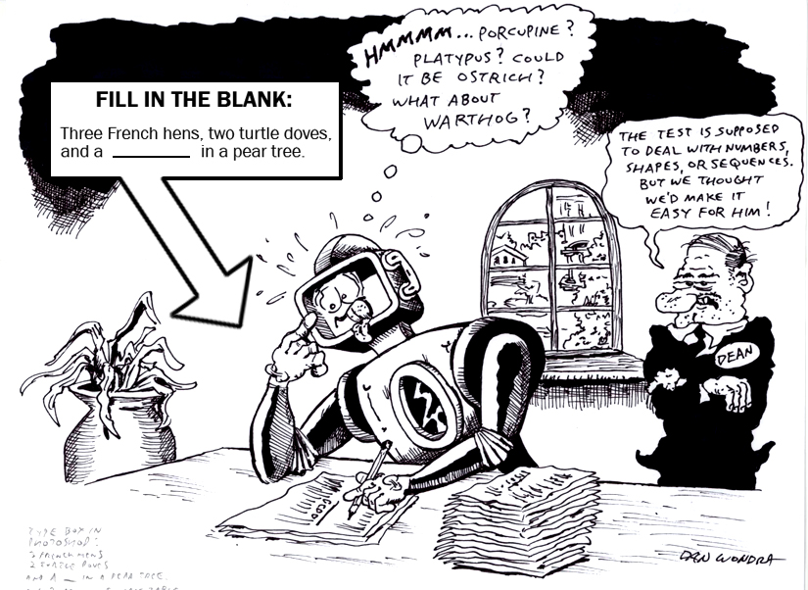
Lesson Title: The Missing Link
Draft Date: June 24, 2009
1st Author (Writer): Megan DeWispelare
Instructional Component Used: Problems solving to create a proper sequence
Grade Level: K -5 grades

Outline of Lesson

Content (what is taught):
- To find the missing number, shape or letter in a sequence
- To find a pattern to the sequence of objects

Context (how it is taught):
- Manipulating numbers, letters and or objects
- Sequencing daily activities

Activity Description:
Students will drive the CEENBoT to the correct numbers or letters to complete the given sequence. The students will use the CEENBoT as an introduction to sequencing.

Standards:

Math Science
MB1 ED1
ME1

Technology Engineering
A1 ED1 ED2 EA1
C4

Materials List:
CEENBoT
Paper for recording
Pencil, Pen, Crayon
Asking Questions (The Missing Link)

Summary: Students will explore different sequences of numbers, shapes or letters using the CEENBoT and the book.

Outline:
- Read Book
- Ask students to see if they can find any sequences of steps necessary for the CEENBoT to operate.
- Identify these sequences by putting them on a poster or white board.
- Let students know that sequences are not only used to do something, but they can be used to complete a number sentence or spell a word.

Activity:
Read Peanut Butter and Jelly: A Play Rhyme (Paperback)
by Nadine Bernard Westcott. Discuss with the students what sequence the story about. Remind them that sequences occur in a specific order.

Questions | Answers
How is the sequence of steps in the book like a sequence we can do with the CEENBoT? | You need to do things in a specific order to get the CEENBoT to work.
What would happen if we missed the first step to making the peanut butter and jelly sandwich? | You would just have peanuts in your hand and they wouldn’t be squished?
What would happen if I forgot to turn the remote control on? | You would only have a working CEENBoT, it wouldn’t drive because it wouldn’t know how to.
Can you come up with the sequence of steps for making the CEENBoT work? | Turn CEENBoT on, turn remote control on, make sure remote control is plugged into bot, etc. Will very for each class.
Can you think of any other sequences we use everyday? | Answers will vary
Do you think that sequences are only used to make something like a sandwich or to turn something on? | Answers will vary
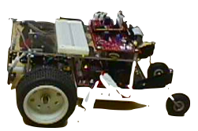
1, 1, 2, 3, 5, 8, 13, 21, 34, 55, 89

Exploring Concepts (The Missing Link)

Summary: The students will explore different sequences while driving the CEENBoT.

Outline:
- Need a variety of cardboard or large paper shapes, letters, and numbers.
- Instruct students to find the initial sequence and to say the sequence to a partner to record.
- Test driving skills to drive CEENbot to correct object that belongs in the sequence.

Activity:
The teacher will have a large amount of shapes cut out of large paper. The teacher will also have different sequences in mind to help students realize how sequences work. So the teacher will model, driving the CEENbot from a red circle to a green and back and forth. So if the teacher had a blank and the circle she just drove on was red, what should color of circle should come next?
The lesson can also be adapted to have numbers on the floor to use for completion of an equation or a word. So, if you had 2+?=6. The student would have to drive to the number 4. Same for words, an example the teacher would say cat and the student would have to drive the CEENbot to the letters, C, A, and T.

Note: This activity could be branched into higher level of thinking with more complex arithmetic sequences or it could be used with younger students to count by ones or twos. The possibilities are endless. It could even see be branched into science and other subjects.

1, 1, 2, 3, 5, 8, 13, 21, 34, 55, 89
1 + 1 = 2
1 + 2 = 3
2 + 3 = 5

Instructing Concepts (The Missing Link)

Problem Solving Process
The problem solving process is teachable and students will become better problem solvers with guidance and practice. Since there are many problem solving models, it depends who you talk to about which model is best. George Polya first outlined one of the best-known problem solving processes. This instructional piece will focus on Polya’s work.

Step One: Understand the problem
This step involves the very beginning of the problem solving process. Students are asked to carefully analyze the problem paying particular attention to these questions.
• Are all the words in the problem known to you?
• What are you supposed to find, solve for, show, or prove?
• Is it possible to restate the problem in your own words?
• Is there a picture, graph or diagram that can help you understand the problem?
• Is there enough information to solve the problem?

Step two: Devise a plan
This step involves the process of deciding how you are going to solve the problem and creation of a plan that will lead to that solution. Below are some possible strategies that students might want to consider.
• Guess and check, look for a pattern, draw a picture, make a list
• Solve a simpler problem
• Think about problems that are similar you might have solved before
• Compare and contrast
• Use a model
• Solve an equation or work backward
This list of strategies is not all-inclusive. One of the most important strategies is to be creative and think “outside” the box to try to devise new and different ideas that may apply.

Step three: Carry out the plan
This step is easier than step two because you just have to stick to the plan you created. Work carefully and diligently to attempt the plan you have devised. If your plan doesn’t work go back to step two and use the knowledge you have gained to think of something else. Often we learn more from a failure than by solving a problem correctly the first time.

Step four: Looking back
This step is very important to becoming better problem solvers. It is this analysis of what worked and what didn’t work that lets you apply knowledge in similar situations and extend into the less familiar. You should think about where you might use the method again and think about how your strategy could be improved upon. This analysis of what happened will make problem solving easier in the future.
Organizing Learning (The Missing Link)

Summary: Students record sequence in notebook using shapes, numbers, and letters.

Outline:
- Create a sequence, an ordered list of objects or events.
- Record the sequence
- Explain the sequence

Activity:
The students will create different sequences for their classmates to try out. From these new sequences the teacher will give each student the opportunity to try and solve the sequence. After each student has tried the sequence the class will review the different sequences that were created.

Sequences that could be created are: shapes, simple math facts, spelling. This could be used for number recognition. It could even be used to identify certain sounds a student is struggling with because they have to say the sequence out loud.

The teacher might encourage students to create a table to organize the information. The table headings might say: Addend + Addend =Sum and Factor x Factor=Product.
Understanding Learning (The Missing Link)

Summary: Students will be assessed on completion of sequences.

Outline:
- Formative assessment of problem solving by creating sequences.
- Summative assessment of problem solving by creating sequences.

Activity:
Formative Assessment
As students are engaged in the lesson ask these or similar questions:
- Were students able to use problem solving to figure out sequences?
- Were the students able to complete the given sequence?
- Can the students locate a new sequence and complete it?
- Can the students describe different sequences we deal with everyday?

Summative Assessment
- Give the students a robot with a remote. Be sure that all power sources are turned off and take the batteries out of the remote. Give students the opportunity to problem solve a sequence that will allow them to move the robot and then have them present that sequence either in writing or orally.
- Present students will different sequences. For example 2,4,6,?,10. What number should go into the space where the question mark is located?
- Then have the students practice driving the CEENBoT in a new sequence. Have other students try and solve the sequence.
- Try it with a math equation. 4-3=? Student should drive to the number 1.

2, 4, 6, 8, 10, 12, 14, 16, 18, 20 …
100, 90, 80, 70, 60, 50, 40, 30, 20, 10, 0, -10, -20 …
6, 9, 12, 15, 18, 21, 24, 27, 30, 33, 36 …
10, 9, 8, 7, 6, 5, 4, 3, 2, 1, 0, -1 …

