SPIRIT 2.0 Lesson:
Can We Draw It? Yes We Can!
==========================Lesson Header ==========================
Lesson Title: Can We Draw It? Yes We Can!
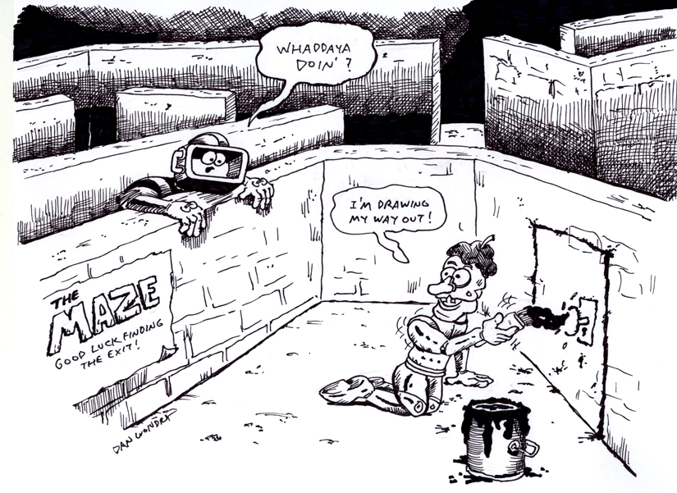
Draft Date: 11/20/09
1st Author (Writer): Lynn Spady
2nd Author (Editor/Resource Finder): Elliot Ostler
Instructional Component Used: Problem Solving
Grade Level: Upper Elementary, Middle School

Content (what is taught):
- Programming of the TI Graphing Calculator Robot
- Problem Solving (Polya’s 4-Step Model)

Context (how it is taught):
- Programs are entered, tested, and modified on the TI Graphing Calculator Robot
- The robots are programmed to draw a given shape and/or travel through a maze
Activity Description:
In this lesson, students will explore the programming syntax for the TI Graphing Calculator Robot by typing in programs, running them and correcting/making modifications. While exploring, students will write down what they typed in on the calculator and the outcome using the robot. After adequate explore time, students will be given a maze and/or a polygon. The task will be to create a program for the robot so that it can successfully travel through the maze and/or create the polygon. This can be done by taping paper to the floor and attaching a marker to the robot so that when it moves, it leaves a line on the paper.

Standards:

Science: SA1, SA2 Technology: TA1, TF3

Engineering: EA1, EA2 Math: MC4

Materials List:
TI Graphing Calculator Robot from Norland Research (www.tirobot.com)
TI-83+ and/or TI-84+ series graphing calculators
Masking Tape
Marker
White Paper (for robots to draw on the floor)
Asking Questions: Can We Draw It? Yes We Can!

Summary: Students will think about terminology that could be used to get another student to draw a given picture.

Outline:
- Put students in groups of two and have them sit back to back.
- Give one student a blank piece of paper and a pencil. Give the other student a piece of paper with one of the drawings from below. The person with the blank piece of paper should not be able to see the drawing.
- The student with the drawing must give directions to the student with the blank piece of paper and pencil. The student must try to recreate the drawing from the directions given.
- Discuss words/instructions that were helpful and those that were hard to understand.

Activity: In this activity, students will work on communication skills. Simple drawings will be given to one person and he/she must give directions to another student who cannot see the drawing. The other student must try to recreate the drawing from the instructions given. You can limit the students by telling them they cannot use certain words (i.e. polygon names, letters, etc.). When a pair of students feels they are finished, have them compare the drawings. As a class, discuss the process and decide which words/instructions were helpful when trying to recreate the drawing. Talk about how those words/instructions could be clearer.

Questions | Answers
Were the drawings easy or hard to re-create? | Answers will vary. Most students will indicate some frustration in trying to follow the instructions without being able to see the drawing.
What kinds of words/instructions were helpful? | Answer will vary. Instructions that involve directions (right, left, up, down, etc.) and/or measurement (a square with a side length of 1 inch, etc.) are usually more helpful.
Why is it important to give clear instructions? | When someone gives clear instructions, the outcome will most likely turn out the way it was intended.

Worksheet: CanWeDrawIt_A_WS.doc
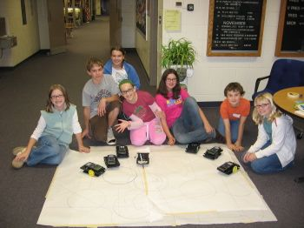

Exploring Concepts: Can We Draw It? Yes We Can!

Summary: Students will practice programming the TI Graphing Calculator Robots.

Outline:
- Show students the basic format for programming the TI Graphing Calculator Robot
:SEND({###,#})
:GET(R)
- Explain what the numbers mean in :SEND({###,#}) (Refer to CanWeDrawIt_ProgGuide.doc)
- Have students practice programming the TI Graphing Calculator Robot

Activity: During this activity, students should become very familiar with programming the TI Graphing Calculator Robot. Students should discover how to move the robot forward a certain distance by altering the 4th number in the programming sequence (:SEND({###,#})). Students should also discover how to make the robot turn left and right (45 degrees, 90 degrees, etc.). The teacher may pose the following situations to help guide the exploration: How would you get the robot to travel in a circle? How would you get the robot to make a square? During the activity, students should write down notes as to how they programmed the robot and the movement it produced. Students can use a table similar to the one shown to record notes.

What Program I Typed In | What the Robot Did | Notes

Worksheet: CanWeDrawIt_ProgGuide.doc
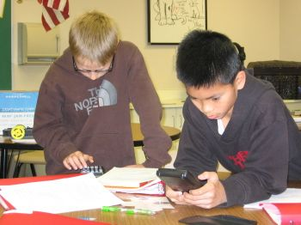

Instructing Concepts: Can We Draw It? Yes We Can!

Problem Solving Process
The problem solving process is teachable and students will become better problem solvers with guidance and practice. Since there are many problem solving models, it depends who you talk to about which model is best. George Polya first outlined one of the best-known problem solving processes. This instructional piece will focus on Polya’s work.

Step One: Understand the Problem
This step involves the very beginning of the problem solving process. Students are asked to carefully analyze the problem paying particular attention to these questions.
• Are all the words in the problem known to you?
• What are you supposed to find, solve for, show, or prove?
• Is it possible to restate the problem in your own words?
• Is there a picture, graph or diagram that can help you understand the problem?
• Is there enough information to solve the problem?

Step Two: Devise a Plan
This step involves the process of deciding how you are going to solve the problem and creation of a plan that will lead to that solution. Below are some possible strategies that students might want to consider.
• Guess and check, look for a pattern, draw a picture, make a list
• Solve a simpler problem
• Think about problems that are similar you might have solved before
• Compare and contrast
• Use a model
• Solve an equation or work backward
This list of strategies is not all-inclusive. One of the most important strategies is to be creative and think “outside” the box to try to devise new and different ideas that may apply.

Step Three: Carry out the Plan
This step is easier than step two because you just have to stick to the plan you created. Work carefully and diligently to attempt the plan you have devised. If your plan doesn’t work go back to step two and use the knowledge you have gained to think of something else. Often we learn more from a failure than by solving a problem correctly the first time.

Step Four: Looking Back
This step is very important to becoming better problem solvers. It is this analysis of what worked and what didn’t work that lets you apply knowledge in similar situations and extend into the less familiar. You should think about where you might use the method again and think about how your strategy could be improved upon. This analysis of what happened will make problem solving easier in the future.
Organizing Learning: Can We Draw It? Yes We Can!

Summary: Students will program the TI Graphing Calculator Robot to draw a pre-determined picture. They will follow the steps of the problem solving process.

Outline:
- Show students a maze and/or picture (see examples below)
- Tell students they must program the robot to travel through the maze and/or draw the picture
- Have students write out their problem using Polya’s 4-Step model (see CanWeDrawIt_O_WS.doc)
- Have students type in the program on the calculator
- Attach a marker to the back of the robot with tape
- Run the program
- If the student is unsuccessful in going through the maze and/or drawing the picture, give them a chance to modify their program and try again.
- Have students complete their problem using Polya’s 4-Step model

Activity: During this activity, students will practice following Polya’s 4-step problem solving model. You can go through the four steps as a group, or have each individual student write out the four steps. Refer to the worksheet (CanWeDrawIt_O_WS.doc) for a sample write-up for each step. The goal is for students to correctly type in a program for the TI Graphing Calculator Robot so that it travels through a maze and/or draws a picture. The learning takes place as the students go through the problem solving process and figure out how to modify the program to do what they want. This activity can be done without attaching a marker to the robot, however, taping large pieces of paper to the floor and attaching a marker to the robot is fun for the kids (see images).
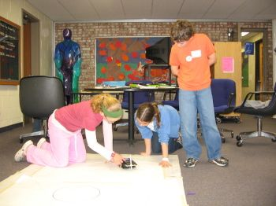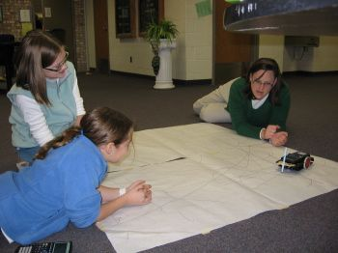

Worksheet: CanWeDrawIt_O_WS.doc
Sample pictures for students to program the robot to draw.

Understanding Learning: Can We Draw It? Yes We Can!

Summary: Students will write a program for the TI Graphing Calculator Robot to draw a given picture or travel through a maze. Students will also answer questions about a given program.

Outline:
- Formative assessment questions asked during the learning activity about programs, their meaning, and programming errors
- Summative assessment questions about programs and tasks to complete using programs

Activity:

Formative Assessment
As students are engaged in the lesson, ask these or similar questions:
- Were the students able to apply the programming command syntax (:Send, :Get, etc.)?
- Can students problem solve if the program they type in does not work? For example, if the calculator displays ‘Error Syntax’, can they select ‘GOTO’ and find the error in their program (missing { or ) or :, etc.)?
- Are students able to modify and adjust their program if it does not draw what was intended?

Summative Assessment
Students will answer the following short questions and/or complete the tasks.
- Present students with a maze and/or polygon. Students will write the program for the graphing calculator robot to go through the maze and/or create the polygon. After writing the program, students can test it by typing the commands in on the calculator and running the program using the robot. Have students write out the 4 steps of Polya’s problem solving model.
- Give students a series of programs and ask what the robot will do when the program is entered and executed. Sample programs can be found at http://smallrobot.bizland.com/testpage.html
- Give students a program with an error and have them identify the error.

Resources:
Norland Research: http://www.smallrobot.com/scimath.html

Worksheet: CanWeDrawIt_U_WS.doc

