Button Sequence for Programming the TI Robot
Programming the TI-Bot:
Every program command includes four numbers. The first three numbers are all single digit numbers that provide basic commands to the servo-motors and the bumper sensors on the front of the robot. The fourth number represents a time and can range from 1-10000. The syntax and description of the programming is illustrated below.

The syntax of each programming command looks like the following:

Send ( {# # # , # } )
Get (R)

The “Send” command sends instructions from the calculator to the robot. The “Get” command retrieves information from the robot. Every “Send” command must be accompanied by a “Get” command.

The First Number: 1 – Forward for a specified time (the
specified time is the 4th number)
2 – Forward until the bumper is
depressed
3 – Forward for a specified time or
until the bumper is depressed
The Second Number: 0 – Left motor in reverse
1 – Left motor inactive
2 – Left motor forward
The Third Number: 0 – Right motor in reverse
1 – Right motor inactive
2 – Right motor forward
The Fourth Number: Time in centiseconds. For example: 300 is three seconds.

Example: This program tells the robot to go forward for three seconds, turn right, and go forward for 5 seconds or until it hits something.

Send ({122,300}) Both motors going forward for three seconds
Get (R)
Send ({120,50}) Left motor going forward, right motor going
Get (R) backward for ½ of a second
Send ({322,500}) Both motors going forward for five seconds
Get (R) or until the bumper is depressed

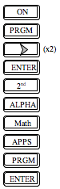  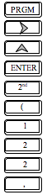  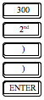 | 