SPIRIT 2.0 Lesson:
Computer Programming I
==========================Lesson Header ==========================
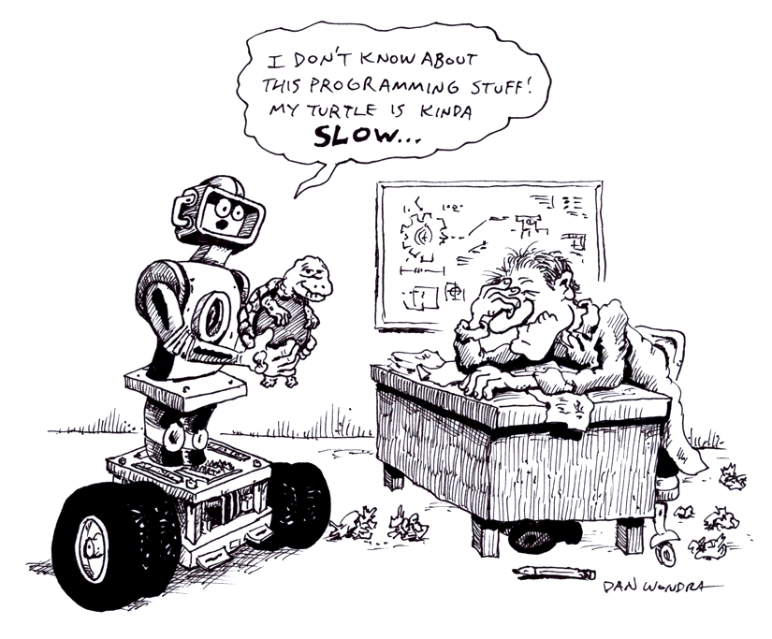
Lesson Title: Computer Programming
Draft Date: 2/26/10
1st Author (Writer): David Porter
Instructional Component Used: Computer Programming
Grade Level: 6-8 Middle School

Content (what is taught):
- Introduction to computer programming
- Use of programming software

Context (how it is taught):
- Boolean logic
- Flowcharting/pseudo-code
- Logo software
Activity Description:
Students will be introduced to the critical nature of software/programming for computers and robots. The concepts of Boolean logic, flowcharting, and pseudo-code will be introduced and practiced. Students will work with the Logo software to control its “turtle” as an introduction to controlling a Texas Instrument calculator-controlled robot in the next programming lesson.

Standards:

Science Technology
SE1 SE2 TF1 TD1

Engineering Math
EA4 ED4 MA2 MD2

Materials List:
Attachments provided
Computer software, links provided
Asking Questions (Computer Programming)

Summary: Students learn that robots and computers require instructions, programs, in order to operate. Students learn the essentials of how those instructions are used and the nature of the instructions.

Outline:
- Exploring the relationship between software and instructions.
- Computers and robots’ programming viewed as a collection of switches: on/off: if/then statements.
- Logic and flowcharting.

Activity: Students will consider questions regarding the nature of how computers and robots operate. It would be useful to have a computer without an operating system installed and ask students of what is it capable? Tell students that computers use electricity and that electricity can be either on or off. Thus, computers are a collection of countless numbers of miniature electronic switches. They do one thing if a particular switch is on and another if it is off.

Discuss with students that computers are operated with languages (programming code) that utilizes logic, which can be represented by turning a switch off or on. For instance, one choice (decision) causes another choice (decision) to happen or not happen. These decisions in Boolean logic are called “if-then” statements. Occasionally, “else” statements are added to the if-then, so that if a statement is true, then the next statement occurs. If the first statement is not true, the else statement occurs. During the discussion, provide examples of if-then-else statements for students. Finally, have students create flowcharts in order to practice logic used by computers and robots. A sample of computer software is shown (attached) using a language called Visual Basic. In today’s video games hundreds of programmers might work a year or more to create one game. The fact that all computers/robots use a binary number system might also be explored.

Questions | Answers
Are robots more than a collection of parts? That is, is there more to them than bits and pieces of plastic and metal? | For a robot to do anything “on its own”, it has to be able to make a decision such as, “if it bumps into an object, then back up.”
How are robots and computers able to do the things they do? | They use a language which uses Boolean logic which instructs them on what to do if certain things happen and what to do if they do not happen.
Hardware : Physical Body :: Software : ______ | Education or learning.
What are computer games? How are they created? | They are a collection of instructions which a computer follows. People work in teams to write the instructions.
Attachments: T011_A_Flow_Chart.doc and T011_A_Programming_Code.doc

Exploring Concepts (Computer Programming)

Summary: Students will explore a computer language as it relates to the manipulation of an on-screen “object.”

Outline:
- Students will learn the basics of a language called Logo.
- Students will practice using Logo to move the “turtle” (the triangle which is moved in Logo).
- Students will understand that learning to control the virtual-world “turtle” is similar to the ability to move a real-world robot.

Activity: Download and start the software program called Logo. Two screens will appear on the computer screen: the MSW Logo screen and the Commander screen. The MSW Logo screen has the “turtle” (a triangle) centered. Everywhere the turtle moves and draws will occur on this screen (unless the user drives the turtle off of the screen). The Commander is where the user types the commands. Students should go to the “Help” menu near the top of the MSW Logo screen and select the “Tutorial” option. The language used to command the turtle is similar to the commands used to control an actual robot in the Texas Instruments version of the Basic language; thus, familiarity with this will assist in understanding how to program a TI-controlled robot.

Students should read and work through the tutorial so that they can learn how repeated instructions are used and how programmers use shortcuts to facilitate these repeated commands. The MIT tutorial is useful to show how to draw some designs. However, it uses a different version of Logo towards the bottom of the tutorial—therefore the final few things will not work on this version of Logo.
The California State University site shows how to use Logo in a much more powerful manner, including how to save commands which you “teach” the turtle. Colors are included as is moving the turtle without drawing a line. If you go to the California State University Dominguez Hills website you can search “Logo” and find several Logo tutorial Powerpoints

Resources:
Logo setup kit may be downloaded for free at: http://www.softronix.com/Logo.html Choose the “setup kit.”

A terrific tutorial operated by California State University: http://www.csudh.edu/fisher/tbe540/MSWLogostudentmanual.pdf

A tutorial site operated by MIT: http://el.media.mit.edu/Logo-foundation/Logo/turtle.html
Instructing Concepts (Computer Programming)

Computer programming is the process of writing code that will cause a machine to do something desired by the user. In addition to the writing or modifying of the program code, programming includes the process of testing and debugging that code to make it work properly. The computer programmer must be able to think logically and sequentially in order for the program to work.

History

The history of electronic computer programming began in the 1940’s with the invention of the ENIAC machine. This first modern computer was developed by the military to help with the writing of artillery-firing tables. These tables were used for different weapons that were fired under varied conditions for target accuracy. As computers improved through the 1950’s to the 1970’s, languages like COBOL for business and FORTRAN for science and engineering were developed and became the standard. With the invention of the personal computer in the 1980’s computers became household items and the number of languages grew and diversified. Pascal and BASIC were languages that sprung up in the 1980’s as a result of the PC. As the computer continues to get more powerful, the languages continue to adapt. Some of the more prevalent languages today are the various iterations of C, Java, PHP, and numerous others.

Basic instructions of computer program (in almost any language)

Input: The acquisition of data from a file, keyboard or other input device.

Mathematical functions: The performance of mathematical operations ranging from basic arithmetic to advanced functions.

Repetition: The performance of an action over and over, sometimes with subtle changes.

Conditional algorithms: The checking for certain conditions and the execution of statements in an appropriate sequence.

Output: The displaying of data resulting from the program on a screen, in a file, or any other means.

Characteristics of modern computer programs

Modern programs look and do very different things but share some common characteristics. They all try to be efficient and high performance thereby providing the most power and speed while using the least amount of system resources. They should be reliable. Programs should be robust in dealing with the user and how they handle errors and data conflicts. The program should be usable, clear in its output and intuitive for its user. Finally the program should be portable across a wide range of operating systems and hardware.
Organizing Learning (Computer Programming)

Summary: Students will learn about the need for special programming languages in order to operate either virtual or real objects.

Outline:
- Students will learn what pseudo-code is and how it works.
- Students will write pseudo-code to perform moving of the Logo turtle.
- Students will create a written summary of how to use a computer language to control a virtual object.

Activity: Pseudo-Code is a numbered list of instructions that perform a task. Three things are critical in writing Pseudo-Code. First, each instruction must be numbered (this forces an order to the steps). Second, instructions must be very specific and doable. Finally, all steps must be included. Note: There are three basic instructions: 1) input (get), 2) calculate (=), and 3) output (display). Finally, any variables used must be stated (normally at the end). For some examples of pseudo-code see attached file: T011_O_PseudoCode.doc
Discuss with students that pseudo-code is a generic technique for writing instructions that can be used to program a computer or robot. Next, have students create a flowchart and then use it to write pseudo-code for making a peanut butter sandwich.
Finally, the students will practice using an elementary computer language and learn how it is used to control a virtual object: the Logo turtle. (For instructions about where to get the Logo software see the paragraph below). A teacher-led discussion will extrapolate this to real objects, such as a Texas Instruments calculator-controlled robot. After having practiced using Logo, students will create a flowchart and then use it to write pseudo-code to provide commands as to how to move a Logo “turtle” to create a specific shape such as a star or chair.
The Logo software may be installed by following the link, below. Two screens will appear on the computer screen: the MSW Logo screen and the Commander screen. The MSW Logo screen has the “turtle” (a triangle) centered. Everywhere the turtle moves and draws will occur on this screen (unless the user drives the turtle off of the screen). The Commander is where the user types the commands. Students should go to the “Help” menu near the top of the MSW Logo screen and select the “Tutorial” option. The language used to command the turtle is similar to the commands used to control an actual robot in the Texas Instruments version of the Basic language; thus, familiarity with this will assist in understanding how to program a TI-controlled robot.

Resources:
Logo setup kit may be downloaded for free at: http://www.softronix.com/Logo.html Choose the “setup kit.”

Attachments: T011_O_PseudoCode.doc

Understanding Learning (Computer Programming)

Summary: Students will create a set of commands to move a Logo turtle as if it were a robotic lander on Neptune.

Outline:
- Formative assessment of computer programming.
- Summative assessment of computer programming.

Activity:

Formative Assessment
As students are engaged in the lesson ask these or similar questions:
- Do students understand the importance of detail and order in flowcharts and pseudo-code?
- Do students understand how to write pseudo-code?
- Do students understand how pseudo-code relates to computer programming?
- How is controlling a Logo turtle similar to controlling a robotic lander?
- What capabilities might a true robotic lander have which the Logo turtle does not have?

Summative Assessment
Students can answer the following writing prompt:
Explain the steps of writing proper pseudo-code and how it relates to computer programming.

Place the CEENBot on a table at the front of the room. Assign students the task of creating a flowchart and writing pseudo-code for moving the CEENBot from table and driving it to the far corner of the room. Be sure that the code includes things like: pick up the robot and put it on the floor, turn it on, etc.

Students can complete the attached Neptune Landing problem.

Attachments: T011_U_Lander_Wrksht.doc

