SPIRIT 2.0 Lesson:
Computer Programming II
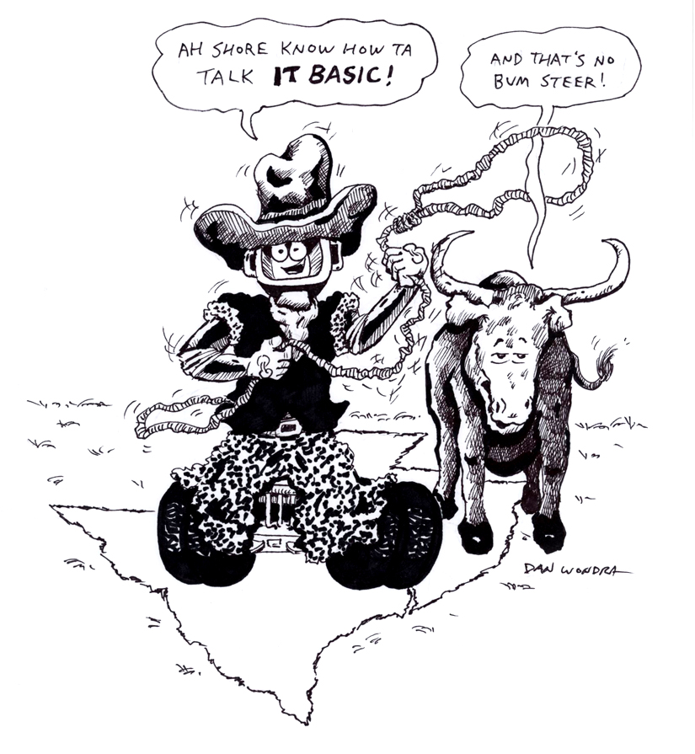
==========================Lesson Header ==========================
Lesson Title: Computer Programming II
Draft Date: 2/28/10
1st Author (Writer): David Porter
Instructional Component Used: Computer Programming
Grade Level: 6-8 Middle School

Content (what is taught):
- Use of computer programming to control a robot

Context (how it is taught):
- Use of TI Basic software
Activity Description:
Students will be introduced to a computer language called TI Basic. It will be used to control a Texas Instrument calculator-controlled robot. Students will use the robot to compute distances and average rate of change. Students will also write and analyze computer code for the TI-bot.

Standards:

Science Technology
SE1 SE2 TF1 TD1

Engineering Math
EA4 ED4 MA2 MD2

Materials List:
- TI calculator-controlled robot with its TI calculator
- Software to simplify use of the calculator-controlled robot.

Asking Questions (Computer Programming II)

Summary: Students will recognize a graphing calculator as a computer capable of controlling a robot. Students will examine such a robot and observe a demonstration of its movement via programming on the calculator.

Outline:
- A Texas Instrument calculator is able to do more than provide answers to math problems.
- Computers and robots communicate via a math-based language

Activity: Teacher will ask students about the nature of calculators, computers, and robots: both physically and the software/languages which operate them. Students will examine a Texas Instruments-controlled robot in order to understand its operation: two motors, one which directly drives each wheel.

Questions | Answers
What is a calculator? | Answers vary: a device used to solve math problems.
What characteristics do calculators and computers have in common? | Many answers: Both can solve problems. Both have ways to enter info. and see results. Both use a language to control what they do.
Could a calculator control a robot? | Yes. Give demo. Show and explain the commands.
Could the rate at which the robot moves be determined? How? | Yes. Measure how far it moves for a given time. Then divide distance by time. If it moved 10 feet in 30 seconds, the rate would be .33 feet/second.
If you know the rate at which a robot moves, could you use it to measure distances? How? Think of how you’d do it if you were in a car: you are driving 50 mph and it takes you 30 minutes to get to a town. How far was it? | Yes. The formula is distance = rate x time. If it moved for 26 seconds at the rate in the above example, it would have moved a distance of 8.58 feet.
What might change the accuracy of our measurements? Suppose the robot was used for a long time? How could we know it was still accurate? | As the batteries wear down, it may move more slowly. Test the rate occasionally to make sure it is still moving at the same rate.
How does the robot move? | Examine the bot—see the two motors-each of which can be controlled independently. Also note the bumper which can stop the bot depending upon the command it’s given.

Resources: TI calculator and Norland manufactured robot.
Exploring Concepts (Computer Programming II)

Summary: Students will learn the language used to control the Norland/TI calculator robot.

Outline:
- The commands will direct the use of each wheel and/or the front bumper as well as the time which the motors operate.
- Students must use “Send” and “Get” commands to operate the robot. The “Disp” command will display time the robot moved.
- Students will operate the robot using the above language.

Activity: Students will experiment with the robot. First, they will be shown how to enter commands and told how to find and use the commands of Send, Get, and Disp (see attachment T012_U_TIbot_Command.doc). Note that braces { } have to be used in the Send command inside of the parentheses ( ).

Students will be challenged by the teacher to command the robot to travel in various patterns such as a square or around an obstacle.

Resources:
Norland robot and compatible Texas Instruments graphing calculator.

Command sheet for the robot from Norland: http://smallrobot.bizland.com/Instructions.pdf

Here are more programs from the Norland site: http://smallrobot.bizland.com/testpage.html

Useful website which has a nice app to make entering commands much easier. A disadvantage of that application, however, is that the commands cannot be saved. It also includes a way to easily calibrate the motors so that it runs in a straighter line. There is also a creative set of driving challenges: http://mste.illinois.edu/resources/ti/robot/about/index.html

Attachments: T012_U_TIbot_Command.doc

Instructing Concepts (Computer Programming II)

Computer programming is the process of writing code that will cause a machine to do something desired by the user. In addition to the writing or modifying of the program code, programming includes the process of testing and debugging that code to make it work properly. The computer programmer must be able to think logically and sequentially in order for the program to work.

History
The history of electronic computer programming began in the 1940’s with the invention of the ENIAC machine. This first modern computer was developed by the military to help with the writing of artillery-firing tables. These tables were used for different weapons that were fired under varied conditions for target accuracy. As computers improved through the 1950’s to the 1970’s, languages like COBOL for business and FORTRAN for science and engineering were developed and became the standard. With the invention of the personal computer in the 1980’s computers became household items and the number of languages grew and diversified. Pascal and BASIC were languages that sprung up in the 1980’s as a result of the PC. As the computer continues to get more powerful, the languages continue to adapt. Some of the more prevalent languages today are the various iterations of C, Java, PHP, and numerous others.

Basic instructions of computer program (in almost any language)

Input: The acquisition of data from a file, keyboard or other input device.

Mathematical functions: The performance of mathematical operations ranging from basic arithmetic to advanced functions.

Repetition: The performance of an action over and over, sometimes with subtle changes.

Conditional algorithms: The checking for certain conditions and the execution of statements in an appropriate sequence.

Output: The displaying of data resulting from the program on a screen, in a file, or any other means.

Characteristics of modern computer programs

Modern programs look and do very different things but share some common characteristics. They all try to be efficient and high performance thereby providing the most power and speed while using the least amount of system resources. They should be reliable. Programs should be robust in dealing with the user and how they handle errors and data conflicts. The program should be usable, clear in its output and intuitive for its user. Finally the program should be portable across a wide range of operating systems and hardware.
Organizing Learning (Computer Programming II)

Summary: Students will use a TI-controlled Norland robot to determine the distance and rate traveled by the robot.

Outline:
- Students will write computer code to make the robot travel until it bumper sensor is depressed.
- Students will determine the rate at which the robot travels.
- Students will use the robot to determine the distance between two points.

Activity: Students will use the TI Basic programming language in order to command the robot to travel until its bumper strikes an object and then display the time it moved (see the command sheet attached T012_O_Organizer.xls).

They will then measure a straight course and determine the length of time required by the robot to travel that distance. They will use the formula R = D / T to determine the rate. The teacher may wish to have the students repeat this in order to determine an average rate. Students may find it appropriate to check the rate from time to time to see if the drain on batteries is altering the robot’s rate of speed.

Students will then set up a course of unknown length for the robot to travel. The course should begin with a line which the bumper will be directly above. It should end with a fixed object at bumper height. The time traveled by the robot will be used to determine the distance, once again using the formula of D = R x T. Students will then measure the course accurately using meter/yard sticks or tape measures in order to compare the calculated distance (using the robot) and measured distance (using the tape measure). The students will discuss and attempt to explain the reasons for any variances.

Resources:
Norland/TI Calculator Controlled robot

Attachments: T012_U_TIbot_Command.doc and T012_O_Organizer.xls

Understanding Learning (Computer Programming II)

Summary: Students will demonstrate their mastery of the TI Basic computer language by reading computer code for a calculator-controlled robot or by doing a performance activity by actually programming a robot to maneuver through an obstacle course.

Outline:
- Formative assessment of computer programming.
- Summative assessment of computer programming.

Activity:
Formative Assessment
- Do students understand the basic commands that need programmed in to control the robot (travel for time vs. using bumpers, etc)?
- Do students understand the step-by-step nature of a program?
- Can students make the robot turn using a program?
- Will the length of the robot make a difference as the robot turns?

Summative Assessment
Students can answer the following writing prompt:
State four things that you need to consider when writing code for a calculator-controlled robot and why they are important? (Things could include each step must be Get({}) with 4 number inside, the time must be in the correct units, etc.)

Summative assessment option #1: Students can look at the code in the attached file (T012_Computer_Programing2-U-Code_Assess.doc) and then describe what it does?

Summative assessment option #2: The teacher should modify the code in the attached file (T012_Computer_Programing2-U-Code_Assess.doc) so that it has an error and ask students if the program will execute. If not, how can it be modified so that it will execute?

Summative assessment option #3 (Project based): A robotic lander is stranded on another planet and needs rescuing via remote operation. Student will write code to control a robot. See attached file for simulation map: T012_Computer_Programing2-U-Lander_Wrksht.doc

Resources:
TI calculator-controlled Norland robot

Attachments: T012_U_Lander_Wrksht.doc and T012_U_TIbot_Command.doc

