LET THE RIVER FLOW ASSESSMENT 1
(Understanding Concepts)

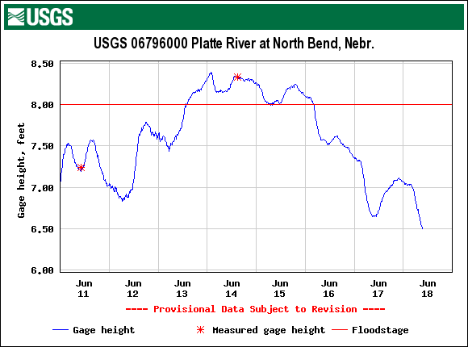

- What river is this information for?
- What approximately is the current gage height for this river?
- During the past 7 days has this river passed the floodstage level?
- On what day was the river at it’s highest level?
- Is this information from a credible source? Explain why you think so or don’t think so.
- Is the information presented in an organized manner or could it be done better?
- What can you learn about your world from this information?

