LET THE RIVER FLOW ASSESSMENT 2
(Understanding Concepts)

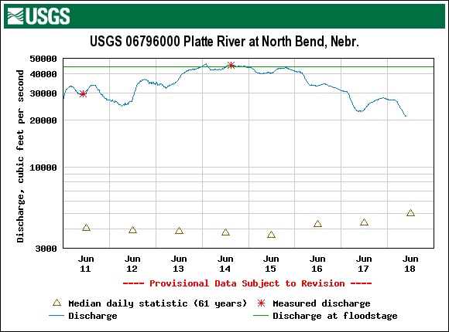

- Is this week’s discharge above or below the median?
- How many times this week was a measured discharge recorded?
- What is the approximate difference in discharge between June 11 and June 14?
- What is the approximate difference in discharge between June 15 and June 18?
- Is this information from a credible source? Explain why you think so or don’t think so.
- Is the information presented in an organized manner or could it be done better?
- What can you learn about your world from this information?

