Project SHINE / SPIRIT2.0 Lesson:
Cutter Madness
==========================Lesson Header ==========================
Lesson Title: Cutter Madness
This Teacher was mentored by:


www.behlenmfg.com

In partnership with Project SHINE grant funded through the

National Science Foundation

Draft Date: July 12, 2010
1st Author (Writer): Megan DeWispelare
2nd Author (Editor/Resource Finder): Behlen Mfg. Co.
Instructional Component Used: Problem Solving
Grade Level: 5-7

Content (what is taught):
- Problem solving
- Placement of shapes to maximize material
- How much waste is left if shapes are not placed correctly

Context (how it is taught):
- The business connection to Behlen Mfg. Co. is they use CNC (Computer Numerically Controlled) Machines to manufacture different pieces of material. In modern CNC systems, end-to-end component design is highly automated using CAD (Computer Aided Drafting) and CAM (Computer Aided Manufacturing) programs. It is very important for the CNC programmer to set up the machine to cut out the maximum amount of pieces he/she can from a piece of steel.
- The student will place different shapes on a piece of paper making the most use of the paper.
- After students have constructed this by hand, they will transfer their knowledge to the computer and use a program that will allow the student to place shapes on the screen.
Activity Description:
The student will explore using manipulatives to see how many different shapes they can fit on a piece of paper. After this is done, students will transfer their hands-on knowledge to the computer where they will use open office or paint to manipulate different shapes.

Standards:

Science: Technology: A1, A2, D4

Engineering: Math: C1, C4

Materials List:
- Pattern blocks, Tangrams, different shaped pieces
- Heavy cardstock
- Computers with Internet access
- Scale to weigh waste cardstock
- Pencil/pen
Asking Questions: (Cutter Madness)

Summary: Students will be shown pictures of tile floors. The discussion will be centered on if a tile completely covers the floor with no waste and if that is always the case.

Outline:
- Show students pictures of tile floors
- Class discussion about whether all shapes will tile completely

Activity: The teacher will show the class pictures of tile floors. The class discussion should be centered around what it takes to tile a floor. The questions below should be considered. After talking about tiling, bring business applications where a group of shapes are cut out of a piece of plastic or metal. Some other questions are below.

Questions | Answers
Do all shapes tile a floor completely? | No some do and some don’t.
Do the shapes have to be identical to tile the floor? | No there are many different shapes that can be combined to tile completely.
If a business is cutting shapes out of a sheet, do they always tile completely with no waste? | Probably not. Tiling is actually pretty rare.
Does waste matter? | Absolutely, if there is waste the cost of each cut shape will increase because you need more materials.
How can we minimize waste? | Trial and error and problem solving.
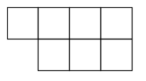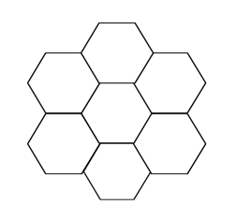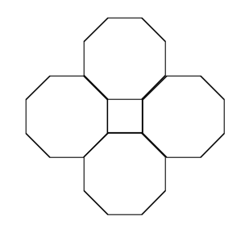
Exploring Concepts: (Cutter Madness)

Summary: Students will practice creating tessellations (tiling) of shapes using an applet from NCTM.

Outline:
- Students will go to a website and problem solve creating tessellations (tiling)
- Students will think about why something tessellates and why it doesn’t

Activity:
Direct the students to go to the website: http://illuminations.nctm.org/ActivityDetail.aspx?ID=202 from NCTM. At this website, students can experiment with creating tessellations with regular polygons. Some shapes will tessellate (tile) completely and others will not. While the are working on the exercise, the teacher should ask guiding questions about what makes a shape tessellate and why. If the shape does not tessellate, how can the waste be minimized? Students should be encouraged to try different combinations of regular polygons. NOTE: The directions are on the website and are pretty self-explanatory. The shapes can be rotated, but not resized.

Resources:
NCTM Tesselation Creator: http://illuminations.nctm.org/ActivityDetail.aspx?ID=202
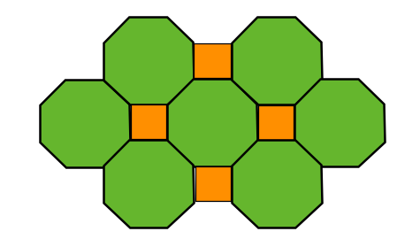
Instructing Concepts: (Cutter Madness)

Problem Solving Process

The problem solving process is teachable and students will become better problem solvers with guidance and practice. Since there are many problem solving models, it depends who you talk to about which model is best. George Polya first outlined one of the best-known problem solving processes. This instructional piece will focus on Polya’s work.

Step One: Understand the Problem
This step involves the very beginning of the problem solving process. Students are asked to carefully analyze the problem paying particular attention to these questions.
• Are all the words in the problem known to you?
• What are you supposed to find, solve for, show, or prove?
• Is it possible to restate the problem in your own words?
• Is there a picture, graph or diagram that can help you understand the problem?
• Is there enough information to solve the problem?

Step Two: Devise a Plan
This step involves the process of deciding how you are going to solve the problem and creation of a plan that will lead to that solution. Below are some possible strategies that students might want to consider.
• Guess and check, look for a pattern, draw a picture, make a list
• Solve a simpler problem
• Think about problems that are similar you might have solved before
• Compare and contrast
• Use a model
• Solve an equation or work backward
This list of strategies is not all-inclusive. One of the most important strategies is to be creative and think “outside” the box to try to devise new and different ideas that may apply.

Step Three: Carry out the Plan
This step is easier than step two because you just have to stick to the plan you created. Work carefully and diligently to attempt the plan you have devised. If your plan doesn’t work go back to step two and use the knowledge you have gained to think of something else. Often we learn more from a failure than by solving a problem correctly the first time.

Step Four: Looking Back
This step is very important to becoming better problem solvers. It is this analysis of what worked and what didn’t work that lets you apply knowledge in similar situations and extend into the less familiar. You should think about where you might use the method again and think about how your strategy could be improved upon. This analysis of what happened will make problem solving easier in the future.
Organizing Learning: (Cutter Madness)

Summary: The students will position different shapes on a piece of paper trying to maximize the area available and minimize the amount not being used.

Outline:
- Give groups a set amount of shapes
- Give group a piece of heavy cardstock
- Let students explore what arrangement is the most useful and measure the results by weighing the “waste”
- Conclude with a discussion about the thought process that occurred

Activity: The teacher will divide the students up into groups of 2 or 3 and give each group a set of shapes and some heavy cardstock (preferably not all groups will have shapes that tessellate). The shape set can contain all the same shape or it can be comprised of several different shapes. The students will manipulate the shapes on the cardstock to see what arrangement will cover the most amount of paper and reduce the waste (the amount not covered). When they have decided on an arrangement, they should trace around the shapes, cut them out and weigh the “waste” on a scale. In industry, businesses cut templates out of large pieces of metal or plastic and there is waste material left over. The goal of the activity is for students to MINIMIZE the waste. After a set time, have the groups switch shape sets. Each group will then be given instructions that they must problem solve the best tiling solutions with the least waste in 2 minutes. Have the groups share their solutions/results and talk about the methods and thought processes that they went through.

Resources:
- Sets of shapes
- Heavy cardstock
- Electronic scale
- Tesselation Resources: http://gwydir.demon.co.uk/jo/tess/index.htm
Understanding Learning: (Cutter Madness)

Summary: Students will be given a set amount of time to maximize the number of stars cut out from pieces of paper while minimizing the waste.

Outline:
- Formative assessment of problem solving
- Summative assessment of problem solving

Activity: Students will complete written and performance assessments relating to problem solving.

Formative Assessment
As students are engaged in the lesson ask these or similar questions:
- Were the students able to move the shapes around the paper?
- Were the students able to rotate the shapes, flip the shapes, or mirror the shapes?
- Can the students roughly think about how many shapes they can get on the paper?
- Can the students sketch a “plan of attack” for starting the computer part?

Summative Assessment
Students can complete the following writing prompt:
Think of a time when you needed to get a certain amount of something and you only had a little bit of material to use. Write about this time, telling in detail the situation and what you did to solve the problem.

Performance Assessment
You will be given 3 sheets of 8x11 paper from which you are to make 55 star shaped pieces. You are required to make 24-one inch, 20-two inch, and 11-three inch pieces. The amount the machiner will get paid will vary relating to the amount of waste. This means if the machiner has very little waste and does not need to use all three sheets of material, they will make more money. If the machiner uses all three pieces of paper and has a lot of waste, he/she will not make a lot of money. The machiner will get ten minutes to sketch ideas out before they have to get to the computer lab to get the pieces placed on the document and printed. Additional incentives are if the machiner gets the pieces placed quickly. If it is under 15 minutes, they get an additional 15 dollars. If it is under 30 minutes, they will get an additional 10 dollars.

