Project SHINE / SPIRIT2.0 Lesson:
This Teacher was mentored by:


www.bd.com

In partnership with Project SHINE grant funded through the

National Science Foundation

Writing Right
==========================Lesson Header ==========================
Lesson Title: Writing Right
Draft Date: 7-15-10
1st Author (Writer): Lori Focher
Associated Business: BD Pharmaceutical
Instructional Component Used: Technical Writing
Grade Level: Middle School

Content (what is taught):
- Introduction to technical writing skills

Context (how it is taught):
- Students will write directions for procedures and then having someone else try to perform the act

Activity Description:
Students will learn about technical writing – what it is, the essential elements of technical writing, and how it is different from other writing styles. First, students will be given a set of steps in random order for creating a product to see if they are able to put them in the correct order. Students will write about the reasoning behind their order and why they were or were not able to do this correctly. Students will then write directions for easy tasks that can be done in the classroom to see if their peers can actually follow the steps and be successful. Finally, to prepare for being able to write procedures for science experiments, students will write the steps for creating a peanut butter and jelly sandwich, which the teacher will then try to follow and see if a sandwich can actually be made.

Standards:

Technology: TB2 Engineering: ED2

Materials List:
- Loaves of sandwich bread
- Jars of peanut butter
- Jars of jelly
- Various utensils
- Plates
- Napkins
Asking Questions: (Writing Right)

Summary: Students will use a set of directions to create a product manufactured locally and try to put the steps in the correct order. Then, they will write about why they chose the order they did.

Outline:
- Order a set of directions to create a locally manufactured product
- Students will defend their order in writing

Activity: Students will be given these steps (but not in the correct order which is given here) with instructions to try to put the steps in the correct order. When they are completed, the students need to explain why they put the steps in a particular order. Conclude the activity by sharing the correct order with the students. See attachment for printable cards.

Long tubes of glass are fed through a cutter to be cut into smaller pieces of the desired length
Product is sent through an ultrasonic washer where they are thoroughly cleaned by a process combining liquid solution and sound
Product is formed with flange and tip into the desired style
Screen printing of needed information onto the product
Assembly – either a small plastic piece or a needle is added
Product is sent through a “super soaker” - high pressure and high temperature washing
Product is packaged
Packaged product is placed in cartons
Product is sterilized using ethylene oxide or radiation
Product is stored in a warehouse

Students will answer the following questions in writing:
Questions | Answers
What order would you put the steps? Give reasons for your order. | Answers will vary - finding the beginning and ending is easy, but the middle may be more difficult.
What would have made this easier? | being more familiar with the product, having actually seen the process at some point, etc.
Was the given information specific enough to figure this out? | No - being unfamiliar with the process, more details would be needed
Would it be specific enough if you worked at this plant and knew the product? | Yes.

Attachments:
T024-SHINE-Writing_Right-A-Activity.doc
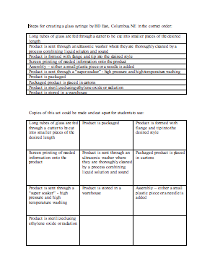

Exploring Concepts: (Writing Right)

Summary: Students will begin practicing technical writing skills.

Outline:
- Write the steps to simple procedures
- Share with others to see if they can be followed

Activity: Have students pick easy tasks that can be done in the classroom. Students will write step-by-step to instructions to complete the task. Task examples include:
- Put a new piece of lead in a mechanical pencil
- Make a paper airplane
- Tie a shoe
- Writing a word
- Using a calculator
- Opening a shut door

Inform students that technical writing should meet these requirements:

- Specific, useful, factual information needed to understand or complete something
- Comprehensive - includes all needed information, but not extra
- Concise - to the point
- Correct - grammar, conventions, etc.

Have students exchange writings and try to follow each other’s directions exactly and be successful. Is there information missing? Extra information?
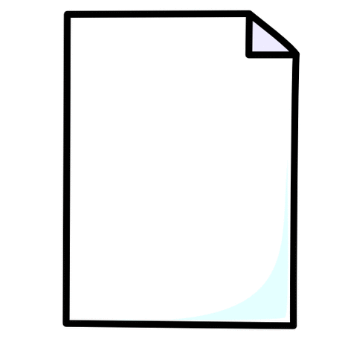
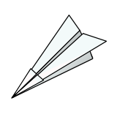
How to Make a
Paper Airplane

1.
2.
3.
4.

Instructing Concepts: (Writing Right)

Technical Writing

Technical writing is a formal style of writing used today in areas as varied as business, science, engineering, technology, social science, and education. Its purpose is to transfer of complex information in a manner that is useful, clear, and easy to understand. Some common examples of technical documents are sales catalogs, financial reports, resumes, handbooks, standard operating procedures, appliance manuals, and business proposals.

Identifying Audience and Purpose
Audience analysis is an important element of all technical writing. First, the writer must identify who the reader will be. Then the writer must determine what information the reader requires, the reader’s background, and the level of understanding. The technical writer must also consider the reason for the document. Is it to inform, persuade, solve a problem, or tell how to do a process.

Organizing and Formatting a Document
Technical writing looks different from other forms of writing, such as newspapers and fiction books. Content is generally delivered in a direct, linear format. Information is presented in specially arranged units called chunks. These chunks are organized through the use of headings, white space, section dividers, horizontal rules, numbering, bulleted lists, and boldface type. Graphics, such as diagrams, tables, and charts can enhance the text and help the reader further understand the information.

An Awareness of Language
Technical writing is not creative writing. Flowery prose, snazzy verbs, colorful adjectives, or long paragraphs do not belong in a technical document. The technical writer must choose words that convey ideas effectively and efficiently. Language should be clear, direct, and grammatically correct. A technical writer should use active rather than passive voice, avoid jargon, and write compact sentences and paragraphs. This will ensure that the reader does not have to struggle to understand the information.

Research
A technical writer may not know everything about his subject before he begins. The writer must gather information from existing documents and subject matter experts, known as SMEs. Through research, a technical writer can become a mini-expert in the subject area, but his main skill lies in being an expert in documentation. Thus, with the proper research, a technical writer can write on almost any subject he chooses.

A Few Final Thoughts
The ability to translate technical knowledge in a clear, concise manner is a skill that can be developed with practice. The challenge for the technical writer is to present the information in a way that a person who isn’t an expert can understand and use. People who are technical writers should have good research skills, a command of grammar and language, an understanding of audience, and the ability to deliver technical information in a straightforward manner.
Organizing Learning: (Writing Right)

Summary: Students will write specific directions on how to make a peanut butter and jelly sandwich. The teacher will have the supplies for making such sandwiches in order to follow the steps exactly to see if a sandwich can be created successfully.

Outline:
- Students will write directions for making a peanut butter and jelly sandwich
- Teacher will follow the steps exactly to see if a “correct” sandwich can be created

Activity: To practice technical writing skills and prepare students for writing out procedures for science projects, students will write specific directions on how to make a peanut butter and jelly sandwich. Students should be given ample time to work on this.

The teacher will bring common essentials for making PB&J sandwiches (bread, peanut butter, jelly, utensils, plates, napkins). The teacher will then read the steps aloud and try to follow them exactly as written in front of the class to see if a sandwich can be successfully made. This may sound like an easy task, but simple things like removing the lid of the jar or what to use to apply the peanut butter to the bread can make it impossible to go on with the steps.

If the attempt to follow the directions is unsuccessful, the student should be allowed to edit to learn from their mistakes.

Materials Needed:
- Loaves of sandwich bread
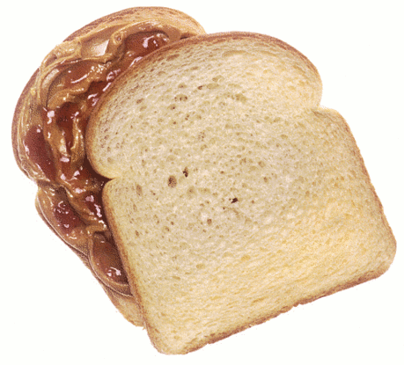
- Jars of peanut butter
- Jars of jelly
- Various utensils
- Plates
- Napkins
Understanding Learning: (Writing Right)

Summary: Students will demonstrate their understanding of technical writing.

Outline:
- Formative assessment of technical writing
- Summative Assessment of technical writing

Activity: Students will be assessed on technical writing by answering writing prompts.

Formative Assessment
As students are engaged in the lesson ask these or similar questions:
- Are students using the components of technical writing?
- Are students able to give each other feedback about their technical writing?
- Do students understand the difference between technical and creative writing?

Summative Assessment
Written responses to the following:
- What is technical writing?
- Give at least 4 examples of technical writing.
- What are the essential elements of technical writing?
- How is technical writing different from creative writing?

