SPIRIT 2.0 Lesson:
Programmable Robot Lesson
==========================Lesson Header ==========================
Lesson Title: Programmable Robot Lesson 1
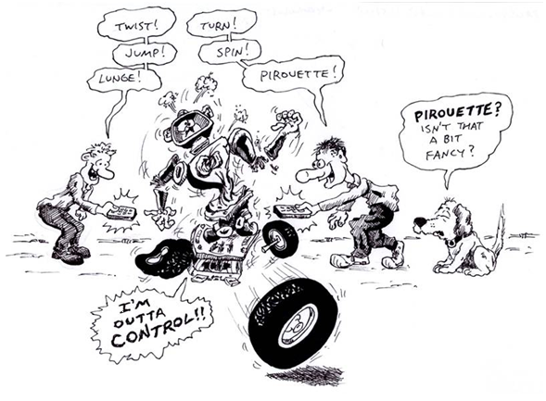
Draft Date: 6/23/10
1st Author (Writer): David Porter
Instructional Component Used: Computer Programming
Grade Level: 4-8 Upper Elementary through Middle School

Content (what is taught):
- Use of computer programming to control a robot.
- Understanding of the variables involved in commanding a robotic vehicle to reach a designated point.

Context (how it is taught):
- Use of TI Basic software
Activity Description: Students will be use a computer language called TI Basic with a Texas Instrument calculator in order to control a classroom robot.

Standards:

Science: SE2 Technology: TA1, TB1, TB4

Engineering: EA4, ED4 Math: MA2, MD2, ME1

Materials List:
- TI calculator-controlled robot with its TI calculator
- Four wheeled sit-on scooters for the activity in the “E” component
Asking Questions: (Programmable Robot Lesson 1)

Summary: Students will consider the difficulties involved in providing directions to control the movement of a robotic device. Students will create a series of commands to move a robot away from and then return to its starting point.

Outline:
- Students consider the variables involved in controlling a robotic vehicle sight-unseen, including direction, distance, and rate of motion.

Activity: Students will be guided through a series of questions that will make them think about providing directions. The variables that affect those directions will be explored.

Questions | Answers
Suppose you had to drive somewhere while blindfolded—and you could only get directions when you were stopped. What difficulties might you experience? How many directions do you think you could accomplish at one time? What problems might you “run into to” if you did several directions one right after the other? | Varied answers: it would be difficult to know how far one traveled and the direction s/he went…you would need a way to measure and/or know those things. Mistakes in directions would multiply and you likely would not get to where you hoped.
What would you need to be able to accurately and safely drive blindfolded? That is what information or instruments? Sorry, no gps coordinates are available. | You would need to be able to measure speed, distance, and direction: a clock and speedometer would do all but direction. The teacher might note that this has been a problem for sailors for many years and has been dealt with in a variety of ways.
Imagine that you are going to control a robotic vehicle on Neptune. It takes 4 hours for pictures/commands to make a one-way trip between Earth and Neptune. “Live” control is not possible—the best you can do is view a picture from the lander and then command it to make a move/series of moves. What risk might there be in sending a series of moves at one time? | If any problems arise during the robot’s execution of the directions, there would be no way to stop it-fix the problem. The robot might end up being damaged or lost.
In what ways would controlling the lander be similar to driving a vehicle blindfolded? | Must be able to control distance and direction without benefit of instant corrections, the stakes are high-accidents could be disastrous.
Imagine that the lander must return to its home base in order to be recharged. Create a series of commands, which would take it to an interesting Neptunian feature, which is located 5 meters away to the side of the lander—and then return it to its home base. | Answers vary but must include aspects of distance and how to determine the angle of turns.

Resources:
TI Calculator and Norland Manufactured Robot: http://www.smallrobot.com/scimath.html
Exploring Concepts: (Programmable Robot Lesson 1)

Summary: Students will complete an activity to understand the difficulties/concepts involved in controlling a robotic vehicle by remote control.

Outline:
- Students will work in pairs to direct a scooter to a spot and back with the rider blindfolded.
- Students will get a hands-on understanding of the complexities involved in creating commands for the movement of a programmable robot.

Activity: The teacher will introduce the discussion by telling the students that they are going to work with a partner in order to direct a blindfolded person to a specific point and then return to the start point—while the blindfolded person is sitting on a four-wheeled scooter in a large open area. Each pair of students will have a simple course that will be created once the blindfolds are in place, as simple as having an “X” under the starting point of the scooters and placing a colored piece of paper as the goal for the scooter to reach and return from. The person doing the directing may give directions ONLY when the scooters are stopped. They will have “x” minutes to complete the task. Once the time is expired, the students will switch places and try again (creating a somewhat altered course for the new trial). The teacher might time the students during their attempts. The teacher could choose to demonstrate how errors in directions multiply by having students do a trial of the above experience while following several consecutive directions without intervening corrections.

For safety reasons, be sure to space the students sufficiently apart so that there is no possibility of them running into one another (you might create a rule that if the scooter operator runs into an object or other person, the team is eliminated from the activity).

Following the exercise, it will be instructive to question the students about the difficulties involved in completing the exercise, such as:
- Why was it so difficult to return to a starting point when someone was giving directions?
- What were (would be) the difficulties in trying to do more than one command at a time?
- What would have made it easier to complete the activity?
- How might this be similar to the difficulties involved in controlling a robotic vehicle on another planet?
- If the wheels of the scooter were controlled by electric motors, how would it be helpful to know the speed of the wheels?
- Why would it be important to be able to control the length of time, which the motors operate?

Resources:
- Large flat area without obstacles (such as a gymnasium)
X
- Low four-wheeled, sit-down scooters, often used in P.E. classes.
Instructing Concepts: (Programmable Robot Lesson 1)

Computer Programming is the process of writing code that will cause a machine to do something desired by the user. In addition to the writing or modifying of the program code, programming includes the process of testing and debugging that code to make it work properly. The computer programmer must be able to think logically and sequentially in order for the program to work.

History: The history of electronic computer programming began in the 1940’s with the invention of the ENIAC machine. This first modern computer was developed by the military to help with the writing of artillery-firing tables. These tables were used for different weapons that were fired under varied conditions for target accuracy. As computers improved through the 1950’s to the 1970’s, languages like COBOL for business and FORTRAN for science and engineering were developed and became the standard. With the invention of the personal computer in the 1980’s, computers became household items and the number of languages grew and diversified. Pascal and BASIC were languages that sprung up in the 1980’s as a result of the PC. As the computer continues to get more powerful, the languages continue to adapt. Some of the more prevalent languages today are the various iterations of C, Java, PHP, and numerous others.

Basic Instructions of Computer Program (In Almost Any Language)

Input: The acquisition of data from a file, keyboard or other input device

Mathematical functions: The performance of mathematical operations ranging from basic arithmetic to advanced functions

Repetition: The performance of an action over and over, sometimes with subtle changes

Conditional algorithms: The checking for certain conditions and the execution of statements in an appropriate sequence

Output: The displaying of data resulting from the program on a screen, in a file, or any other means

Characteristics of Modern Computer Programs: Modern programs look and do very different things but share some common characteristics. They all try to be efficient and high performance thereby providing the most power and speed while using the least amount of system resources. They should be reliable. Programs should be robust in dealing with the user and how they handle errors and data conflicts. The program should be usable, clear in its output and intuitive for its user. Finally, the program should be portable across a wide range of operating systems and hardware.
Organizing Learning: (Programmable Robot Lesson 1)

Summary: Students will learn the commands necessary to operate a robot controlled by a calculator using TI Basic. Through repeated trials and collection of data, the students will determine the relationships between time and distance (the speed of the robot) and time and the angle of turn (how to command the robot to make specific turns (such as right angles).

Outline:
- Students will determine the rate at which the robot travels.
- Students will learn how to command the robot to make turns of a specific angle.

Activity: Students will use the TI Basic programming language in order to command the robot to travel in a straight line for a measured distance (ten meters or feet would be an easy to use distance). Stopwatches will be used in order to determine the time taken by the robot to travel the distance. The teacher may wish to have the students repeat this in order to determine an average rate. They will use the formula R = D / T to determine the rate. This formula will result in an answer in the following format: x feet/second or x meters/second. The teacher may wish to challenge students to convert this to miles or km per hour. The original format, however (feet or meters/second) would be more useful to the student. Students may find it appropriate to check the rate from time to time to see if the drain on batteries is altering the robot’s rate of speed.

Students will then create a program that causes the robot to turn for a specific length of time. The teacher or student will need to decide whether to have one wheel stopped while the other turns OR have one wheel turn backward while the other turns forward. This could be an option for testing/data collection/comparison. Students will record both the length of time turned and the corresponding degree of angle the robot turned. Using data from these trials, the students will determine the length of time required for a robot to turn specified amounts, such as 90, 180, 270 or 360 degrees.

In order to accomplish the above activity, students will need to become familiar with the command structure in TI Basic. Several tutorials are available:
- http://smallrobot.bizland.com/Instructions.pdf
- TI-Bot Users Guide by the University of Nebraska at Omaha (attached)

Resources:
- Norland/TI Calculator Controlled robot
- Instructions for programming a robot using TI Basic

Attachments: T027_Programmable_Robot1_U_TIBot_Users_Guide and TIBot_Program
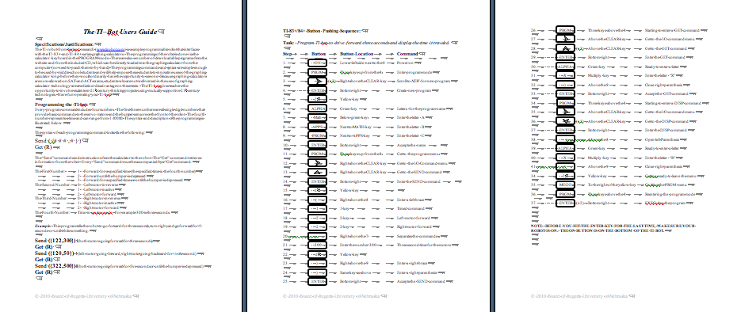
Understanding Learning: (Programmable Robot Lesson 1)

Summary: Students will demonstrate their familiarity with the TI Basic computer language through the creation of programs to control a TI calculator-controlled robot.

Outline:
- Formative assessment of computer programming
- Summative assessment of computer programming

Activity: Students will complete a performance assessment based using computer programming on the TI-Bot.

Formative Assessment: The teacher will set three tasks for the students to accomplish with their robots.
- Were students able to give commands to their partner that allowed them to “ride” the scooter to its destination?
- Do students understand the command structure of TI-Basic?
- Can students program the TI-Bot using TI-Basic?
- Students can “practice” these formative skills:
  - Travel in a straight line for a distance of 15 feet or meters
  - Execute a 270-degree turn

Students should be able to accomplish those if they previously accomplished tasks such as those described in part O of the “Programmable Robot Lesson 1.” If students have difficulty or need repeated trials, the teacher can redirect their learning.

Summative Assessment: Students can complete the following performance assessment.
The teacher will have a square or squares laid out on the floor (masking tape might be used). Students will take turns having a robot run their program around the square with sides of 2.5 feet or 1 meter. The teacher should expect minor errors to be multiplied as each turn is executed. Some calculator-controlled robots have calibration errors in the drive motors that result in the robot not progressing in a precisely straight motion despite correct programming. The teacher will need to decide upon the precision required for student grades—this will depend upon the grade level of the students. A suggested passing point for the assessment would be a program which commands the robot to complete four turns which creates a closed figure.

