Project SHINE / SPIRIT2.0 Lesson:
A Brief History of Electricity
==========================Lesson Header ==========================
Lesson Title: A Brief History of Electricity
This Teacher was mentored by:

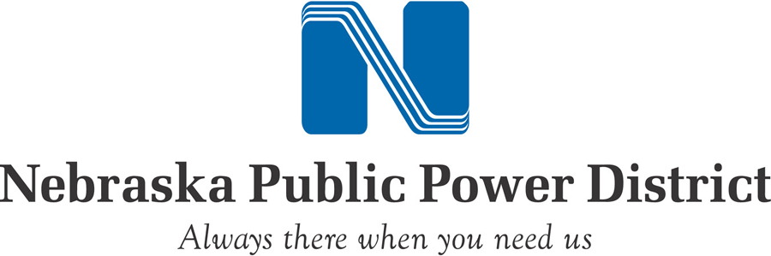
www.nppd.com

In partnership with Project SHINE grant funded through the

National Science Foundation

Draft Date: July 29, 2010
1st Author (Writer): John Pierce
Instructional Component Used: Information Literacy
Grade Level: High School/College Freshman

Content (what is taught):
- Electrical discoveries and inventions
- 1800’s: The industrial revolution and electricity’s role
- AC vs. DC: the great debate
- 1900’s: Electrical distribution begins
- REA and the Tennessee Valley Authority
- US Power distribution today

Context (how it is taught):
- Handouts with timelines
- Have class do research with assigned reading in LRC materials
- Have class do specific research with Internet resources
- Bring class together for discussion of research topics
- Create role-playing debate between AC and DC
Activity Description:
In this lesson, students will be presented with historical facts that are easily found in various locations regarding the development of the electrical generation and distribution systems. See attached PowerPoint for an overview of all the topics researched.

Standards:

Science: SB1, SE2 Technology: TA2

Engineering: EE2, EE5 Math: MD1

Materials List:
- Internet URL’s for research
- List of research topics
- Books, magazines, etc. for research

Asking Questions: (A Brief History of Electricity)

Summary: Students will think about electricity from different perspectives and compile what they currently know about electricity.

Outline:
- Questions will be posed to students that concern electricity relating to history, politics, inventions, etc.
- Students will discuss what they know about electricity.

Activity: The teacher will pose the questions about electricity to the students. The list is far from exhaustive so additional questions can be asked. The goal of the activity is to have students think about electricity and state what they know. Information that students cite should be listed on the board. These might be inventions, inventors, how it works, the power grid, recent news about electricity, etc.

Questions | Answers
Who were the first people to play a significant role in electrical discoveries? | B. Franklin, T. Edison, N. Tesla, Westinghouse
Who played an influential role in the development of electrical power? | G. Westinghouse, JP Morgan, Insull, Roosevelt, Norris
How has the development of electricity changed the way we live? | Automation, cleaner lighting, transport of food, air conditioning, etc.
What was the AC/DC debate about? | Has to do with safety, ease of changing voltage levels to transport long distances
Who were the key players supporting DC? AC? | Edison/Morgan promoted DC, Tesla/Westinghouse promoted AC.
How did America get electrified? | TVA and REA were acts passed by Congress in the 1930’s and signed into law by FDR.
What does REA mean? | Rural Electrification Act.

Attachments:
T028-SHINE-History_electricity-LESSON_POWERPOINT.ppt
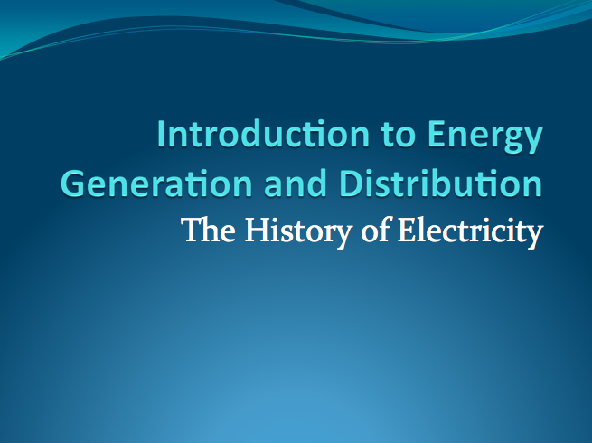
Exploring Concepts: (A Brief History of Electricity)

Summary: In this lesson, students will explore the key figures and technologies that have evolved concerning discoveries and inventions in the electrical business.

Outline:
- Students will research electricity including history, key players, inventions, types, and the politics surrounding electricity in America during the late 1800’s and 1900’s.
- Students will compare the pros and cons of AC and DC and discuss why AC won.
- Students will compare America’s TVA/REA electricity system to other countries around the world.

Activity: Students should use the Internet to research the topic of electricity. There are several websites listed below that would be a good starting point. The class can be divided into group with each group focusing on a particular topic. Topics that students should research include:
  - History of electricity
  - Key players in electricity (these could be inventors or politicians who made the choice about how to distribute electricity
  - AC vs. DC (pros and cons and why AC was chosen)
  - Inventions that helped make electricity a viable commodity
  - The American power generation and distribution system vs. other countries’ versions of similar systems
  - The TVA/REA system.
A class discussion will culminate in a presentation showing the current electrical distribution system and how it needs to be improved if we are to grow any further. The Smart Grid will likely be a final topic of discussion, leading later into more detailed analysis of that proposed new grid improvement.

Resources:
Some Internet and/or library resources could be utilized, if necessary. Timelines, biographies of key players, TVA and REA fact sheets, general map of USA power grids, chart showing pros and cons of AC and of DC for class discussions and more can be found on the websites below.

http://newdeal.feri.org/tva/tva01.htm
http://newdeal.feri.org/tva/tva10.htm
http://www.eskimo.com/~billb/tesla/tesla.html
http://www.thomasedison.com/biography.html
http://inventors.about.com/library/inventors/blwestinghouse.htm
http://www.eia.doe.gov/emeu/aer/pdf/pages/sec1_3.pdf
http://www.eia.doe.gov/cneaf/electricity/chg_str_fuel/html/fig02.html
http://www.school-for-champions.com/science/ac.htm
http://www.need.org/needpdf/infobook_activities/IntInfo/Elec3I.pdf
http://library.thinkquest.org/6064/history.html
http://www.electricityforum.com/electricity-history.html
Instructing Concepts: (A Brief History of Electricity)

Information Literacy

Locating Information
Information can be found in many different ways. It might be through traditional means like reading professional journals or going to the library or it could be through more technological means by searching the Internet using a search engine. Typically, it will not be difficult to locate information rather the problem is finding relevant, reliable information.

Organizing Information
For the information that you locate to be useful it must be organized properly. There are many ways to organize data and ultimately you must pick the one that best works for you. In fact, the organizational method might change depending on what the information is. Some common organizational strategies for information are: data bases, word processing documents, spreadsheets, pocket mods, graphic organizers, mind maps, clustering, webbing, etc.

Evaluate Information and Information Sources
The evaluation of information is critical to using it properly. First, it must be relevant to the purpose intended and honestly presented. Second, it must be deemed reliable. To do this you will want to consider the source of the information. Primary source information is a source that is closest to the thing being studied. These sources will be the most likely to be reliable. Secondary source information is a source where the information was originally presented somewhere else. It is best to use primary sources when possible.

Synthesize Information
Synthesizing information is the process where you take information previously known and combine it in a new way that provides new information and insights. This process is where new product is created.

Ethically Use Information
Ethical use of information is becoming a very important topic in society. Information should provide insight into what is going on in the world and it is important that it not be misrepresented or misused. Manipulation of information for the purpose of convincing an audience of a particular outcome is not desirable, ethical, and might be illegal. The information should stand on its own under scrutiny from experts as unbiased. Information that belongs to others must be cited otherwise plagiarism or copyright infringement is present.
Organizing Learning: (A Brief History of Electricity)

Summary: Students will consolidate numerous charts and other handouts from their own and other classmate’s research into a concise section in their notebooks.

Outline:
- Students will practice information literacy by organizing all the information collected from their research.
- Students will synthesize their information to make generalizations about what they learned.
- Students will present their information to the class.

Activity: Students will take the research that was completed about a topic relating to electricity and organize it into a coherent product. They should analyze the information and the sources where it was located to see if any generalizations can be made. Each group will create a media presentation for the class. After each group has presented, a class discussion centering on what was learned will take place. The class can debate the politics of AC vs. DC, public vs. private utilities, and the electrification of rural America. Finally, students should try to synthesize the research to see if any new insights were learned.
Understanding Learning: (A Brief History of Electricity)

Summary: Students will gain an understanding of the very complex nature of the development of electrical technologies as well as the business of electricity, its generation, distribution, effects on society and the economics of various types of businesses involved in electricity.

Outline:
- Formative assessment of information literacy
- Summative assessment of information literacy

Activity: Students will be assessed on information literacy by synthesizing their knowledge of electricity in writing assessments. There is also a quiz option.

Formative Assessment
As students are working, ask yourself these questions:
- Did students utilize the Internet to find valid sources and information?
- Were students able to evaluate the information they found for relevance?
- Were students able to compile (organize) information and synthesize it into a new understanding relating to the creation and development of electric utilities in America?

Summative Assessment
Students can answer the following writing prompts:
- Identify the key players (individuals and organizations) in the development of the electric utility industry. Explain what they did and how they influenced the current system.
- Describe AC and DC. Describe their differences, pros and cons.
- Explain public utilities and how they differ from investor-owned utilities.
- What are TVA and REA? When were they formed? What do they do?
- Choose either the role of investor-owned utilities or the role of public utilities. Cite the key arguments about why their side of this debate is the “correct” side and attempt to refute what the other side says about your “role’s” side.
Students can also take an electricity quiz (T028-SHINE-History_electricity-U-quiz.doc)

Attachments:
T028-SHINE-History_electricity-U-quiz.doc
