Ladder Logic Code Components

Create a Ladder Logic code that uses a switch to turn on a motor controlling a conveyor belt. The conveyor belt will transfer boxes down its length and past an IR sensor which will provide an input to a counter.

To begin programming, you need to start a new code and insert a new rung. The program will read the coded rungs successively and perform the appropriate actions.

Ladder Logic Code Components:

New Rung:
Input Switch:
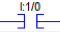
Output:
Last Rung / End of program code:
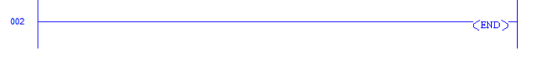
Solution to the O component Ladder Logic code:

