Project SHINE Lesson:
Say What?
==========================Lesson Header ==========================
Lesson Title: Say What?
Draft Date: June 10, 2011
1st Author (Writer): Deb Ohnoutka
This Teacher was mentored by:

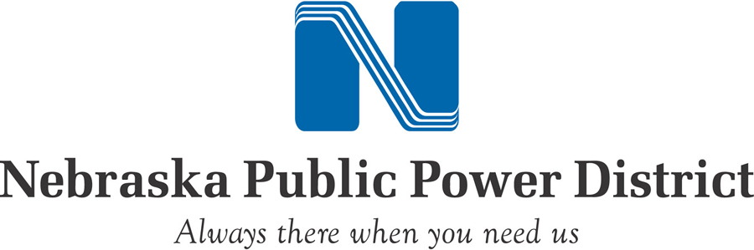
www.nppd.com

In partnership with Project SHINE grant funded through the

National Science Foundation

Associated Business: Nebraska Public Power District
Instructional Component Used: Communication/Listening
Grade Level: Middle School

Content (what is taught):
- Listening is an important of the communication process
- Speaker and listener are actively engaged in communication

Context (how it is taught):
- Practice sending and receiving messages

Activity Description:
In this lesson, students will explore the importance of listening carefully. Possible problems and solutions with listening will be identified. Students will hear from a guest speaker who uses listening skills in his/her job. Students will be placed in situations where listening will be important to complete a task.

Standards:

Technology: TB4

Materials List:
- 10-12 sets of identical colored paper shapes
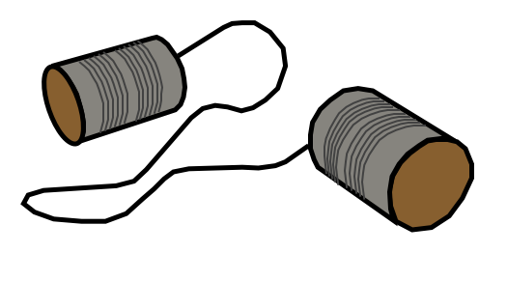
Asking Questions: (Say What?)

Summary: Students will be asked to think about why good listening skills are important to them now and in their futures.

Outline:
- Ask students why listening is important
- Listen to guest speaker whose job requires careful listening (i.e. NPPD linesman)

Activity: A class discussion will be held about communication, particularly listening. The questions (below) should help focus the discussion on the importance of good listening. Next, a guest speaker whose job requires good listening should be invited to speak. They can give first-hand knowledge of why listening is important and the problems that can arise when poor listening occurs.

Questions | Answers
Why is listening important? | So clear communication can be achieved.
Can you think of a time when a message got mixed up? What happened? | Answers will vary.
What are the consequences of not listening carefully? | Errors can be made. Some errors may be able to be corrected, but others may not. Some messages are the difference between life and death! You could also miss important information so that you cannot complete the task as asked.

Resources:
- Guest speaker who uses listening skills in critical situations (i.e. NPPD linesman)
Exploring Concepts: (Say What?)

Summary: Students will participate in the “telephone game” to see how verbal messages can possibly be miscommunicated. Student will discuss problems that occur when listening to messages and brainstorm “troubleshooting” techniques to use so that the message is clearly received and understood.

Outline:
- The teacher will start a message which students will repeat to each other until it has traveled across the room
- Students will compare the end message to the beginning message
- Students will explore what makes a message break down.

Activity: The teacher will begin by whispering a simple message to a student. The student will turn to the next student and repeat the message. This continues until the message has traveled around the classroom. Students are not allowed to repeat the message. The last student in the chain will state what he/she heard to message to be. The teacher will restate the original message to compare with the last. The class will discuss how the message changed and places around the chain where the message changed. Students can share problems they encountered while listening or speaking. Students can discuss what actions or methods would have helped in getting the original message across the room correctly.

In groups of 3-4, students will brainstorm possible problems or reasons why verbal messages may be misinterpreted. Students will record their ideas in a table (sample below). After thinking of at least five reasons, students will then generate possible solutions that both speaker and listener can use so that messages are sent and received with no miscommunication. The groups come together and share their ideas, adding additional ideas to their tables.

Problem | Speaker “Troubleshooting” | Listener “Troubleshooting”
Word switch (‘two’ for ‘blue’) | Make sure to enunciate. | Focus on listener; remove distractions; use context clues to fill-in correct word.
Instructing Concepts: (Say What?)

Communication

Communication is a two-way process related to the transfer of information from one person to another. There has to be an initiator and a receiver for communication to take place. In the most general terms, it can be thought of as the exchange of thoughts, opinions, information, and feelings for the achievement of a common goal.

Communicate Effectively to Multiple Audiences: When communicating information you must be aware of whom your audience is and adapt your methods to fit each unique audience. For instance you would communicate information very differently to a group of business people from the chamber of commerce than a group of middle school students. The content can be very similar but your delivery must be tailored to fit your audience.

Communicate Effectively Using a Variety of Media: Communication in the 21st century is very different than it was even several years ago. When conveying your ideas there are many different technologies available. It could be by e-mail, telephone, web conferencing, texting, blogging, discussion boards, traditional written methods, or verbally. This list is not exhaustive but is presented to show the diversity of communication methods. When choosing the media that you will use to communicate, you should consider the information to be transmitted and your audience very carefully. The reason is to insure that you choose the most efficient and the least likely method to be misunderstood. Remember the goal of communication is the successful transfer of information. If the wrong media type is used it is possible that communication will be ineffective.

Develop Cultural and Global Awareness: In this world with a global economy, rapid travel, instant communication, and instantaneous news it has become critical that we develop a multicultural awareness. The people that we are communicating with may very well have different backgrounds, values, and customs. If we are to understand each other and create quality communication, we must be aware of these differences. This multicultural awareness is a critical component for effective communication. With it communication flows freely in both directions and common goals can be easily achieved. Without multicultural awareness misinterpretations and poor communication will be commonplace.
Organizing Learning: (Say What?)

Summary: Students will learn a communication technique to minimize misunderstanding. Students will practice using this technique to complete a task with a partner.

Outline:
- Students will learn the 3-Part Communication technique
- Students will use 3-Part Communication to complete a simple task with a partner.

Activity: Students will learn the 3-part Communication technique:

3-Way Communication
1. Initiate message (speaker)
2. Repeat message (listener)
3. Confirm (speaker)

Students will work with a partner to assemble identical images from colored paper shapes while sitting back-to-back or side-by-side with a divider in between. One student will be designated as the speaker and the other will be the listener. The speaker gives directions telling where to place the colored shape. The listener repeats the direction, and the speaker confirms or modifies the message. Students will attempt to create identical images with their shapes. Students will be required to repeat process with a different partner.

Resources:
- 10-12 identical sets of colored paper shapes

Understanding Learning: (Say What?)

Summary: Students will reflect on the importance of good listening skills in the communication process.

Outline:
- Formative assessment of Communication Process
- Summative assessment of Communication Process

Activity: Students will complete writing and performance based assessments related to their learning about the communication process.

Formative Assessment: As students are engaged in the lesson ask these or similar questions:
- Are the speakers clearly expressing the message?
- Are listeners repeating messages to speaker?
- Are speakers responding to listeners and adapting messages so they are understood?

Summative Assessment: Students can answer the follow writing prompt:
- Cite an instance where communication is critical for success of a task. Explain why communication is important and how communication difficulties could possibly be eliminated.
- Explain why communication is important in your life and give one instance where the message you sent was not properly received. Why did the miscommunication happen?

