Project SHINE Lesson:
Accident Report
=============================Lesson Header=========================
Lesson Title: Accident Report
Draft Date: June 9, 2011
1st Author (Writer): Amanda Berg
Associated Business: NPPD
Instructional Component Used: Problem Solving
This Teacher was mentored by:


www.nppd.com

In partnership with Project SHINE grant funded through the

National Science Foundation

Grade Level: English 9-12

Outline of Lesson
Quote of the Day: “If you give me five hours to cut down a tree, I will spend the first four sharpening my knife.” Meaning: Prevention and preparation is key!

Content (what is taught):
- Students will understand the basic steps within the problem solving process
- Students will better understand the format of, and how to properly write a 5-paragraph essay

Context (how it is taught):
- Class discussion
- Small Group discussion
- Reading and evaluation of an article
- Writing a 5-paragraph essay
Activity Description:
Students will work together in small groups to chew through an article on the 2003 Northeastern area blackout. They will discuss how one person’s seemingly small mistake, took out power for millions of people. They will then reflect on past mistakes they have made. Although perhaps not on such a grand scale, students will relate how that situation was handled to how they personally handle situations when they make mistakes. Students will end by writing a 5-paragraph essay focusing on how they hope to handle mistakes in the future.

Standards:

Math: ME1 Science: SG1

Technology: TD2 Engineering: ED1

Materials List:
- A classroom set of Northeastern area blackout articles
- A classroom set of NPPD crisis form
- Paper and pencils for brainstorming and for the final essay
Asking Questions: (Accident Report)

Summary: Students will discuss questions in relation to making mistakes. They will be introduced to the steps in the problem solving process.

Outline:
- Students will participate in a group discussion to answer questions about mistakes
- Students will be asked to think about the definition of a mistake: “An error in action, calculation, opinion, or judgment caused by poor reasoning, carelessness, or insufficient knowledge
- The teacher will briefly address the problem solving steps: understanding the problem, devising a plan, carrying out the plan, and looking back

Activity: Students will engage in conversations with the class. Students will be asked a series of questions to guide them in their thinking about a mistake they have made. Students will begin to evaluate the mistake they made, what happened, and the consequences of the mistake. They will begin to think about the decisions before/during/after their mistake in terms of the problem solving process.

Questions | Answers
Define mistake | “An error in action, calculation, opinion, or judgment caused by poor reasoning, carelessness, or insufficient knowledge
Raise your hand if you have never made a mistake? | No one should raise their hand
Think about a mistake you have made? Did it involve your friends? Family? Teachers? School? | Varies for each student
What was the mistake and what was the consequence? | Varies for each student
OOPS!
Exploring Concepts: (Accident Report)

Summary: Students will read the article about the 2003 Northeastern area blackout, as well as the NPPD crisis protocol manual. Students will be actively involved in discussion with their classmates about the article.

Outline:
- Students will read through the article and manual
- Students will highlight information that sticks out
- Students will make marginal notes on questions they have
- Two students will share a summary statement with the class
- The class will discuss what mistake was made by the electrical worker

Activity: The teacher should hand out an article on the Northeastern area blackout to each student, as well as the NPPD crisis protocol manual. Students should take no more than 10 minutes to read through the article and 5 minutes to review the manual. While they are reading, students should highlight areas of information that stick out to them, as well as making marginal notes on any comments or questions they have about the reading. They should then discuss their findings in a small group of peers, focusing on the mistake/ramifications made by the electrical worker. After reading the article, the students should place themselves in the shoes of the electrical worker and write out the four steps in the problem solving process in relation to the incident.
1) Understanding the Problem
2) Devising a Plan
3) Carrying out the Plan
4) Look Back
Then the teacher should have two students share their problem solving plans/
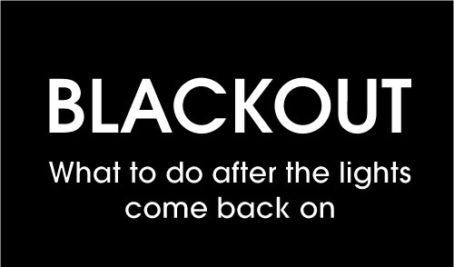

Attachments:
- Northeastern Blackout Article: T035_SHINE_Accident_Report_E_Blackout_Article.doc
- NPPD Crisis Form (11 pages): T035_SHINE_Accident_Report_E_NPPDCrisisReport.pdf
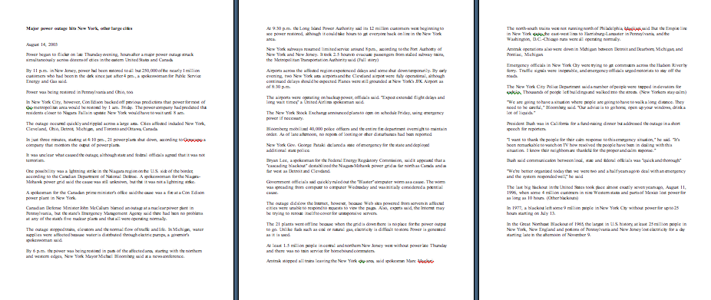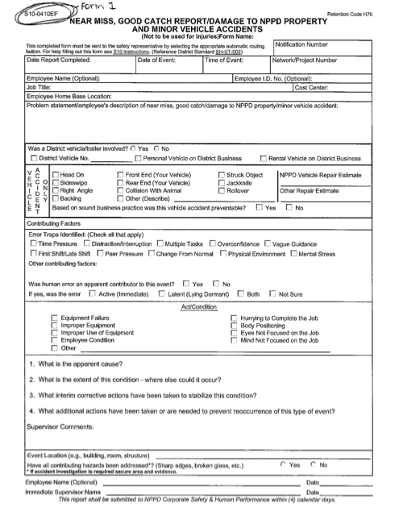
Instructing Concepts: (Accident Report)

Problem Solving

Problem Solving Process
The problem solving process is teachable and students will become better problem solvers with guidance and practice. Since there are many problem solving models, it depends who you talk to about which model is best. George Polya first outlined one of the best-known problem solving processes. This instructional piece will focus on Polya’s work.

Step One: Understand the Problem
This step involves the very beginning of the problem solving process. Students are asked to carefully analyze the problem paying particular attention to these questions.
• Are all the words in the problem known to you?
• What are you supposed to find, solve for, show, or prove?
• Is it possible to restate the problem in your own words?
• Is there a picture, graph or diagram that can help you understand the problem?
• Is there enough information to solve the problem?

Step Two: Devise a Plan
This step involves the process of deciding how you are going to solve the problem and creation of a plan that will lead to that solution. Below are some possible strategies that students might want to consider.
• Guess and check, look for a pattern, draw a picture, make a list
• Solve a simpler problem
• Think about problems that are similar you might have solved before
• Compare and contrast
• Use a model
• Solve an equation or work backward
This list of strategies is not all-inclusive. One of the most important strategies is to be creative and think “outside” the box to try to devise new and different ideas that may apply.

Step Three: Carry out the Plan
This step is easier than step two because you just have to stick to the plan you created. Work carefully and diligently to attempt the plan you have devised. If your plan doesn’t work go back to step two and use the knowledge you have gained to think of something else. Often we learn more from a failure than by solving a problem correctly the first time.

Step Four: Looking Back
This step is very important to becoming better problem solvers. It is this analysis of what worked and what didn’t work that lets you apply knowledge in similar situations and extend into the less familiar. You should think about where you might use the method again and think about how your strategy could be improved upon. This analysis of what happened will make problem solving easier in the future.
Organizing Learning: (Accident Report)

Summary: Students will work as a class to polish their problem solving skills. They will participate in the game called “Magic Shoes.”

Outline:
- The class works together to problem-solve their way through the game “Magic Shoes”
- The goal of the game is to get the whole class from one side of the room to the other
- They must figure out the problem, devise a plan, and execute the plan as a group
- When they are done, students must debrief and discuss what made them successful or what made them unsuccessful

Activity: The students will work together as a class to play the game “Magic Shoes.” The goal of the game is to get each student from one side of the classroom to the other. The only problem is that there is a power line down in the middle of the classroom, so the only way to safely get across is to wear these magic shoes. The problem with the shoes is that they can only be worn by each person one time, and only in one direction. This means that if someone wears them from side of the room to the other, they cannot wear them back. In addition, the shoes cannot be tossed, slid or moved to the other side of the room in any other way than a person wearing them. The students must work together to figure out the best way to get everyone across safely. The other problem is that they need to do it in ten minutes or less. When or if students finish, allow for a debrief time or “looking back time” to discuss what went well and what did not go well. Were they successful? Why or why not? Who stood out as a leader? Why? What would have helped them be more successful or successful more quickly? The idea here is to get them to see that having a proper problem solving process is the best way to ensure success.

*HINT (this should NOT be revealed to the students): Your students are going to have to ride on one another’s backs to solve this game. Students tend to figure this out quite quickly, but what they do not think about is what to do when they get down to the last couple of people. The lesson behind this is that when doing problem solving, they need to think their problem/solution all the way through before jumping in and trying it.
Understanding Learning: (Accident Report)

Summary: Students will complete assessments based on the concepts of problem solving.

Outline:
- Formative Assessment of Problem Solving
- Summative Assessment of Problem Solving

Activity: Students will complete writing assessments relating to problem solving.

Formative Assessment: As students are engaged in the lesson, ask these or similar questions:
1) Can students analyze and understand the proper steps in problem solving?
2) Can students read and understand the steps in the NPPD crisis protocol manual?
3) Can students read and understand the article on the 2003 Northeastern blackout?
4) Can students effectively problem solve to reflect on their own past experiences?

Summative Assessment: Students can answer the following writing prompts:
- Describe the problem solving process and what happens in each step.
- Students will write a 5-paragraph essay on this prompt:
What mistake have you made? Did you admit to it, or get caught? Were there consequences? In your essay, discuss what happened, how you reacted, and then create a prevention strategy for yourself to ensure that it does not happen again.
Make sure that your essay incorporates the following:
- Uses descriptive and vivid verbs
- Uses good/clear sentence structure
- Creates a fluid flow for the reader

*NOTE: Remind students that we all make mistakes, but what makes us different is how we respond and use the 4-step problem solving process. Thinking through this process helps to ensure that similar mistakes do not reoccur in the future.

