Project SHINE Lesson:
Where Does Columbus get Electricity?
==========================Lesson Header ==========================
Lesson Title: Where does Columbus get Electricity?
This Teacher was mentored by:

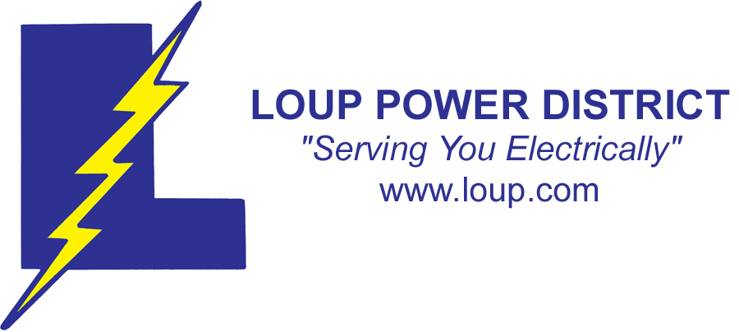
www.loup.com

In partnership with Project SHINE grant funded through the

National Science Foundation

Draft Date: June 13, 2011
1st Author (Writer): Brad Hansen
Associated Business: Loup Public Power District
Instructional Component Used: Economics
Grade Level: Middle School

Content (what is taught):
- Electricity and where it comes from in Columbus
- Government jobs created during the Great Depression that constructed the Loup Public Power District

Context (how it is taught):
- Group sharing of what electricity is and its uses. Exploration of how we get our electric power in Columbus and how Loup Public Power came to be via LPPD video and lecture.
- Lecture on government funding jobs to construct the canal and generate income for the unemployed during the Depression.

Activity Description:
Students will discuss electricity and where it comes from in Columbus. Students will be taught about the Great Depression and that it meant no jobs. The Loup Project created many jobs in this part of Nebraska. The students will learn how important Loup Public Power is to today’s current economic development.

Standards:

Math: ME1 Science: SC4, SF2

Technology: TC1, TB 2, TD1 Engineering: EC1, EE1

Materials List:
- LPPD video
- Poster Board
- Markers
- Computers
Asking Questions: (Where does Columbus get Electricity?)

Summary: Students will be introduced to the everyday impact of simple electricity in their lives and how the unique situation of Loup Public power came to be.

Outline:
- Students will understand that economics is decision-making regarding money
- Students will learn how the decision was made to construct the Loup Power canal
- Students speculate on the Loup Power canal’s effect on the economic development of Columbus

Activity: A class discussion will be conducted concerning economics and why a project like building the Loup Canal was reached. Electricity and its uses, production, and costs will be stressed since the Loup Canal produces electricity. Students will view pictures of the Loup Canal and a list of economic impacts from the canal will be generated both past and present.

Questions | Answers
What did Ben Franklin do with electricity? | Kite flying experiment
What do they know about electricity?  What are its uses? | Various answers  Various answers
Where do we get our electricity in Columbus?  Do you know where the Loup Canal is? Lake North?  The Loup Power Plant? | Loup Public Power  North of Columbus
What role does government play in everyday life? | Regulations, laws to protect, services to improve life.

Resources:
- Loup Canal from Headwaters to Tailrace
T039_SHINE_Where_Does_Columbus_Get_Electricity_A_Loup.pdf
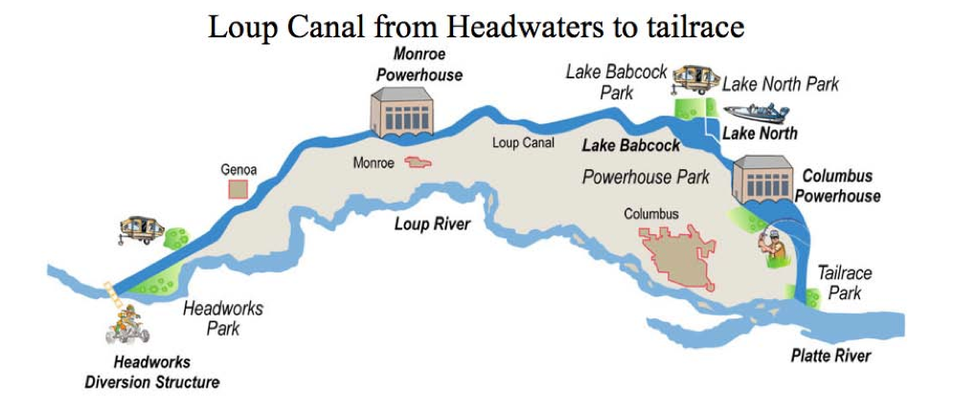

- Ben Franklin: http://www.eia.gov/kids/energy.cfm?page=fp_franklin
- Loup Public Power District http://www.loup.com/aboutus/virtualTour.asp (Virtual Tour)
Exploring Concepts: (Where does Columbus get Electricity?)

Summary: Students will understand the development of government owned utilities and the effects this had on the local economy and the far lasting effects of cheap electric power.

Outline:
- Students will understand what life was like during the Great Depression
- Students will understand the Loup Canal project via lecture and video
- Students will understand the effects short and long term of the Loup Canal project

Activity: A general overview of the Great Depression will be given by lecture and short video. The class will watch and take notes over the LPPD video on the construction of the Loup Canal (see resources below). As the video and lecture occur, students should think about the economic impact of this project. The questions below should be addressed.

Questions | Answers
What was it like to live in the 1930’s in Nebraska?  What is Loup Public Power?  How did it come about?  What kind of jobs were created by the Loup Project? | Depression: no jobs  Company that provides electricity for Columbus. Government program for jobs  Engineers, surveyors, contractors, laborers
Could the Loup Project have been done by private business? | Idea was put forward earlier but it took the federal government revenue to carry it out.
What was the effect of the project immediately? | $7 million was spent on the project locally, not including daily needs of the workers: food, shelter.
What was the long-term effect of the project? | Cheap electric power for the residents of the area. More jobs as businesses located in the area.

Resources:
- Book on the history and building of the Loup Canal: Power and Progress: The History of Loup Power District 1933-2006 by Sharon Farritor, Loup River Public Power District 2006
Instructing Concepts: (Where does Columbus get Electricity?)

Economics

Economics is a social science that analyzes the production, distribution and consumption of goods and services. The study of economics considers: how things are produced, distributed, and the decisions that we make about how we use our resources (money, time, natural, human and man-made). Economic theories explain how economies work and how agents of economies interact. Economics analysis can be applied in many diverse areas including: business, finance, government, education, health, politics, and other areas.

There are two main divisions of economics: Microeconomics and Macroeconomics. Microeconomics examines the behavior of individual markets and agents (consumers, buyers, sellers, etc.). Macroeconomics examines issues relating to the entire economy, including inflation, monetary policy, economic growth, and unemployment.

There are three major types of economies. These include: 1) Feudalism (traditional): Wealthy class of landowners and a class of workers, 2) Market: free enterprise or capitalism, and 3) Command: Government decides what is produced. The economy is a mixed economy with three types of business enterprises: Single proprietorship (one owner), partnership (two or more owners) and corporation (chartered by the government and sell shares of ownership).

A major concept in economics is economic trade offs and opportunity cost. Some things to consider are that people make choices because of scarcity (all things are limited). You cannot have everything you want (a luxury) or a need (essential to live), therefore decisions have to be made, in the home and the national as well as the international level. There is a limited supply (amount of a good or service available for sale) and created demand (ability and willingness of people to buy something). What determines price (the value of the product) is the amount of supply relative to the demand for that product.

Economies are cyclic in nature. There are upward (growth) and downward (recession) patterns. One measure of economic health is Gross Domestic Product (GDP) which is the monetary value of all goods and services produced in a year. During times of growth the GDP increases, job creation tends to increase, and businesses expand. During recession, there is less business growth, unemployment rises and the GDP shrinks. A depression is the low point in the business cycle. Concepts that influence the economic cycle are: taxes, government spending, inflation (rising prices), interest rates and unemployment.

Our market economy is a mixture of free enterprise and some government regulation.
The government determines fiscal policy and the amount deficit spending. It sets monetary policy that includes interest rates, tax revenues, and other government spending. Tax revenue comes from a combination income, corporate, property and other forms of taxes. Currently the government spends more than it receives placing the United States in a deficit situation with a growing national debt. Other things that affect the economy in the United States are: international trade, other countries economic decisions, foreign corporations, commodity prices and foreign markets. All these things interact to create a larger world economy, which connects the world, and what happens somewhere else on the globe can have far reaching effects for everyone.
Organizing Learning: (Where does Columbus get Electricity?)

Summary: The students will understand the Loup Public Power project and how it provides cheap electricity to Columbus, the multitude of tasks involved in its construction, the costs of the project and where the money came from, the immediate economic benefits as well as the long term economic benefits, and compare it to other projects like the Panama Canal, Hoover Dam and space program.

Outline:
- Student research the building of the Loup Canal
- The tasks involved in construction, costs, how it was paid for, and economic impact both past and present will be cited
- Comparison of the Loup Canal to other projects will be made

Activity: Students will research the building of the Loup Canal using resources from Loup Public Power District and the Internet. The research should focus on the history and economic impact of building the Loup Canal. Comparisons to other projects like Hoover Dam, Panama Canal, or the space program should be drawn. When research is completed, the students will demonstrate the benefit LPPD public works project had on the local population in the short and long term by completing one of the three choices below. Students will share this project with the class.
- Constructing a poster/cartoon panel/PowerPoint or model of the construction of the Loup Canal that will demonstrate the economic impact of this monumental project (in the 1930’s and during the ‘50’s and ‘60’s)
- Constructing a poster/cartoon panel or model of how the Loup project provides economic opportunities
- Construct a poster/cartoon panel/PowerPoint on the construction of the Panama Canal, Hoover Dam or Space Shuttle program and the economic cost and benefits.

Resources:
- Book on the history and building of the Loup Canal (Video is included with the book)
Power and Progress: The History of Loup Power District 1933-2006 by Sharon Farritor, Loup River Public Power District 2006
- Overhead on the Making of Electricity: T039_SHINE_Where_Does_Columbus_Get_Electricity_O_Electricity.pdf
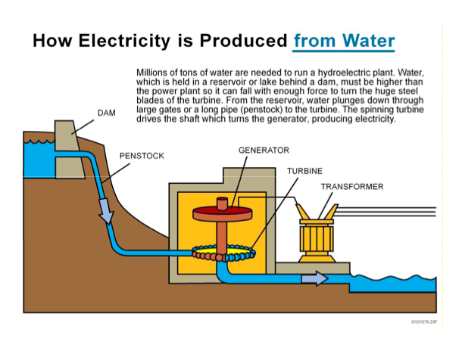
Understanding Learning: (Where does Columbus get Electricity?)

Summary: Students will understand the difference between Private Enterprise and Public Ownership of a business. Students will understand the construction of the Loup Project and the role of LPPD in the economic development of this area.

Outline:
- Formative Assessment of Economics
- Summative Assessment of Economics

Activity:
Students will complete written, quiz, and project based assessments on economics.

Formative Assessment: As students are engaged in the lesson ask these or similar questions:
- Do students know examples of free enterprise? (single proprietorship, partnerships, corporations)
- Can students explain how government protects the consumer? (Safety regulations, monopoly rules)
- Do students know when does government competes with private enterprise? (Roads, public utilities)

Summative Assessment: Students can complete the following writing prompt:
Write a short answer essay on the topic: “When is government involvement in business bad for individuals? “

Students can answer the following quiz and test questions:
- Test over the history of the Loup Project (recall)
a) What was Ben Franklin’s kite experiment?
b) What are some of the ways electricity is created?
c) What is the source of Columbus’s electricity?
d) What were the obstacles in constructing the Loup Canal?
e) What are the environmental effects of the Loup Canal?
2) Test over the economic terms (recall)
a) What is a Depression?
b) What are the economic cycles?
c) What can a government do to help citizens in an economic down cycle?
d) What is free enterprise?
e) In what ways does our government compete with private enterprise?

Students can complete the following project assessment:
Students will create a poster/model of construction of Loup Canal. The project must include the transfer of hydro to electric power to homes and factories, show the type of jobs used in the construction and for the operation, and how these jobs are related to economics.

