Project SHINE Lesson:
This Teacher was mentored by:

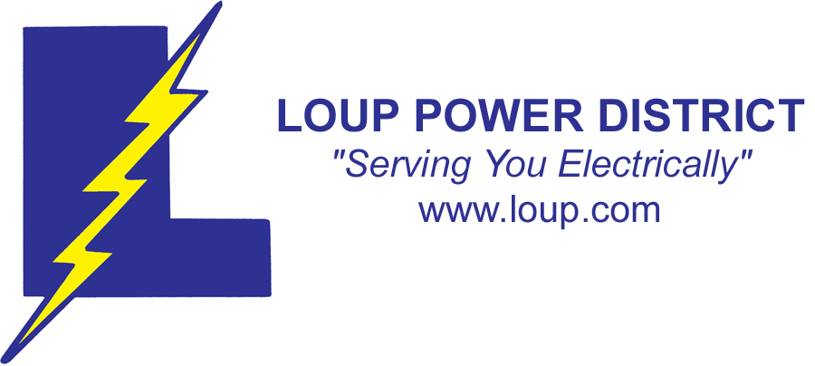
www.loup.com

In partnership with Project SHINE grant funded through the

National Science Foundation

What is the National Debt?
==========================Lesson Header ==========================
Lesson Title: What is the National Debt?
Draft Date: June 10, 2011
1st Author (Writer): Brad Hansen
Business: Loup Power District
Instructional Component Used: Economics
Grade Level: Middle School (8th grade)

Content (what is taught):
- Understanding the value of money in multiples of ten and going to a trillion
- Understanding of how our government spends its money (The Loup Canal project during the Great Depression is an example)
- Understanding where our government gets its revenue
- Understanding how we got in to the current debt situation and what can be done

Context (how it is taught):
- Group sharing on multiples of 10 and understanding what these values look like
- Demonstrating what government spending looks like (pie graphs and discussion)
- Demonstrating what government revenue looks like (pie graphs and discussion)
- Demonstrating how we got in to the current debt situation and what can be done

Activity Description:
Students will be asked to come up with everyday examples of multiples of 10 to eventually understand the concept of a trillion and how it applies to our national debt. The Loup Canal Project will be used as an example of what the government spends tax money on to create jobs.
The students will understand the national debt by proposing cuts in government programs, raising taxes or defaulting on debt payments in a short essay and a mock debate.

Standards:

Math: MA1, ME3 Science: SD3, SE2

Technology: TD2, TD3, TD4, TF4 Engineering: EB3, ED2, ED6

Materials List:
- Introduction to Social Studies Prentice Hall 1996
  - Unit 8 Political Science
  - Unit 9 Economics
- Internet Access
- Fantastic Trip Video
Asking Questions: (What is the National Debt?)

Summary: Students will be asked to come up with everyday examples of multiples of 10 to eventually understand the concept of a trillion and how it applies to our national debt.

Outline:
- Students will be asked to think of examples of multiples of 10
- Students will understand that economics is decision making regarding money
- Students will discuss what they can do with small amounts of money and what our government spends money on

Activity: Students will think about multiples of 10. A PowerPoint called Fantastic Trip (attached) is a good resource to introduce this concept. The goal is for students to start thinking about the large numbers that are involved in the US economy. A group discussion will be conducted centered around students understanding of economics. After input from the teacher, individual students will orally give examples to the above questions.

Questions | Answers
What is economics? | Decision making regarding money
What does our government spend money on? | Military, welfare, health care, roads
What can you do with a penny? If every student in class had one, what would it look like if they were put in a column? Spread across a desk?  What can you do with a $1? If every student in class had one, what would it look like if they were put in a column? Spread across a desk? | Various answers
If your parents gave you $10, what would you do with it personally? What if each class member pooled their $10, what could they do with the total?  How many gallons of gas could you purchase? What is the current rate for mowing a lawn? Babysitting? | Various answers

Attachments:
Fantastic Trip Power Point:
T040_SHINE_What_Is_the_National_Debt_A_Fantastic_Trip.ppt
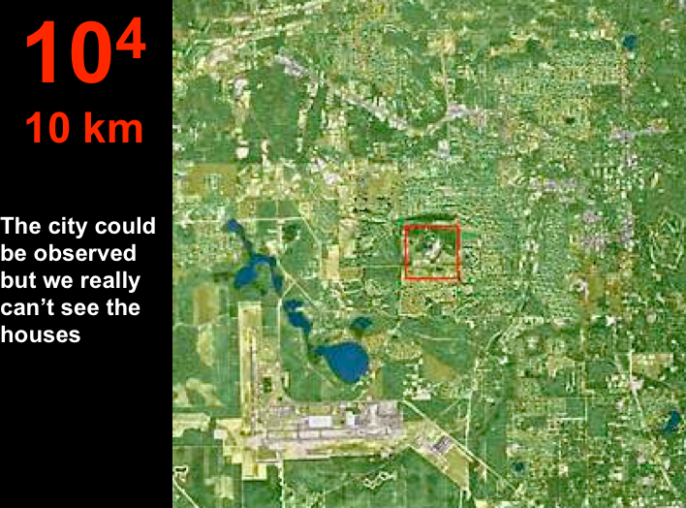
Exploring Concepts: (What is the National Debt?)

Summary: Students will understand what the US government spends tax revenue on after understanding the smaller denominations of money.

Outline:
- The students will understand what they can do with their money
- The students will understand what the government will spend tax revenue on
- The students will understand where the US gets its revenue

Activity: Students will brainstorm everyday examples (5) for 100, 1000, 10,000 and 100,000 going on to a trillion to get them thinking about the size of the national debt. The exercise should help them visualize the large numbers. Next, students will read relevant sections of the Economics text or do research on the Internet to understand terms that are assigned (Gross Domestic Product (monetary value of all goods and services produced in a year) recession (less business growth, depression (low point in the business cycle), inflation (rising prices) and unemployment (lack of jobs); fiscal policy and deficit spending; tax revenue and national debt.) After research is complete, the teacher will instruct students about the current American economic situation. They will view pie graph overheads (see attachment below), to help understand what the US government spends its money on (Loup Canal project is an example of this from the “30’s) and where the revenue comes from and why there is the current deficit.

Questions | Answers
What can you buy with $100?  What happened 100 years ago?  What would 100 people look like in the gym? | Personal items  American history events  Basketball game
What can you buy with $1000?  What happened 1000 years ago?  What would 1000 people look like in the stadium? | Family items  Middle Ages  HS football game
What can you buy with $10,000?  What happened 10,000 years ago?  What would 10,000 people look like at Memorial Stadium in Lincoln? | Business expenses  Migration  Spring FB game
What are examples of 100,000? 1,000,000? 1,000,000,000? | Space travel. Salaries of professional athletes. Cost of military weapons and machines. Cost of Social programs

Attachment:
US Fiscal pie charts: T040_SHINE_What_Is_the_National_Debt_E-O_graphs.doc

Resources:
- http://www.kowaldesign.com/budget/
- www.usdebtclock.org
- “What does a Trillion look like?” YouTube by Eyder Peralta May 17, 2011 & NPR Weekend Edition Saturday, June 4, 2011
Instructing Concepts: (What is the National Debt?)

Economics

Economics is a social science that analyzes the production, distribution and consumption of goods and services. The study of economics considers: how things are produced, distributed, and the decisions that we make about how we use our resources (money, time, natural, human and man-made). Economic theories explain how economies work and how agents of economies interact. Economics analysis can be applied in many diverse areas including: business, finance, government, education, health, politics, and other areas.

There are two main divisions of economics: Microeconomics and Macroeconomics. Microeconomics examines the behavior of individual markets and agents (consumers, buyers, sellers, etc.). Macroeconomics examines issues relating to the entire economy, including inflation, monetary policy, economic growth, and unemployment.

There are three major types of economies. These include: 1) Feudalism (traditional): Wealthy class of landowners and a class of workers, 2) Market: free enterprise or capitalism, and 3) Command: Government decides what is produced. The economy is a mixed economy with three types of business enterprises: Single proprietorship (one owner), partnership (two or more owners) and corporation (chartered by the government and sell shares of ownership).

A major concept in economics is economic trade offs and opportunity cost. Some things to consider are that people make choices because of scarcity (all things are limited). You cannot have everything you want (a luxury) or a need (essential to live), therefore decisions have to be made, in the home and the national as well as the international level. There is a limited supply (amount of a good or service available for sale) and created demand (ability and willingness of people to buy something). What determines price (the value of the product) is the amount of supply relative to the demand for that product.

Economies are cyclic in nature. There are upward (growth) and downward (recession) patterns. One measure of economic health is Gross Domestic Product (GDP) which is the monetary value of all goods and services produced in a year. During times of growth the GDP increases, job creation tends to increase, and businesses expand. During recession, there is less business growth, unemployment rises and the GDP shrinks. A depression is the low point in the business cycle. Concepts that influence the economic cycle are: taxes, government spending, inflation (rising prices), interest rates and unemployment.

Our market economy is a mixture of free enterprise and some government regulation.
The government determines fiscal policy and the amount deficit spending. It sets monetary policy that includes interest rates, tax revenues, and other government spending. Tax revenue comes from a combination income, corporate, property and other forms of taxes. Currently the government spends more than it receives placing the United States in a deficit situation with a growing national debt. Other things that affect the economy in the United States are: international trade, other countries economic decisions, foreign corporations, commodity prices and foreign markets. All these things interact to create a larger world economy, which connects the world, and what happens somewhere else on the globe can have far reaching effects for everyone.
Organizing Learning: (What is the National Debt?)

Summary: Students will understand what the government spends money on (using the Loup Canal project as a personal example) and discuss what happens when the government spends more than it takes in from taxes (debt). After viewing a graph of tax revenue, students will discuss ways in to increase revenue or cut spending.

Outline:
- Students will understand government expenditures per year on defense, social programs, interest, etc. by viewing pie graph slides
- Students will understand how government spending has increased over the years to where it is now

Activity: Students will engage in a class discussion to help them understand the national debt, why it exists, and what it means for America. They will apply economic principles that they learned through discussion and research to propose solutions (proposing cuts in government programs, raising taxes or defaulting on debt payments) to the debt issue. For a summary exercise, students will create a multimedia presentation that illustrates their solutions for the debt problem and be able to defend their proposals in a mock debate.

Attachments:
US Fiscal Pie Charts: T040_SHINE_What_Is_the_National_Debt_E-O_graphs.doc
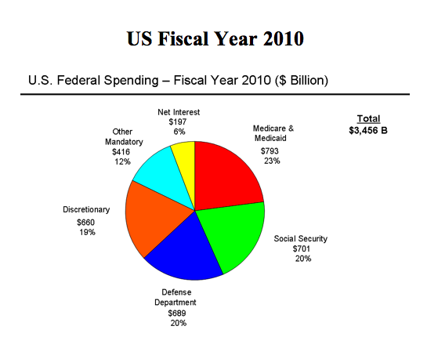

Understanding Learning: (What is the National Debt?)

Summary: Students will understand what the government spends taxpayer funds on, where it gets its revenue, what the national debt is and what can be done to reduce the national debt.

Outline:
- Formative Assessment of Economics
- Summative Assessment of Economics

Activity: Students will complete written and performance assessments relating to economics.

Formative Assessment: While doing activities, will students answer these questions:
- What is the value of money, what can you buy?
- What does the US government spend taxpayer’s money on?
- Where does the US government get its income?
- What is the US government debt?

Summative Assessment: Students can complete the following writing prompt:
Write a short essay to their congressman on what they would do about the national debt: raising the debt ceiling, cutting government programs, raising taxes or defaulting on debt payments.

Students can complete the following performance assessment:
Students will engage in a mock debate with their classmates to defend their position in their essay. Economic principles must be incorporated into the debate to support arguments.

