Project SHINE Lesson:
“Say Again?!?!”
===============================Speech=============================
Lesson Title: Say What?!?!
This Teacher was mentored by:

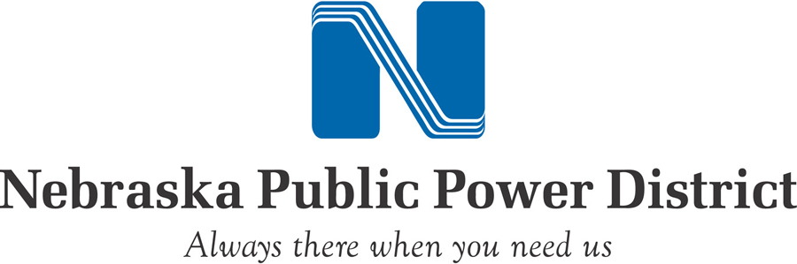
www.nppd.com

and


www.vishay.com

In partnership with Project SHINE grant funded through the

National Science Foundation

Draft Date: July 14, 2011
1st Author (Writer): Amanda Berg
Associated Business: Nebraska Public Power District & Vishay
Instructional Component Used: Communication
Grade Level: Speech 9-12

Content (what is taught):
- Verbal Communication Skills
- Non-Verbal Communication Skills
- The Importance of the Listening Part of Communication

Context (how it is taught):
- Class Discussion
- Small Group Work
- Partner Work
- Building an Object
Activity Description:
Students will begin by exploring the idea of verbal communication. They then will explore the idea of non-verbal communication. They will discuss what it is, and then have the opportunity to practice it. They will demonstrate understanding by communicating directions, and building an object.

Standards:
Math: ME3 Engineering: ED2

Technology: TD2 Science: SA1

Materials List:
- Metal Rings
- Tennis Balls
- Strings
- Rubber Bands
- Straws
- Paper Clips
- Napkins
Asking Questions: (Say Again?!?!)

Summary: Students will each be given one word to a quote. They then must work with their classmates to line up in the correct order to complete the quote. They must continue to work until they get it right. They then will answer questions about the process.

Outline:
- Students will each be given one word of a quote written largely on a piece of paper
- They will work with their classmates WITHOUT TALKING to complete the quote
- They must work until they get it right- the teacher will inform them when they are done
- When they are successful, the teacher will ask them questions about the process

Activity: Students will work together as a class to complete a quote. They will each be given one word to the quote written largely on a piece of paper. They will have to silently without talking and work together to put the words of the quote in the right order. The teacher will inform them when they are done. Discuss what is meant by this quote, “It is not what you said; it is how you said it.” Then prompt the class into discussion by using the following questions:

Questions | Answers
Were you successful? Why? | Collaboration
What made it difficult? | No background info/ not being able to talk
Define communication? | Not just words but using non-verbals
What would you do differently next time? | Answers will vary

Exploring Concepts: (Say Again?!?!)

Summary: Students will work together to move a tennis ball from one end of the room to the other. The tennis ball will be placed on a small metal ring. Attached to the ring are enough strings for the entire class. The only way the students can move the tennis ball is by using the strings. The only verbal communication that can be used is gibberish.

Outline:
- Students will work together to move a tennis ball from one side of the room to the other
- The tennis ball will be placed on a small metal ring with strings attached
- The only way the students can move the tennis ball is by everyone lifting up on the end of their individual strings
- If the ball drops, they must start over
- The only verbal communication that can be used is to speak in gibberish
- When they are successful, discuss the process

Activity: Students will work together to move a tennis ball from one side of the room to the other. The tennis ball will be placed on a small metal ring. Attached to the metal ring are strings that are 7 feet long. Ensure that there are enough strings for the entire class. If your class is larger than 20, make 2 groups. The only way that they can move the ball, is by lifting it up using the end of the strings. If the ball drops, the group needs to start over. The only verbal communication they can use is gibberish. They can use as much verbal communication as they want. If you want to make the activity more difficult, you can blindfold every other student. When the students are successful, discuss the process. What worked? What didn’t? Were you successful? Why? What made the process difficult? Relate it to the business world. Discuss how in the business world, you have to communicate with people from other countries, and the language barrier forces you to be creative in your communication. Also, discuss how sometimes even people who speak the same language struggle to communicate in terminology that they will each understand. For example, when an engineer has to communicate to a machinist, they have to ensure that they are using vocabulary that each other understands.

Resources:
- Metal Rings
- Tennis Balls
- String
Instructing Concepts: (Say Again?!?!)

Communication

Communication is a two-way process related to the transfer of information from one person to another. There has to be an initiator and a receiver for communication to take place. In the most general terms, it can be thought of as the exchange of thoughts, opinions, information, and feelings for the achievement of a common goal.

Communicate Effectively to Multiple Audiences: When communicating information you must be aware of whom your audience is and adapt your methods to fit each unique audience. For instance you would communicate information very differently to a group of business people from the chamber of commerce than a group of middle school students. The content can be very similar but your delivery must be tailored to fit your audience.

Communicate Effectively Using a Variety of Media: Communication in the 21st century is very different than it was even several years ago. When conveying your ideas there are many different technologies available. It could be by e-mail, telephone, web conferencing, texting, blogging, discussion boards, traditional written methods, or verbally. This list is not exhaustive but is presented to show the diversity of communication methods. When choosing the media that you will use to communicate, you should consider the information to be transmitted and your audience very carefully. The reason is to insure that you choose the most efficient and the least likely method to be misunderstood. Remember the goal of communication is the successful transfer of information. If the wrong media type is used it is possible that communication will be ineffective.

Develop Cultural and Global Awareness: In this world with a global economy, rapid travel, instant communication, and instantaneous news it has become critical that we develop a multicultural awareness. The people that we are communicating with may very well have different backgrounds, values, and customs. If we are to understand each other and create quality communication, we must be aware of these differences. This multicultural awareness is a critical component for effective communication. With it communication flows freely in both directions and common goals can be easily achieved. Without multicultural awareness misinterpretations and poor communication will be commonplace.
Organizing Learning: (Say Again?!?!)

Summary: Students will work with a partner to create a random object. One student will have the directions on what to build. They will have to communicate those directions to their partner using gibberish. It will be a race to see which group gets done first. When done, they will have to create a use for the object.

Outline:
- Students will work with a partner to create a random object
- Student 1 will be given 1 straw, 2 napkins, 1 rubber band, and 1 paperclip
- Student 2 will be given the written directions on what to build
- Student 2 is not allowed to touch the pieces. They must communicate to student 1 how to build the object
- The students are only allowed to communicate using gibberish
- Time each group to see who finishes first
- When all groups are done, each pair must create a use for their particular object
- Using the provided directions, the teacher should create the object in advance so they know what the end product is supposed to look like

Activity: Students will work with a partner to create a random object (picture below) Student 1 will be given 1 straw, 2 napkins, 1 rubber band, and 1 paperclip. Student 2 will be given the written directions on what student 1 will be building with the given supplies (directions below). Student 2 is not allowed to touch the pieces, and student 1 is not allowed to see the directions. Student 2 must communicate to student 1 how to assemble the object. The 2 students are only allowed to communicate using gibberish. They are allowed to use as much non-verbal communication as necessary. It will be a race to see who can communicate most effectively and finish first. When the students are successful, discuss the process. What worked? What didn’t? Were you successful? Why? What made the process difficult? Relate it to the business world. Discuss how in the business world, you have to communicate with people from other countries, and the language barrier forces you to be creative in your communication. Also, discuss how sometimes even people who speak the same language struggle to communicate in terminology that they will each understand. For example, when an engineer has to communicate to a machinist, they have to ensure that they are using vocabulary that each other understands. When discussion is done, each pair must create a use for their particular object, and then share it with the class. It needs to be a unique device that has yet to be created.

Assembly Directions:
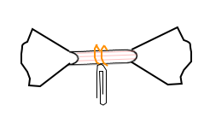

Supplies: 1 rubber band, 1 straw, 2 napkins, 1 paperclip

- Take the straw
- Wrap the rubber band around the middle of the straw 2 times
- Stick 1 napkin in each end of the straw
- “Fluff” the napkins out on each end
- Attach the paper clip to the middle of the rubber band so it dangles freely

Resources:
- Paper Clips
- Rubber Bands
- Straws
- Napkins
Understanding Learning: (Say Again?!?!)

Summary: Students will demonstrate an ability to communicate using non-verbals. They will understand that when communicating, most of what you say has nothing to do with the words that you use.

Outline:
- Formative Assessment of Communication
- Summative Assessment of Communication

Activity: Students will complete written and performance assessments.

Formative Assessment: As students are engaged in the lesson, ask yourself these or similar questions:
- Do students understand the concept of non-verbal communication?
- Are students able to effectively communicate using non-verbal communication?
- Can students define and apply communication skills?

Summative Assessment: Students can complete the following writing prompt:
Explain what communication is and what part non-verbals play in the communication process.

Students can complete the following performance assessment:
Students will create a new object using a rubber band, a paper clip, a straw, and 2 napkins. They must write up directions on how to assemble the object, make a prototype of the object, create a name and explain its purpose. When they are done, students must communicate about the object to their peers in a presentation.

