==================== Attachment Sample ====================
Download the DOC or PDF file to access the full document

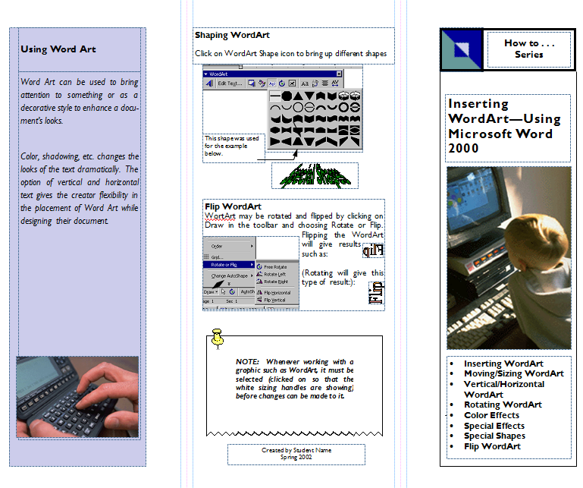
Sample Word Art Brochure

