SHINE Lesson:
Communicating Through the Noise
==========================Lesson Header ==========================
Lesson Title: Communicating Through the Noise
Draft Date: 6/11/12
1st Author (Writer): Jared Berg
Instructional Component Used: Communication
Grade Level: 8-12 Grade

Content (what is taught):
- Identify forms of non-verbal communication
- Following a process of directions conveyed non-verbally
- Create a non-verbal presentation to convey a process of information to other students

Context (how it is taught):
- Students will brainstorm different forms of non-verbal communication and determine how effective this form of communication is for classmates and co-workers
- Students will communicate non-verbally through a factory noise simulation and through a presentation
Activity Description:
In this lesson, students will identify different forms of non-verbal communication and be required to utilize these various forms through a variety of activities. Students will first attempt to communicate directions to others in a noisy environment that does not allow verbal communication; additionally, students will be required to follow non-verbal directions in a presentation as well as create a presentation of their own detailing how to complete a process of interest to the student using only non-verbal communication.

Standards:

Technology: TB2 Engineering: ED2

Materials List:
- Ear plugs
- Noise CD
- Computer/projector with PowerPoint capability
Asking Questions: (Communicating Through the Noise)

Summary: Students are asked to respond in writing to several questions over communication posed by the instructor electronically through instant messaging or a class blog.

Outline:
- Explain to students that no talking is expected for this activity, all questions/responses should be shared, in writing, through the class blog
- Instructor poses the questions listed below online and guides discussion around those questions

Activity: Each student is provided with a laptop/desktop computer and expected to participate in the class blogging activity by responding to questions, in writing, posed by the instructor. Students are also encouraged to respond to their peer’s comments.

Questions | Answers
What is communication? | Communication is a two-way process related to the transfer of information from one person to another.
What environmental issues might inhibit communication? | Noise, lighting, etc.
How might people communicate without using words (non-verbal) in a noisy environment? | Hand gestures, reading lips, facial expressions
What forms of non-verbal communication have you used this week? | Wave to a friend, smile, body language

Materials:
- Computers with internet capability
Exploring Concepts: (Communicating Through the Noise)

Summary: Students will participate in a factory simulation using non-verbal communication to instruct each other in a particular task.

Outline:
- Half of the students are given a specific set of directions they must communicate to their partner before beginning the activity
- Students are divided into groups of 2 (partner 1 is the instructor who gives the directions; partner 2 is to complete the task) and placed 5 feet away from each other
- Earplugs are put on and factory sounds CD begins; partner 2 is given the materials needed to complete the task
- Partner 1 attempts to communicate the directions given at the start of class to partner 2 without using verbal words

Activity: Half of the class is given a specific set of directions (For example, students may be given the written directions for tying a half-Windsor knot tie (see link below)) before beginning the activity. Students are placed in groups of two and are each given a pair of earplugs. A CD of background noise is played loudly to simulate the factory sounds that might be experienced in a manufacturing plant. Students are required to stand 5 feet away from each other in their own taped off area; neither partner may leave this area during the activity. Each partner has a job. The first partner is to pass on the information given to them by the instructor at the beginning of class to their partner across the barrier without using verbal communication. The second partner’s job is to complete the assigned task without communicating to their partner verbally. Students will debrief this activity through a group discussion over the potential difficulties of non-verbal communication.

Resources/Materials:
- Ties for students to use during activity
- Directions on how to tie a half Windsor knot: http://www.tieanecktie.com/HalfWindsorKnot.php
Instructing Concepts: (Communicating Through the Noise)

Communication

Communication is a two-way process related to the transfer of information from one person to another. There has to be an initiator and a receiver for communication to take place. In the most general terms, it can be thought of as the exchange of thoughts, opinions, information, and feelings for the achievement of a common goal.

Communicate Effectively to Multiple Audiences

When communicating information you must be aware of whom your audience is and adapt your methods to fit each unique audience. For instance you would communicate information very differently to a group of business people from the chamber of commerce than a group of middle school students. The content can be very similar but your delivery must be tailored to fit your audience.

Communicate Effectively Using a Variety of Media

Communication in the 21st century is very different than it was even several years ago. When conveying your ideas there are many different technologies available. It could be by e-mail, telephone, web conferencing, texting, blogging, discussion boards, traditional written methods, or verbally. This list is not exhaustive but is presented to show the diversity of communication methods. When choosing the media that you will use to communicate, you should consider the information to be transmitted and your audience very carefully. The reason is to insure that you choose the most efficient and the least likely method to be misunderstood. Remember the goal of communication is the successful transfer of information. If the wrong media type is used it is possible that communication will be ineffective.

Develop Cultural and Global Awareness

In this world with a global economy, rapid travel, instant communication, and instantaneous news it has become critical that we develop a multicultural awareness. The people that we are communicating with may very well have different backgrounds, values, and customs. If we are to understand each other and create quality communication, we must be aware of these differences. This multicultural awareness is a critical component for effective communication. With it communication flows freely in both directions and common goals can be easily achieved. Without multicultural awareness misinterpretations and poor communication will be commonplace.
Organizing Learning: (Communicating Through the Noise)

Summary: After viewing a model communication presentation, students will create their own presentation using non-verbal communication such as written text and images to teach a particular process to their classmates.

Outline:
- Students view an instructor-generated presentation and follow directions to complete the step-by-step process
- Students select a process they know and understand as a topic for their presentation
- Students complete the 5-step worksheet detailing their process step-by-step
- 5-step worksheet is reviewed by instructor
- Photos are taken or gathered online of each step in the process to be incorporated into the presentation
- Presentation is completed

Activity: The instructor will show the presentation (see attached file) explaining through written text and images how to tie a half-Windsor knot to all students without speaking to them verbally. Students should follow the directions in the presentation to complete the task being described in the presentation. Following this, students will debrief their success and critique the clarity of the directions given.
Students are then asked to select a process that they are familiar with and find interesting (shooting a basketball, braiding hair, etc.) to teach to their peers through a form of non-verbal communication. After gaining approval for their topic from the instructor, students must complete the 5-step worksheet before they create a PowerPoint presentation of their own using text and photos. Their presentation should demonstrate a step-by-step process for achieving their desired result.

Attachment:
- T059_SHINE_Communicating_Through_Noise_O_Presentation.ppt
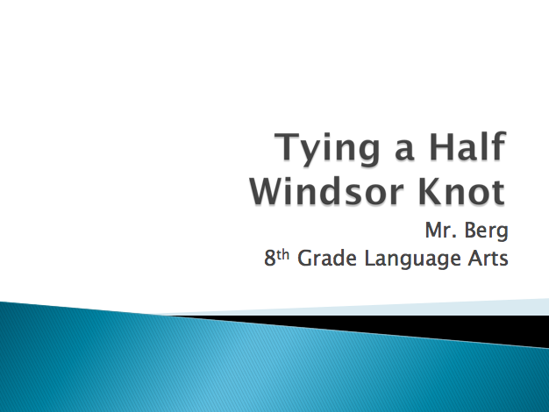
Understanding Learning: (Communicating Through the Noise)

Summary: Students will demonstrate their understanding of non-verbal communication by listing five modes of non-verbal communication and explaining the influence of non-verbal communication in the real world.

Outline:
- Formative Assessment of Communication
- Summative Assessment of Communication

Activity: Students will complete written and performance assessments of communication (non-verbal).

Formative Assessment: As students are engaged in the lesson ask these or similar questions:
- Do students understand how to communicate a process non-verbally?
- Are students able to follow non-verbal directions to complete a task?
- Can students explain what non-verbal communication is?

Summative Assessment: Students can answer one of the following writing prompts:
- List 5 examples of ways people are able to communicate non-verbally.
- In one paragraph, explain how non-verbal communication (such as body language) can impact the message you are trying to convey to a classmate.

Students can complete the following performance assessment:
Students will participate in a game of charades to display their understanding of non-verbal communication.

