SHINE Lesson:
Universal Ethics
==========================Lesson Header ==========================
Lesson Title: Universal Ethics
This Teacher was mentored by:

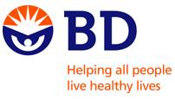
www.bd.com

In partnership with Project SHINE grant funded through the

National Science Foundation
Draft Date: 6/11/12
1st Author (Writer): Jared Berg
Associated Business: BD Medical
Instructional Component Used: Soft Skills
Grade Level: 8-12 Grade

Content (what is taught):
- Identify ethical behaviors
- Understand behavioral expectation in school and work
- Analyze similarities in behavioral expectations between school and work

Context (how it is taught):
- Students will discuss the meaning of ethical/behavioral expectations.
- Students will discuss the features of productive employees in a business setting.
- Students will compare ethical expectations in school and business.
Activity Description:
In this lesson, students will identify the types of ethical behaviors expected in school and business. They will discuss the meaning of ethical/behavioral expectations, and be responsible for comparing the expectations in school to those behaviors expected in the business/industry sector.

Standards:

Science: SE2 Technology: TE1

Materials List:
- Management simulation PowerPoint
- BD Core Values
- CMS Student Performance Goals
Asking Questions: (Universal Ethics)

Summary: Students participate in a discussion over ethics and its importance in school, online, and in the workplace.

Outline:
- The instructor poses questions to the students
- Students take turns answering/responding to each question and other student’s comments

Activity: Students will be asked to respond to the following questions verbally and participate in the discussion each question creates.

Questions | Answers
What is ethics? | Ethics is a discipline that is concerned with the morals and values relating to human conduct with respect to right and wrong.
How is ethics important in school? | There are consequences for your behavior, completing schoolwork, etc.
How is ethics important for workers in a job? | People must be treated fairly and create a quality product if they expect to stay employed.
Exploring Concepts: (Universal Ethics)

Summary: Students are placed into management groups to undergo a management simulation asking them to gauge the importance of soft-skills in a work environment.

Outline:
- Students are placed into management teams consisting of four people
- One by one, the instructor poses questions concerning an employee working for the management team
- Each management team discusses the question and comes to agreement, they then write down their response for each question
- The entire class debriefs by discussing their answers for the management team questions.

Activity: Students are placed into four person management teams. They then participate in a management simulation (see attachment) that asks them to consider and discuss the types of behavior they would expect from potential employees working for them. This simulation requires students to consider how they would respond when potential employees make mistakes in the workforce, and requires students to consider which mistakes are serious enough to merit termination.

Attachment:
- T060_SHINE_Universal_Ethics_E_Simulation.ppt
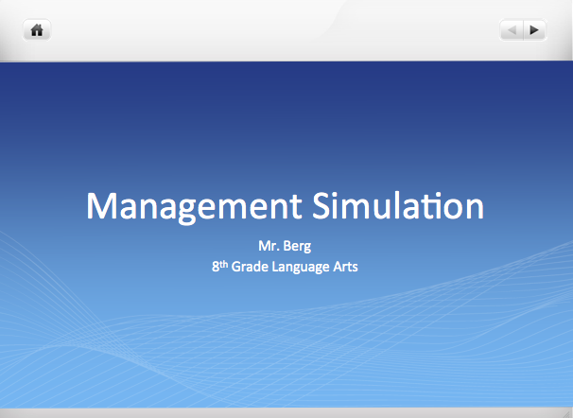
Instructing Concepts: (Universal Ethics)

Soft Skills

Definition:
Soft skill is a general term for behavioral skills difficult to quantify or measure, but they greatly influences the quality of the work place environment. In sociological terms, soft skills are referred to as the EQ (Emotional Intelligence Quotient) or the individual’s personal attributes often called “interpersonal skills” or “people skills”. Soft skills can be refined and developed within an environment of support, frequent feedback, encouragement and reinforcement.

Types of Soft Skills:
Please note the list below is a sample list of common soft skills, but is not an extensive list.
1. Communication Skills: Communication is the ability of a person to convey and comprehend messages sent by one to another. These messages include not only information, but also a personal tone (i.e. welcoming, affirming, friendly, formal etc.).

2. Flexibility/Adaptability: Flexibility is the willingness (attitude) and adaptability is the ability (aptitude) of a person to adjust, change, or modify when circumstances alter in an environment.

3. Lifelong Learner: Lifelong learning is the willingness of a person to continue seeking growth through developing knowledge and skills.

4. Positive Attitude: A positive attitude is the ability of a person to exude optimism as well as remain cooperative and congenial when circumstances become challenging.

5. Professionalism/Respect: Respect is the ability to personally interact with others in a mature manner that honors another’s dignity, personhood, and/or position. Professionalism is the demonstration of respect within the workplace environment.

6. Punctuality/Reliability: Punctuality is the ability to demonstrate consistency in schedule following behavior, while reliability is the ability to demonstrate consistency in task accomplishing behavior.

7. Self-motivated: Self-motivation is the ability to take initiative without outside monitoring or enforcement.

8. Team Work: Teamwork is the willingness to cooperate and collaborate with others to accomplish a common objective.

9. Time Management: Time management is the ability to prioritize and monitor one’s productive activity.

10. Work Ethic/Integrity: Integrity is high moral character exhibited in principled decision-making and actions. Work ethic is work accomplished with integrity or principled driven ownership in accomplishing a task to meet quality standards.
Organizing Learning: (Universal Ethics)

Summary: In groups, students will discuss and determine the meaning of each core value a business expects of its employees. They will then compare the behavioral expectations of business/industry with the expectations in their own school.

Outline:
- Divide students into groups based on the number of core values your chosen business has (BD Medical has four core values so I will place four students in each group)
- Display businesses core values on the board for all students to see
- Each student leads a discussion over the meaning of one of those core values
- Each student reports to the whole group their understanding of the core value they discussed
- Students compare local business’s values with their school’s behavior expectations
- Students will summarize their findings in writing

Activity: The instructor begins by dividing students into groups and displaying the core values of their selected business on the board. As an example, BD Medical has four core values (listed below). Students are instructed to discuss in groups what each of the core values means to the employees at that business. Each member of the group is responsible for leading the discussion, writing down comments, and presenting their understanding for 1 of the core values to the entire class.

Next, students are given a Venn diagram to compare the local business’s core values with the Student Performance/Behavior Goals for their school. As an example Columbus Middle School’s Student Performance/Behavior Goals are listed below. Once they have finished comparing/contrasting the business/school values, students will summarize their findings in a three-paragraph essay. The first paragraph will contain the introduction and summarize the activity; the second paragraph will discuss similarities between school/business behavior expectations; and the third paragraph will discuss differences in school/business behavior expectations as well as reasons why these expectations might differ between a school and business setting.

Resource:
- Venn Diagram

BD Medical Core Values  - Treat others with respect  - We do what is right  - We always seek to improve  - We accept personal responsibility | Columbus Middle School Student Performance Goals  - Arrive to class prepared and on time  - Use work time appropriately  - Complete assigned tasks on-time with proficiency  - Demonstrate respect for people and property  - Respond appropriately to staff directives
Understanding Learning: (Universal Ethics)

Summary: Students will demonstrate their understanding of behavioral expectations by explaining why non-productive behaviors might be dangerous in a working environment and listing four essential behavior expectations for productive employees.

Outline:
- Formative Assessment of Soft Skills (Ethics)
- Summative Assessment of Soft Skills (Ethics)

Activity: Students will complete written assessments on soft skills (ethics).

Formative Assessment: As students are engaged in the lesson ask these or similar questions:
- Are students able to communicate characteristics of productive employees?
- Can students recognize similarities in behavioral expectations between school and manufacturing plants?
- Can students explain the importance of ethics in and business and school?

Summative Assessment: Students can answer one of the following writing prompts:
- Select one of the following topics and write a one-paragraph response explaining why that particular behavior may be dangerous for employees in a work environment.
- Theft
- Violence
- Tardiness
2) List four essential behavior expectations for productive students in a classroom as well as
productive employees in a business.

