Scratch Blocks with descriptions

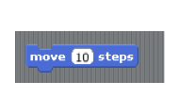 | 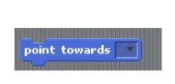 | 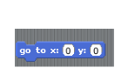
Moves sprite | Positions sprite towards certain part of stage | Tells sprite to go to a certain part of coordinate graph
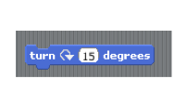 | 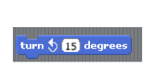 | 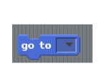
Rotates sprite on its axis clockwise | Rotates sprite on its axis counterclockwise | Instructs sprite to move to part of graph
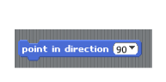 | 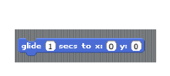 | 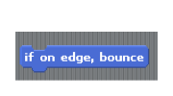
Points sprite in direction | Moves sprite in continuous motion | Tells sprite to bounce of edge if it hits it
 |  | 
Tells sprite to repeat instruction forever | Tell sprite that If something happens. Do this set of instructions | Tell sprite to do instructions if green flag is clicked on stage
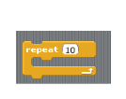 | 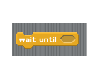 | 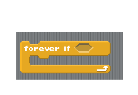
Tells sprite to repeat instructions so many times | Tells sprite to wait until something happens to complete instructions | Tells sprite to continue movement forever if something happens
 | 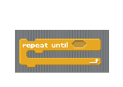 | 
Tells sprite to follow directions when the space bar is clicked (or selected key) | Tells sprite to repeat until something happens | Tells sprite to do instructions if it’s clicked
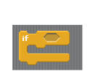 |  | 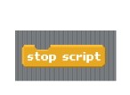
If something happens sprite follows directions | Tells sprite to wait certain amount of time before doing instructions | Tells sprite to stop following set of directions
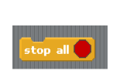 |  | 
Tells program to completely stop | Tells sprite that if it’s touching edge/other sprite | Tells sprite to randomly move
 | 
 | Follows sprite with a pen marking

