RET Lesson:
Hiding in Plain Sight
==========================Lesson Header ==========================
Lesson Title: Hiding In Plain Sight: The Sound of Steganography

Draft Date: July 16, 2012
1st Author (Writer): Therese Laux
Instructional Component Used: Steganography
Grade Level: 9 - 12

Content (what is taught):
- Definition of steganography and its application for secure communication
- Low-tech methodologies to employ steganography
- High-tech methodologies to employ steganography
- How music may be employed in steganography

Context (how it is taught):
- Reading and discussing selected materials on steganography
- Student examination of steganography examples
- Application of music to steganography to hide a message
Activity Description:
Students will explore the concept of steganography and how it has been used historically and today. They will learn about the various ways music can be employed in steganography. Finally, students will use the language of music to hide information through print music and/or audio files.

Standards:

Math: MB1 Science: SE1

Technology: TA1 Engineering: EB5

Computer Science: CT:L2:7, CT:L2:15, CT:L3:CP:7, CL:L2:1, CL:L2:2, CL:L2:3, CL:L2:4, CCP:L2:2, CCP:L2:6, CCP:L3:CP:5, CCP:L3:CP:6, CI:L1:6:1, CI:L1:6:2. CI:L1:6:4, CI:L2:5, CI:L3:MW:10, CI:L3:CP:1, CI:L3:CP:2, CI:L3:CP: 6

Materials List:
Materials list is flexible. Most learning environments will have what is necessary.
- Internet access to obtain reference materials
- Staff paper, pen, pencil
- Piano or other musical instrument
- Computer with music notation software
- Computer with MIDI keyboard controller
- Digital audio recorder
Asking Questions: (Hiding in Plain Sight)

Summary: The possibility exists that students may have no experience with steganography. In order to facilitate discussion, the teacher may present students with a brief overview of what steganography is, ways in which steganography has been used throughout history, and how it is used today.

Outline:
- Brief overview of steganography
- Questions and scenarios related to historic usage of steganography
- Class discussion about how steganography could be used today

Activity: The teacher will present a brief overview of what steganography is and ways in which steganography has been used throughout history. Questions and scenarios will be posed to students that relate to how steganography has been used throughout history. Finally, students will discuss what they learned about the topic of steganography and how it may be in use today.

Questions | Answers
What is steganography? | Steganography is a method for concealing information within seemingly innocent media.
Why would information need to travel securely? | The information is sensitive, or any time you would not want anyone else to know your information (personal, financial).
If you had to deliver a “secret message,” what are some low-tech ways you could do so? | Invisible ink, writing in code, speaking in a foreign language
Where can information be hidden electronically? | Information can be hidden in text, disc space, network packets, software & circuitry, and audio and images.
01010111011010000110000101110100001000000110100101110011001000000111001101110100011001010110011101100001011011100110111101100111011100100110000101110000011010000111100100111111

Translation: What is steganography?
Exploring Concepts: (Hiding in Plain Sight)

Summary: Various examples of steganography will be presented to the group. Using this knowledge, students will be challenged to discover hidden messages in presented examples of steganography.

Outline:
- The teacher will share with the students low-tech examples of steganography
- Presented with documents using steganography, students will identify the technique used and decode the message

Activity: The teacher will provide a brief overview of steganography and share examples (see attached file) of different techniques. Students will be presented with documents (see attached file) and challenged to identify the steganographic technique used. Students may work alone or in groups to decode the messages.

Attachment:
- Steganography Examples: T065_RET_Hiding_in_Plain_Sight_E_Examples.doc
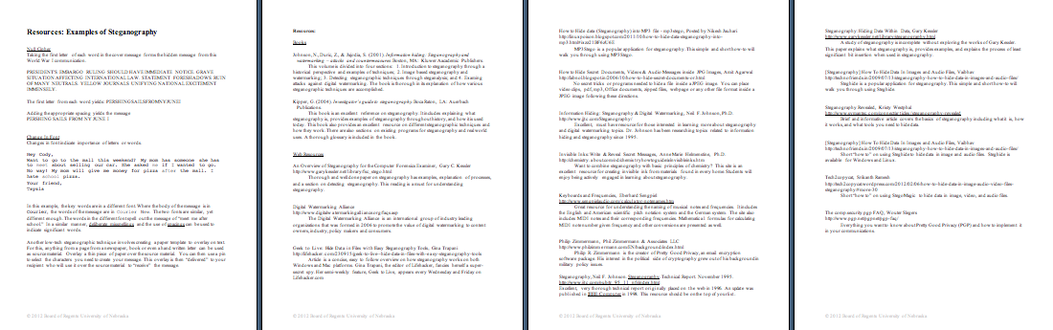
Instructing Concepts: (Hiding in Plain Sight)

Steganography

Steganography is a method for concealing information within seemingly innocent media. The true craft comes from sending the information in a manner so that only the sender and the intended recipient realize its existence. Steganography may be as simple as altering the language of a message. It can also involve using a “container,” such as a jpg image, to carry a “cargo” of data, such as a text file. However the message is concealed, the art is in hiding the data in plain sight so as to hide its true intention. With steganography, seemingly unaltered images, video files, sound files, and even blank disc space can all inconspicuously carry extra data.

History of Steganography: The first recorded use of steganography dates back to the early Greeks and the ruler, Demaratus. As king of Sparta, Demaratus ruled from 515 to 491 B.C. At this time, it was common to write on waxed tablets. To communicate a warning of an impending attack on Greece by the Persian ruler Xerxes, Demaratus scraped the wax off of a wooden tablet, inscribed a message, and then covered the tablet in wax once again. In this way, the tablets carried secret information to the intended recipient without arousing suspicion. Other times of conflict are rich with examples of steganography. The Underground Railroad used quilt patterns to direct slaves on their journey northward, cryptographic writing was used numerous times in both World War I and II, and it is suspected the terrorists of 9-11 communicated through messages hidden in jpg images. Even gang graffiti can covertly pass information.

Methodology: To employ a steganographic technique, begin with a “carrier” to conceal the data. The carrier could be an image, text , or audio file. Insert the “cargo” into the carrier. The cargo is often encrypted to allow for an even greater degree of security. The finished file will be in the same format as the carrier.

Example Techniques of Steganography
Color → Letter Conversion: Colors: Every color on a computer is represented as a mixture of red, green and blue colors. Since everything is digital, at its rawest level, these colors are simply binary 0s and 1s.
Letters: Similarly to colors, every letter on the keyboard or in a message has a binary representation based on the ASCII standard. For example, the letter ‘A’ is the number 65 on the ASCII conversion chart. One easy way to hide information in an image is to simply change an entire color to the number from a single letter. For example, say you wanted to hide the message “Hello World” in an image. We could find the ASCII value of each of those letters and change the Red value of every 13th pixel to match that data. This method will leave visual artifacts of the modification.
Least Significant Bit: This method is much more difficult to detect but also more difficult to implement. In the least significant bit (LSB) method, we change rightmost bit of each color to match our data. For example in the pixel color (Red = 178, Green = 216, Blue = 222) if we switch to the binary values we get: (10110010, 11011000, 11011110). Since the letter ‘H’ is ASCII 72 is 01001000 in binary, we can begin hiding the data from this ‘H’ across the red, green and blue of many pixels in the rightmost bit by making this change: 10110010, 11011001, 11011110. The next pixel would have the right three bits values be changed to 0, 1, 0 with the remaining values of H’s ASCII in the next pixel’s right most bits. This process can be continued to hide an entire message.
Organizing Learning: (Hiding in Plain Sight)

Summary: Students will use techniques of steganography to hide data within print music or an audio file.

Outline:
- Students will organize a relationship between letters of the alphabet and musical pitches.
- Using the established relationships a product to hide data using steganography will be created.

Activity: Students will use the language of music to develop a steganographic technique for hiding information. This begins by developing a relationship between pitch and the letters of the alphabet. For example, letter A = pitch F3, B = F#3, and so on. The system students create can start on any pitch they designate and move in an ascending, descending, or random order. This system is what will be used to “write” a message.

Once the message is written, the final product can be in print or digital audio format. Possible mediums for the final product are:
- Sheet music: The message is a melodic line either hand-written on a staff, or produced with music notation software.
- Digital audio file: The message is a single melodic line played on an instrument or sung. This is recorded digitally, and the final form of the message is a digital audio file.
- Digital audio file (advanced): Using GarageBand or other digital music production software, the message is recorded on a single melodic line. Additional background tracks are recorded to create a musical product. This is exported as a digital audio file and/or print music.

The message can be a single melodic line written on staff paper. Students can also use an instrument to play the melodic line, and record this in a digital format. Audio production software will allow students to record the melodic line and background tracks, and export this as a digital file.

Resources:
Materials list is flexible. Most learning environments will have what is necessary.
- Internet access to obtain reference materials
- Staff paper, pen, pencil
- Piano or other musical instrument
- Computer with music notation software
- Computer with MIDI keyboard controller
- Digital audio recorder
Understanding Learning: (Hiding in Plain Sight)

Summary: Students will demonstrate their understanding of steganography, especially in its application to music.

Outline:
- Formative Assessment of Steganography
- Summative Assessment of Steganography

Activity: Students will complete written assessments related to steganography.

Formative Assessment: As students are engaged in the lesson, ask these or similar questions:
- Are the students constructing a working relationship between the letters of the
alphabet and musical notes?
- Are students using a MIDI keyboard controller to input information?
- Are students using music notation software to input information?

Summative Assessment: Students can answer one of the following writing prompts:
- What are some different methods of steganography?
- How may steganography be used today?
- How could you use the language of music to develop a steganographic technique for hiding information?

