RET Lesson:
Graph Theory in Drama
==========================Lesson Header ==========================
Lesson Title: Graph Theory in Drama
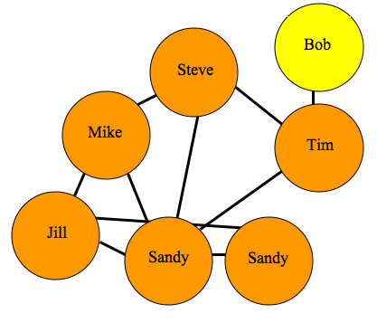
Draft Date: 7/18/2012
1st Author (Writer): Ramsey Young
Instructional Component Used: Graph Theory, Drama/ Literature, Social Networking
Grade Level: Secondary 9-12
Content (what is taught):
- Introduction to Graph Theory
- Dramatic/ Literary Analytics
- Data Analysis of Social Networking

Context (how it is taught):
- Students explore the practical concepts of graph theory through questioning
- Students practice the application of graph theory charting personal social networks
- Students create a social graph for a dramatic text.
- Students derive meaning from the graphs they have created and craft an essay explaining the results.
Activity Description:
Students will use graph theory to create social graphs for their own social networks and apply what they have learned to create a graph representing the social dynamics found in a dramatic text. Students will then derive meaning based on what they know about the text from the graphs that they have created.

Standards:

Math: MB1, MC4 Science: SA1, SA2, SE2, SF5

Technology: TC2, Engineering: EA1

Computing: CT: L2:7, CT: L2:8, CT: L2:11, CT:L3:MW:1, CT:L3:MW:9, CT:L3:MW:11, CT: L3:CP:5, CT: L3:CP:6, CL:L2:4, CCP:L2:2, CCP:L2:3, CCP:L3:CP:1, CCP:L3:CP:7, CI:L3:MW:2, CI:L3:CP:4

Materials List:
- Any play or piece of literature rich in dialogue (Classic drama available for free via the Internet)
- Computer Access - Software
- Microsoft Office (Word and Excel) or Google Docs
- Cytoscape (Free downloadable software http://www.cytoscape.org/)
Asking Questions: (Graph Theory in Drama)

Summary: Students begin to look at concepts of graph theory. Questioning is used to lead students to think about graph structures, purposes and layouts.

Outline:
- Students are asked questions
- Students both answer and draw theoretical answers to the questions
- The whole class discusses the answers and begins to look at implications of the theories

Activity: Students respond to questions both through writing and drawing graphics. The class discusses the answers and refines the concepts discussed. The teacher should guide discussion in the desired direction during this portion of the class.

Questions | Answers
How do people define who is in a relationship with another person? | Relationships are defined by communication.
How can we mathematically determine the quality of a relationship? | Quantity vs. quality of communication. Quantity builds quality.
How can a relationship be represented in a graph? | Nodes, edges, connections.
How can a relationship be tracked in a piece of literature? | Quantity of communication between characters.
What character has the greatest social impact? | A character who communicates with large numbers of other characters. A character who does something significant.
What variables on a graph can we change to represent importance of a character? | Size of nodes. Color of nodes.
What are some real world social relationships that can be tracked in this way? | Social groups, advertising research, social networks (facebook, myspace, twitter…)
What is the practical side of discovering who has the greatest social impact in real life? | Advertising, identifying trend setters vs. followers, understanding people(human science).

Exploring Concepts: (Graph Theory in Drama)

Summary: Students explore graph theory by mapping their own social networks.

Outline:
- Students are given the handout explaining how to collect and apply data
- Students independently gather data using their social media
- Students use the data gathered to create a Cytoscape graph of their social network

Activity: Students will use the ideas explored for collecting data to graph social networks to look at their own network of friends. Using the worksheet provided (see attached file: T066_RET_Graph_Theory_Drama_E_Wrksht.doc), students will track their social network of choice. Facebook is the preferred network but should a student not have Facebook other networks can be substituted. If a student has no social network to track they may tally the interactions they have throughout the course of a day. This will prove to give the students better direct interaction tracking, however, Facebook is more directly poignant to the next activity since it is restricted strictly to dialogue.
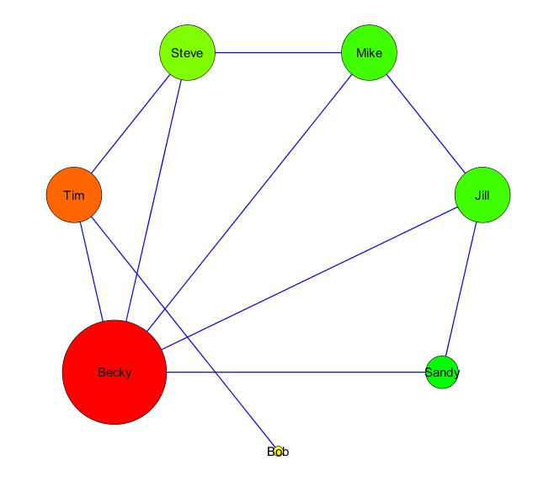

Attachment:
- T066_RET_Graph_Theory_Drama_E_Wrksht.pdf
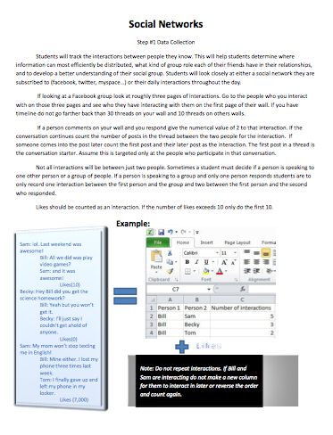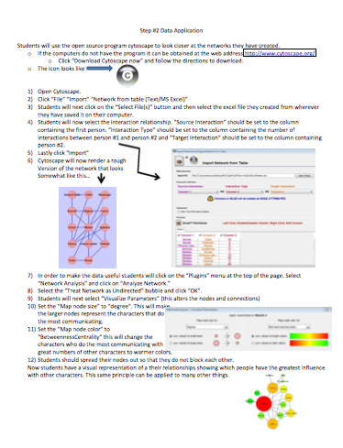
Instructing Concepts: (Graph Theory in Drama)

Graph Theory
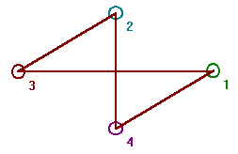
Graph theory is the mathematical study of graphs. A graph consists of a set or collection of vertices or nodes and a set or collection of edges that connect the vertices. As an illustration, a graph defined by vertex set V={1, 2, 3, 4} and edge set E={(1, 3), (1, 4), (2, 3), (2, 4)} would have the diagram shown to the right. Vertices that are connected by an edge are said to be adjacent. The degree of a vertex is the number of edges connecting to the vertex as an end point. In the example graph to the right, all vertices have a degree of 2. Some of the different types of graphs are the complete graph and the regular graph. A complete graph is a graph where every vertex is adjacent to every other vertex. A regular graph has the same degree on all vertices.

$\begin{matrix}0 & 0 & 1 & 1 \\ 0 & 0 & 1 & 1 \\ 1 & 1 & 0 & 0 \\ 1 & 1 & 0 & 0\end{matrix}$An adjacency matrix for a graph with n vertices is an n x n matrix where entry (i, j) is 1 if there is an edge in the graph between vertex i and j, otherwise the entry is 0. The adjacency matrix shown to the right is for the graph shown above.

An adjacency list for a graph has a row for each vertex and contains the vertex label followed by the vertex labels of adjacent vertices. The adjacency list for the graph above would be:

A path in a graph from vertex v to u is a sequence of edges where the first edge starts at v, each successive edge connects to the previous edge, and the final edge terminates at u. A path from 1 to 2 in the graph above would be: (1, 3), (3, 2). A vertex v is reachable from vertex u, if there is a path from v to u. A graph is connected, if every vertex is reachable from every other vertex, otherwise the graph is considered disconnected.

A graph traversal is the process of visiting every vertex of a graph. There are a number of algorithms or methods of graph traversal with the most common being depth first search (DFS) and breadth first search (BFS). Considering a given node as the parent and connected nodes as children, DFS will visit the child vertices before visiting siblings, where as BFS will visit the sibling vertices before the child vertices. DFS and BFS have their own special applications. DFS for example is useful in creating or solving mazes. BFS is more useful finding a winning strategy in games. (Courtesy of Steve Hamersky, 2012)

Attachment:
DFS and BFS Algorithms: I_Tech_020_Graph_Theory_DFS_BFS_Algorithms.doc
Organizing Learning: (Graph Theory in Drama)

Summary: Students explore graph theory by mapping the networks that they discover by reading drama texts.

Outline:
- Students are given the handout explaining how to collect and apply data
- Students gather data using an assigned play to be determined by the teacher
- Students use the data gathered to create a Cytoscape graph of the social networks in dramatic texts

Activity: Students will use the ideas explored for collecting data to graph social networks in drama. Using the worksheet provided, (see attached file: T066_RET_Graph_Theory_Drama_E_Wrksht_O_Drama_networks_wrksht.doc) students will track the social network of a play. Students should put their data into an excel spreadsheet so that it may easily be entered into Cytoscape.

Resources:
- Greek drama and Shakespeare have both been examined in the past, but any play lend itself to this activity.

Attachment:
- T066_RET_Graph_Theory_Drama_O_Drama_networks_wrksht.pdf
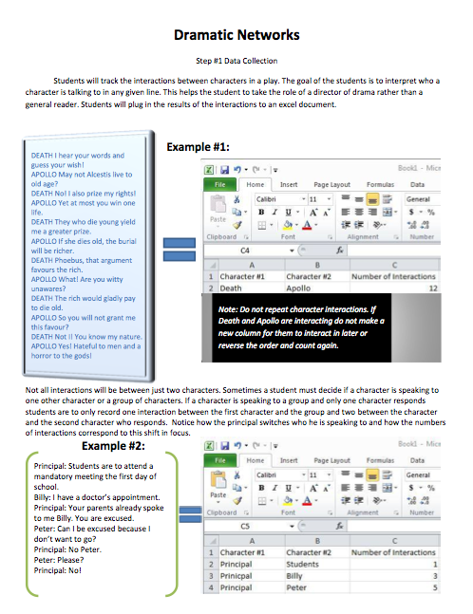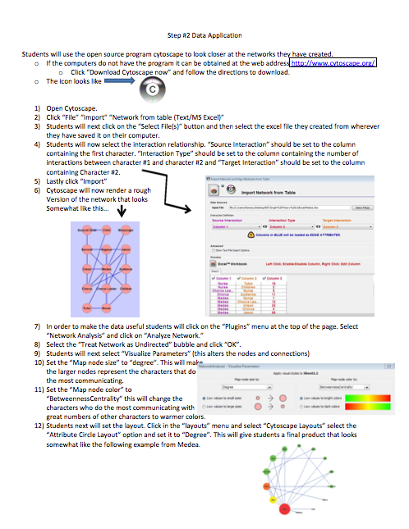
Understanding Learning: (Graph Theory in Drama)

Summary: Students take the graphs that they have constructed and interpret what is the significance of the data.

Outline:
- Formative Assessment of Graph Theory
- Summative Assessment of Graph Theory

Activity: Students will complete written and performance assessments related to graph theory.

Formative Assessment: As students are engaged in the lesson ask these or similar questions:
- Were students able to identify their connections correctly?
- Do students know what nodes of a network are?
- Can students explain what betweeness centrality tells you about the people in your graph?
- Do students know what degree of interaction in a graph is?

Summative Assessment: Students can complete the following writing prompts.
- Explain how you can apply a mathematical concept like graph theory to literature and what you can learn from that application.
- Students can complete the following performance assessment. Pick a dramatic text, chart the relationships in the text and apply graph theory to that text the Cytoscape software. As you interpret your findings answer these questions. What has this graph taught you about the different character’s roles in the play? Who are the most socially crucial characters in the play? Did this coincide with your pre reading expectations? What do the degree and betweeness centrality statistics tell you about how characters should be represented in a play? Use specific examples. As a summation of the assignment, write an essay detailing your findings. The essay requirements are: two pages double spaced with 0 set for before and after spacing, size 12 Times New Roman font, margins set to the standard setting for Word.

