RET Lesson:
Making The Connection
==========================Lesson Header ==========================
Lesson Title: Making The Connection
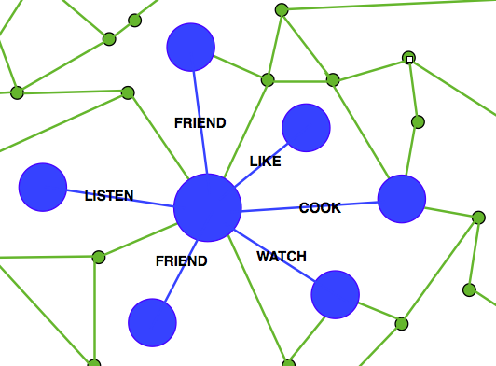
Draft Date: July 10, 2012
Author (Writer): Steve Hamersky
Instructional Component Used: Graph Theory
Grade Level: 9-12

Content (what is taught):
- Basic concepts of Graph theory
- Applications of Graph theory analysis
- Analysis of the spread of disease using Graph theory concepts

Context (how it is taught):
- Students create a social graph of their friends
- Students simulate and analyze the spread of a disease
Activity Description:
Students apply concepts and methods of graph theory to analyze data for different relationships such as friendships and physical proximity. Students are asked about relationships between people and how those relationships can be illustrated. Students are given the problem of finding the social graph of their friends. Students simulate and analyze the spread of disease using graph theory by assuming close proximity to an infected individual would cause the disease to spread.

Standards:

Math: MB1, MC4 Science: SA1, SA2, SC3, SE2, SF5

Technology: TC2, TC4 Engineering: EA1

Computer Science: CT:L3:MW8, CT:L3:CP5, CCP:L3:CP7

Materials List:
- Computer with Internet access
- Android device with Bluetooth discovery application (Optional)
Asking Questions: (Making The Connection)

Summary: Students consider the relationships that connect people in social graphs.

Outline:
- Ask students questions about the relationships between people
- Ask students questions about social graphs in marketing

Activity: Students answer questions that prepare them for the study of basic graph theory. Students are asked about relationships between people and how those relationships can be illustrated. The importance and value of mapping relationships is included in how Facebook uses the social graph of members to focus marketing for their advertisers.

Questions | Answers
What relationships connect people? | Friends, family, teams, clubs
How can relationships between people be organized or illustrated for ease in understanding? | List, outline, vertex and edge graph
What is a graph? | Most would describe an X, Y graph
What is the Facebook social graph? | The connections that exist between people through friendships
How could advertisers use the Facebook social graph in their marketing of products? | Advertisers find products your friends like and market those items to you

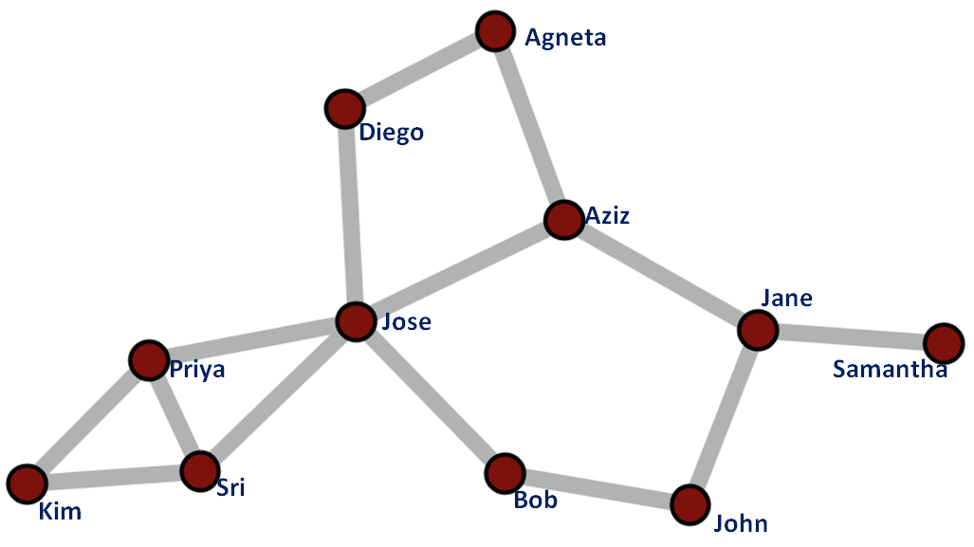
Image from Wiki Commons:
http://commons.wikimedia.org/wiki/File:Katz_example_net.png

Exploring Concepts: (Making The Connection)

Summary: Students create and use social graphs using relationships between people.

Outline:
- Students create a social graph of their friends
- Students research basic graph theory concepts
- Students look at Six Degrees of Separation

Activity: Students are given the problem to find the social graph of their friends. Students will make a list of 5 of their friends, then the student will ask each of those friends to make a list of 5 of their friends. Students will then construct the social graph of the results.

As students create their social graphs, they are encouraged to lookup basic concepts of graph theory and the ideas surrounding Six Degrees of Separation. Students describe their graphs using terms such as vertex (or node) and edges and can apply degree of separation in their graph.
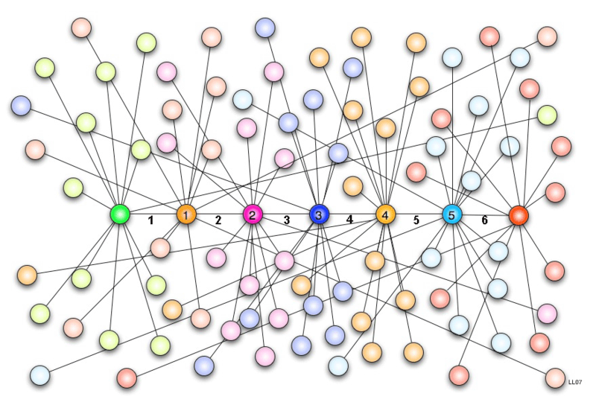
Image from Wiki Commons:
http://commons.wikimedia.org/wiki/File:Six_degrees_of_separation_01.png

Resources:
- Graph Theory Lessons – Uses Java Web Start programs to illustrate Graph theory concepts
http://www.mathcove.net/petersen/lessons/
- Cytoscape – An open source platform for data visualization
http://www.cytoscape.org/

Attachment:
Social Networks Using Cytoscape: T068_RET_Making_The_Connection_E_Social_Networks.pdf
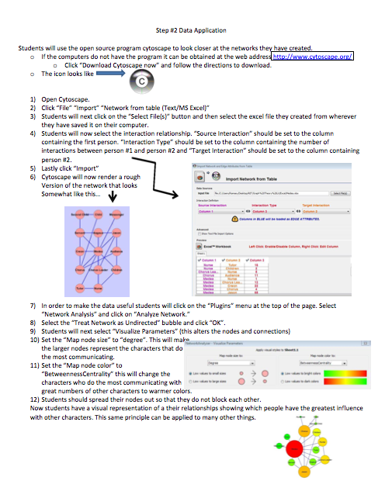
Instructing Concepts: (Making The Connection)

Graph Theory
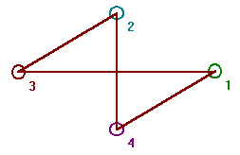
Graph theory is the mathematical study of graphs. A graph consists of a set or collection of vertices or nodes and a set or collection of edges that connect the vertices. As an illustration, a graph defined by vertex set V={1, 2, 3, 4} and edge set E={(1, 3), (1, 4), (2, 3), (2, 4)} would have the diagram shown to the right. Vertices that are connected by an edge are said to be adjacent. The degree of a vertex is the number of edges connecting to the vertex as an end point. In the example graph to the right, all vertices have a degree of 2. Some of the different types of graphs are the complete graph and the regular graph. A complete graph is a graph where every vertex is adjacent to every other vertex. A regular graph has the same degree on all vertices.

$\begin{matrix}0 & 0 & 1 & 1 \\ 0 & 0 & 1 & 1 \\ 1 & 1 & 0 & 0 \\ 1 & 1 & 0 & 0\end{matrix}$An adjacency matrix for a graph with n vertices is an n x n matrix where entry (i, j) is 1 if there is an edge in the graph between vertex i and j, otherwise the entry is 0. The adjacency matrix shown to the right is for the graph shown above.

An adjacency list for a graph has a row for each vertex and contains the vertex label followed by the vertex labels of adjacent vertices. The adjacency list for the graph above would be:

A path in a graph from vertex v to u is a sequence of edges where the first edge starts at v, each successive edge connects to the previous edge, and the final edge terminates at u. A path from 1 to 2 in the graph above would be: (1, 3), (3, 2). A vertex v is reachable from vertex u, if there is a path from v to u. A graph is connected, if every vertex is reachable from every other vertex, otherwise the graph is considered disconnected.

A graph traversal is the process of visiting every vertex of a graph. There are a number of algorithms or methods of graph traversal with the most common being depth first search (DFS) and breadth first search (BFS). Considering a given node as the parent and connected nodes as children, DFS will visit the child vertices before visiting siblings, where as BFS will visit the sibling vertices before the child vertices. DFS and BFS have their own special applications. DFS for example is useful in creating or solving mazes. BFS is more useful finding a winning strategy in games. (Courtesy of Steve Hamersky, 2012)

Attachment:
DFS and BFS Algorithms: I_Tech_020_Graph_Theory_DFS_BFS_Algorithms.doc
Organizing Learning: (Making The Connection)

Summary: Students apply graph theory to the spread of disease.

Outline:
- Students collect data using Android Bluetooth discovery or a manual method
- Students construct the vertex and edge graph for the discovered data
- Students determine which individuals are connected
- Students determine individuals infected given an initial infected individual

Activity: In this activity students simulate and analyze the spread of disease using graph theory. Students will assume close proximity to an infected individual would cause the disease to spread. A simulation is performed where students collect data on their proximity to other students.

If Bluetooth Android devices are available, students can use Bluetooth discovery to collect the data. Students are considered to be in close proximity when their Bluetooth device discovers another Bluetooth device. Only Bluetooth devices participating in the simulation are considered.

If Bluetooth Android devices are not available, students can use a proximity estimate, such as being within arm’s length, and can record the data manually. Students can use a data table similar to the one below. Simulation ID could be used if multiple simulations are recorded. UserID is used to identify which student is recording the data. Close Proximity To UserID is the UserID of the person the recording student was in close proximity to during the simulation. The Time is the time when the data table line was recorded. The UserID and time will be used to sort the data when students combine all their data into one table.

Simulation ID | UserID | Close Proximity To UserID | Time

After the simulation students will collect the information into one table for analysis. Multiple simulations could be performed to produce a different data set for each student. A number of questions could be answered using the data such as:
1. Which students are connected through close proximity between all students?
2. Given an initial infected individual, which students are infected?
Understanding Learning: (Making The Connection)

Summary: Students will demonstrate the basic concepts of graph theory, create and interpret graphs, and illustrate the depth first search (DFS) and breadth first search (BFS) of a graph.

Outline:
- Formative Assessment of Graph Theory
- Summative Assessment of Graph Theory

Activity: Students will complete the lesson activities while the instructor makes formative assessment observations. Students will complete a series of problems as a summative assessment.

Formative Assessment: As students are engaged in the lesson ask these or similar questions:
- Can students apply the basic vocabulary of graphs such as vertex and edge?
- Can students translate between the adjacency matrix or list and the graph?
- Can students apply the DFS and BFS algorithm for a given graph?

Summative Assessment: Students will complete problems similar to the ones listed.
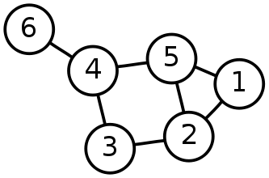
Given the graph to the right, answer the following questions:
- What is the vertex list for this graph?
- What is the edge list for this graph?
- What is the adjacency matrix for this graph?
- What is the adjacency list for this graph?
- Starting at vertex 1 and using a DFS search, what would be the visitation order of the vertices? Do the same for the BFS search.
Adjacency Matrix
$\begin{matrix}0 & 1 & 0 & 0 & 1 & 0 \\ 1 & 0 & 1 & 0 & 1 & 0 \\ 0 & 1 & 0 & 1 & 0 & 0 \\ 0 & 0 & 1 & 0 & 1 & 1 \\ 1 & 1 & 0 & 1 & 0 & 0 \\ 0 & 0 & 0 & 1 & 0 & 0\end{matrix}$Summative Assessment Answers:
- 1, 2, 3, 4, 5, 6
- (1, 2), (1, 5), (2, 3), (2, 5), (3, 4), (4, 5), (4, 6)
- The adjacency matrix is shown to the right
- The adjacency list is shown to the right
- A DFS search has a visitation order of: 1, 2, 3, 4, 5, 6
- A BFS search has a visitation order of: 1, 2, 5, 3, 4, 6
Adjacency Lists
{1 2 5}
{2 1 3 5}
{3 2 4}
{4 3 5 6}
{5 1 2 4}
{6 4}

