Students will use a world time zone map like the one below or another can be used from the URL: http://www.csgnetwork.com/timezonemap.html
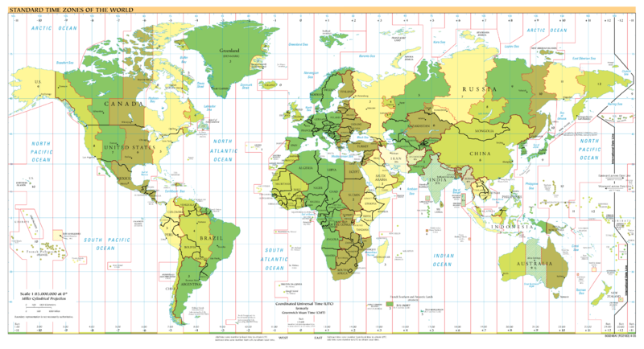
Image courtesy of Wikimedia commons (http://commons.wikimedia.org/wiki/File:2007-02-21_time_zones-white.png)

If it is 8:00 a.m. in Columbus, Nebraska, what time is it in:

-New York City, New York:
-Stockholm, Sweden:
-Shanghai, China:
-London, England:
-Los Angeles, California:
-Tel Aviv, Israel:
-Buenos Aires, Argentina:
-Moscow, Russia:
-Honolulu, Hawaii:
-Bangkok, Thailand:
-Denver, Colorado:

What barriers might prevent prompt (immediate) communication between workers in Columbus and workers in Israel or China?

*
*
*
Why is it essential that business workers in different countries have access to cellular phones and internet service 24 hours a day?

