RET Lesson:
Learning App Inventor
==========================Lesson Header ==========================
Lesson Title: Learning App Inventor
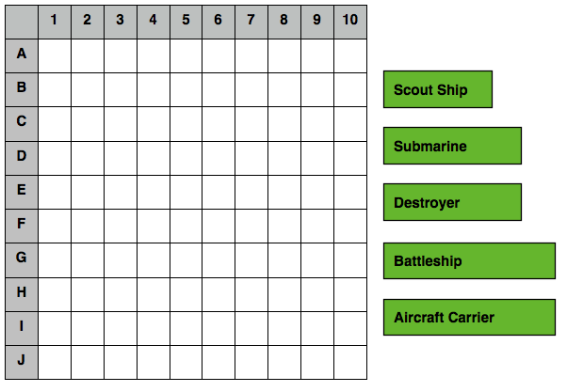
Draft Date: July 20, 2012
1st Author (Writer): Rich Powers
Instructional Component Used: Computer Programming
Grade Level: 6-9

Content (what is taught):
- Where computer programming is present in society
- Flow charts as a tool to design computer programs
- Basic knowledge of App Inventor

Context (how it is taught):
- Questioning and discussion
- Students explore flowcharts and algorithms by playing a Battleship®-like game and create a flowchart that demonstrates how to play the game
- Working through App Inventor tutorials to learn how App Inventor functions

Activity Description:
In this lesson students will think about computer programming and where it is present in solicited. They will be introduced to flow charts and create a flow chart for a game. To conclude, students will work through several App Inventor tutorials and draw a flow chart of what one of the tutorial apps does.

Standards:

Science: SE1 Technology: TF1, TF2,
Computer Science: CT:L2:8, CCP:L1:3:4, CCP:L1:6:4, CCP:L1:6:7, CCP:L1:6:8, CD:L2:1

Materials List:

- Mobile Android device
- Google Gmail account
- App Inventor online registration
- Computer
- Computer Lab

Asking Questions: (Learning App Inventor)

Summary: Students will be asked about their experience with computer programming and how computer programming is used.

Outline:
- Discuss experience with computer programming
- Discuss how computer programs are constructed/structured

Activity: A class discussion will be conducted about computer programming and where students might encounter it as they move through the world. Students will be asked about their experience with computer programming. The questions below should be addressed as part of the discussion.

Questions | Answers
What is computer programming? | Writing a detailed set of instructions that tells a computer how to perform a task, which is later translated into machine language through a process called compiling.
Where do you encounter computer programming on a daily basis? | Cell phone, computer applications, traffic lights, and numerous other examples. Basically anything with a computer as part of its function.
How do you think that computer programs are structured? | Answers vary
Can you think of any organizational structures that would help write a computer program? | Flow chart, pseudo code, etc.
Exploring Concepts: (Learning App Inventor)

Summary: Students explore flowcharts and basic algorithms by designing a flowchart that demonstrates how to play a Battleship®-like game.

Outline:
- Students play a Battleship®-like game with a partner
- Students develop a flowchart that demonstrates how the game is played
- Students test, improve, and redesign flowchart

Activity: Students work in groups of 2 and to play a Battleship®-like game using the Explore Worksheet (see attached file: T070_RET_Learning_App_Inventor_E_worksheet.doc). After playing game, students discuss game strategies with partner and develop a flowchart that demonstrates how to play the game. Students play another game to test if the flowchart works and make improvements as needed. The students create a final design of flowchart, which will be presented to the class for discussion.

Attachment:
- Battleship Worksheet: T070_RET_Learning_App_Inventor_E_worksheet.doc
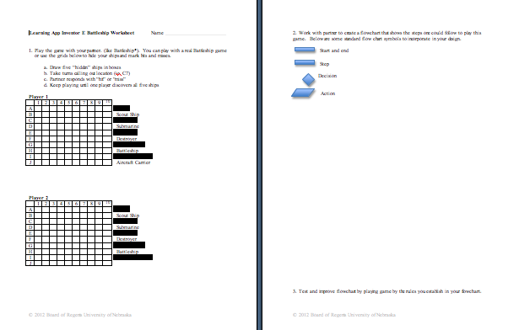
Instructing Concepts: (Learning App Inventor)

Computer Programming

Putting Programming in Recognizable Terms: Programming is defined as designing and creating software that allows a computer or other device accomplish a desired task.

Putting Programming in Conceptual Terms: Programming is how a human user gives commands and tasks to a computing machine. This is done through a wide variety of mediums that are often layered upon each other. The most primitive programming involves the use of bits, or electronic signals that represent symbols such as 0’s and 1’s. This base can be translated into programming that turns symbols into words, making it easier for humans to write plans or processes for the machine (the plans or processes are often called “algorithms”). Further translations make the simple languages more complex and allow more use of common human language, leading to high level languages such as Java and C++.

Putting Programming in Mathematical Terms: Mathematically, programming is built on conditional logic taught in most geometry courses, Boolean logic which is the simply examining on/off or true/false results, finite loops of a process, and recursion methods. Programming is a direct application of a wide variety of mathematical thinking.

Putting Programming in Process Terms: Programming is usually done using a chosen high level language such as Java, C++, Python, or one of many others and an integrated development environment (IDE) which provides the programmer with text editing for typing the code of the program. Programming also uses a compiler which will translate the written code down through the languages understood by the respective machine, and debugger which allows for step-by-step inspection of a program in order to find errors in the code.

Putting Programming in Applicable Terms: Programming describes variety of tasks done in computer science. Any software that operates on a computer is composed of a program developed by a programmer. Programming is also used to control industrial machinery, encrypt and decrypt messages or data, and solve multi-variable problems like weather and economic forecasting.

History: The history of electronic computer programming began in the 1940’s with the invention of the ENIAC machine. This first modern computer was developed by the military to help with the writing of artillery-firing tables. These tables were used for different weapons that were fired under varied conditions for target accuracy. As computers improved through the 1950’s to the 1970’s, languages like COBOL for business and FORTRAN for science and engineering were developed and became the standard. With the invention of the personal computer in the 1980’s computers became household items and the number of languages grew and diversified. Pascal and BASIC were languages that sprung up in the 1980’s as a result of the PC. As the computer continues to get more powerful, the languages continue to adapt. Some of the more prevalent languages today are the various iterations of C, Java, PHP, and numerous others.

Basic Functions of Computer Program (in almost any language)
Input: The acquisition of data from a file, keyboard or other input device.
Mathematical Functions: The performance of mathematical operations ranging from basic arithmetic to advanced functions.
Repetition: The performance of an action over and over, sometimes with subtle changes.
Conditional Algorithms: The checking for certain conditions and the execution of statements in an appropriate sequence.
Output: The displaying of data resulting from the program on a screen, in a file, or any other means.
Organizing Learning: (Learning App Inventor)

Summary: Students will setup their computer to run App Inventor and complete the App Inventor tutorial to gain a basic working knowledge of how to use App Inventor.

Outline:
- Students will setup App Inventor on their computers
- Students will complete 3 basic App Inventor tutorials
- Students will complete at least 2 advanced App Inventor tutorials

Activity: To begin, the computer must be configured to run App Inventor. Students should go to the website: http://beta.appinventor.mit.edu/learn/ and click on the Setup link. The website will lead them through a step-by-step process to install the App Inventor software. NOTE: If the teacher does not want to have students do the install, it could be done ahead of time and then start the activity with the tutorials.

After installing App Inventor, students will be divided into groups and should complete the first 3 basic tutorials (these can be found at: http://beta.appinventor.mit.edu/learn/tutorials/index.html) and then complete at least 2 of the advanced tutorials. Students should be careful to learn the structure and environments that they will be required to interact with when programming with App Inventor. The flow of how programming should be observed and documented. To document program flow, students should draw and submit a basic flow chart that represents the function of one of the tutorial apps that they worked through. To conclude, a presentation about what each group learned about App Inventor will be created and shared with the class. As presentations are given, each group should note information that other groups discovered but they did not.

Resources:
- Computers
- Computer Lab
- Student Google Accounts
Understanding Learning: (Learning App Inventor)

Summary: Students will be assessed on their understanding of how computer programming can be applied using App Inventor.

Outline:
- Formative Assessment of Computer Programming
- Summative Assessment of Computer Programming

Activity: Student will complete written and performance assessments related to computer programming.

Formative Assessment: As students are engaged in the lesson ask these or similar
questions:
- Were students able to analyze the game to make a flow chart?
- Did students compete the basic App Inventor tutorials?
- Were students able to manipulate the App Inventor programming environment?

Summative Assessment: Students can complete one of the following writing prompts.
- Describe 3 different environments that computers are present in your life and state the basic programming task that the computer performs in each environment.
- Explain the purpose of a flow chart and how it relates to computer programming.
- Describe the App Inventor user interface and how you can use it to program an android device. Provide an example program that you have seen or created using App Inventor.

Students can complete the following performance assessment: Use App Inventor to create a basic Android app. When finished, take a screen shot of the App Inventor environment and write a brief description of what the app does.

