RET Lesson:
Using JUnit
==========================Lesson Header ==========================
Lesson Title: Using JUnit
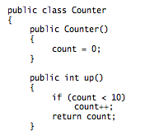
Draft Date: 7/20/2012
1st Author (Writer): Ryan Stejskal
Instructional Component Used: Program Testing
Grade Level: High School

Content (what is taught):
- Using the JUnit testing environment
- Creating test cases with JUnit
- Interpreting the results of JUnit tests

Context (how it is taught):
- Students explore a demonstration Java class and associated JUnit test set
- Students then create JUnit test cases for an already-written class
- Students use test-driven development to create JUnit tests for a class they write
Activity Description:
In this lesson, students explore the use of the popular JUnit testing tool for Java programming. Students begin by examining an existing Java class and its associated JUnit tests, and exploring the connection between the tested class and the JUnit code. After seeing the basics of JUnit, students continue to explore by writing JUnit tests for an existing class. Finally, students employ principles of test-driven development to create both a Java class and an associated set of JUnit test cases.

Standards:

Math: A3, E1 Science: A1, A2

Technology: D3, F3 Engineering: A2, D2

Computer Science: CT:L3:MW2, CCP:L3:MW3

Materials List:
- Computers (with Internet access)
- Java programming environment
- JUnit testing tool - All code samples in this lesson use version 4 of JUnit, though the code can be adapted to JUnit 3 fairly easily if desired.
Asking Questions: (Using JUnit)

Summary: Students discuss how programmers can check a program for correctness.

Outline:
- Students discuss how to check a program for correctness
- Demonstrate the use of JUnit to check a program
- Ask students how JUnit can be used to help check a program

Activity: Ask students to recall a Java program that they have recently written. Students should consider how they checked their program for correctness, and whether their checks were sufficient to ensure that the program is in fact correct.

Then the teacher should demonstrate the use of JUnit with the attached Java class and accompanying JUnit test. See resource links and attachments below. Show students how the JUnit tests correspond to the tested class's methods. Ask students these questions:

Questions | Answers
How is a test method labeled in the test class? | It has the annotation @Test.
How does a test method check that a given condition is true? | It calls the assertEquals() function.
Does the fact that the class passes all its tests ensure that the class is correct? | No, but it does ensure that the class doesn't contain any defects that are tested for by the test suite.
Can any set of tests guarantee that a program or a part of a program is correct? | No, we can never guarantee a program is correct by testing alone. However, if we choose tests well and our code passes the tests, we can greatly reduce the chance that the program contains errors.
If you were to change the Pirate class in some way, how hard would it be to check that the change didn't break anything? | It would be very easy, only requiring that the tests be run again.

Resources:
- JUnit home http://www.junit.org/home
- Writing JUnit tests in NetBeans http://netbeans.org/kb/docs/java/junit-intro.html
- Using JUnit with Eclipse http://onjava.com/pub/a/onjava/2004/02/04/juie.html

Attachments:
- T074_RET_Using_JUnit_A_Pirate.doc
- T074_RET_Using_JUnit_A_PirateTest.doc
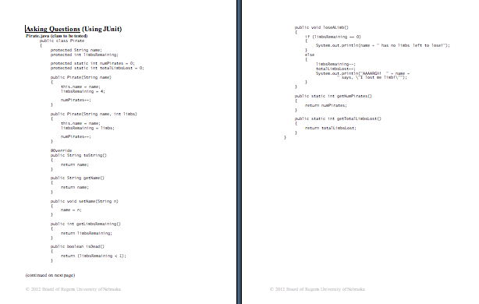
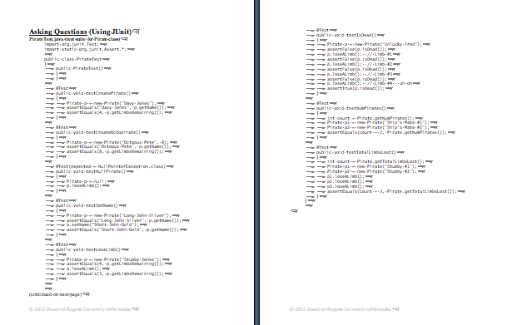
Exploring Concepts: (Using JUnit)

Summary: Students learn to use JUnit to create unit tests for an existing class.

Outline:
- Discuss the requirements for the provided class
- Create JUnit tests that check the requirements
- Run JUnit tests and verify that the code passes the tests

Activity: In this activity, students will explore the JUnit testing tool and its use. Students should start by downloading the BankAccount class (see attachment), saving it as a Java file, and checking that it compiles correctly.

Once students have this class, ask them to name some of the requirements of the class that they might want to test. For example, students might test that the deposit() method correctly adds money to the account or that the withdraw() method does not allow the user to withdraw more money than is present in the account.

Then ask students to work individually or in small groups to write JUnit tests for one or two of the requirements that they listed. You may wish to have each student or group write tests for a different requirement and then combine all the tests into a more complete test set, or you might have students write tests for the same requirement so that they can compare their work.

To provide formative assessment as students work, ask yourself or the students these questions:
- Did students identify the major requirements listed in the BankAccount class description as testable requirements?
- Were students able to write JUnit test cases that compile and run successfully?
- Does the BankAccount class as provided pass the students' tests? If not, why not - is there an error in the test case or an error in the BankAccount class itself?

Resources:
- JUnit home, http://www.junit.org/home
- Writing JUnit tests in NetBeans, http://netbeans.org/kb/docs/java/junit-intro.html
- Using JUnit with Eclipse, http://onjava.com/pub/a/onjava/2004/02/04/juie.html

Attachment:
- T074_RET_Using_JUnit_E_BankAccount.doc
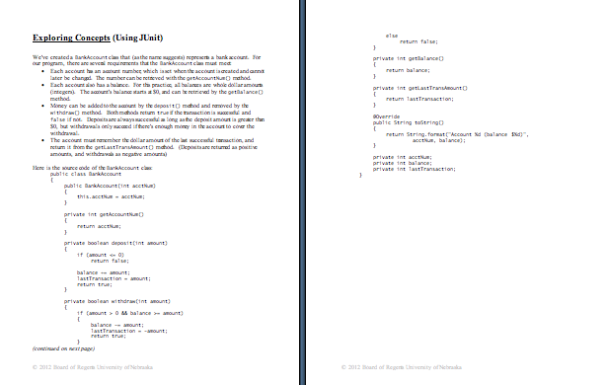
Instructing Concepts: (Using JUnit)

Program Testing

Why do we test programs? A computer program is a (potentially) very complex logical creation. The computer will happily follow the instructions you give it, whether those instructions match what you actually want it to do or not. Computers are not smart enough to understand their programmers' intent - they can only follow the instructions you give, right or wrong. Since most computer programs are large, it's common for programmers to make mistakes somewhere in the process of creating a program.

How do we test programs? The most common way to test a program is simply to run the program and see whether its results match what you expect. This kind of testing can be useful, but it's not the only kind of test available. In particular, large programs are difficult to test by just running the program, because the program may contain many special cases that don't come up very often in normal use. An effective software designer anticipates and tests those special cases, designing specific tests to make sure that the program works even with unusual input.

While testing is a critical part of software design, keep in mind that testing alone cannot verify a program's correctness, because it's usually not possible to test every possible input to a program. However, a well-chosen set of tests can help diagnose and ultimately fix nearly all program errors, if the tests are complete and "exercise" code that is more likely to contain errors.

Testing-Related Vocabulary Terms:

A test case is a specific set of input for a program or part of a program, along with the expected results of running the program with that input. Note that a test case must contain both the input and the output! A test can only help to verify a program's correctness if the expected output can be compared to the actual output of the test case.

An edge case is a test case whose input is near a "boundary" where the program changes from one behavior to another. For example, if a game allows a character to hold four items at a time, then edge cases would include collecting the fourth item (the last item that the character can hold) and collecting the fifth item (an item that would exceed the character's carrying capacity).

An error case is a test case whose expected result is an error. For example, for a program that divides two numbers, dividing by zero is an error case. A well-written program should have a plan in place to handle unexpected data in a reasonable manner; error cases test this plan.

A test suite is a collection of test cases that is intended to fully "exercise" a section of a program. A complete test suite should include edge cases and error cases as well as a representative selection of "normal" cases.

In test-driven development, the software designer creates test cases for a section of code first, before writing the program itself. While this seems "backwards" to many programmers, writing tests first helps the programmer to focus on what the code should do. By considering expected results in advance, most programmers write better code with fewer errors.
Organizing Learning: (Using JUnit)

Summary: Students create JUnit test cases for a class and then create the corresponding class.

Outline:
- Discuss the requirements for the code to be written
- Create JUnit tests that check the requirements
- Write code that implements the requirements
- Run JUnit tests and verify that the code passes the tests

Activity: In this activity, students will practice creating code in a test-driven style, writing tests for the code first and then writing the corresponding code. Begin by showing students the description of the BowlingGame class, included in the attachment. Once students have had a chance to examine the class requirements, they should discuss what tests will be required to ensure that the class does what it's supposed to. As students plan the tests they will write, they should complete the first two columns of the test chart, shown below in the Resources section. (Expand the table with more rows as needed.)

Once students have planned their test cases, they can then implement them. As students create each test, they should fill in the table with the names of the JUnit test functions they write. One sample test function is included in the attachment.

Students should then run the JUnit testing tool for their test cases. Remind them that all their test cases are expected to fail at this point since the corresponding code is not written yet - this is normal! Every new test case should fail when it's first created. After students have written their test cases, they should fill in the methods of the BowlingGame class. As students write code for the class, ask them to run the tests frequently. They should find that as they progress, their JUnit tests begin to pass. (As students work, remind them that if they expected a test case to pass, but it does not, then they should check both the tested code and the test case itself for errors.)

When students finish the BowlingGame class, they can exchange their classes with each other, and verify that their classes pass each other's tests.

Resources:
Test case organization chart:
Requirement | Brief Description of Test Case | Test Function | Passed?
Start on frame 1, ball 1 | Create a new BowlingGame, test that frame and ball are both 1 | testStartGame

Attachment:
- T074_RET_Using_JUnit_O_BowlingGame.doc
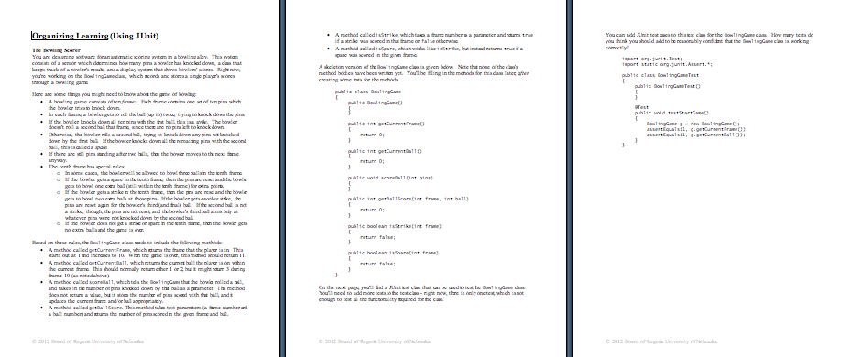
Understanding Learning: (Using JUnit)

Summary: Students answer questions about JUnit tests, and create their own JUnit test cases.

Outline:
- Formative Assessment of Program Testing
- Summative Assessment of Program Testing

Activity: Students will complete written and performance assessments related to program testing.

Formative Assessment: As students are engaged in the lesson ask these or similar questions:
- Were the students able to use their programming tools to create and run JUnit tests?
- Can the students explain the meaning of a test succeeding versus a test failing?
- Can students identify and use different kinds of JUnit assert statements?

Summative Assessment: Students can complete the following writing prompt.
Create a list of the steps necessary to create a JUnit test case, using the development tools used in class.

Students can complete the following performance assessment.
Write JUnit test cases with the following descriptions, to test the accompanying class. (A full implementation of the class is included in the attachment.)
Your application needs a Counter class which will be used to count active objects. When a new Counter object is created, it has a count of zero. The Counter object has three methods:
- up() increases the counter value by 1, to a maximum of 10. It then returns the new counter value.
- down() decreases the counter value by 1, to a minimum of 0. It then returns the new counter value.
- getCount() returns the current counter value (without changing it).
Write two test cases for this class, as listed. (Note that the two test cases listed here are not a full test suite for the Counter class; more tests would be required to test it fully.)
- Create a test that verifies that the up() method causes the counter to increase.
- Create a test that verifies that the up() method does not increase the counter if the counter's value is already 10.

Attachment:
- T074_RET_Using_JUnit_U_Counter.doc
