SPIRIT Lesson:
Robotic Color
============================Lesson Header ============================
Lesson Title: Robotic Color
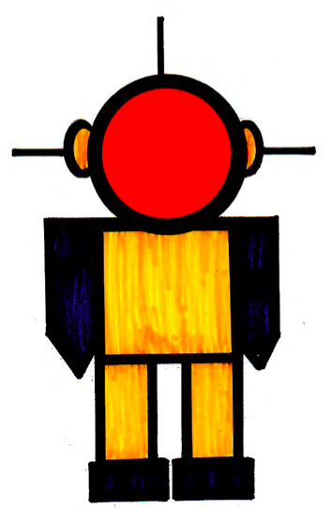
Draft Date: 5/12/12
1st Author (Writer): Thomas Orange
Instructional Component: Color
Grade Level: Art – Upper Elementary to High School

Content (what is taught):
- Identify the meaning of color
- Where color is found
- Different classifications of color: hue, intensity, and value, primary, secondary, hot, cool, tint, shade, neutral colors, and complimentary colors
- Understand the make-up of a color wheel
- Apply the information to create a robot color wheel study

Context (how it is taught):
- Questioning/brainstorming activities
- Research into color via the Internet
- Completion of the color packet
- Creation of robotic drawings that will include: primary colors, secondary colors, hot colors, cool colors, tint colors, shade colors, neutral colors, complement colors, warm and cool colors

Activity Description:
In this lesson, students will learn about the science of color. The instructor and students will define, discuss sources of, view a variety of robotic color images, and complete a variety of robotic color studies on their own (with the help of the instructor).

Standards:
Math: MB1 Technology: TA1, TA2 TB1, TB2

Creative Visual Arts: CS1, CS2

Materials List:

- Worksheet set for each student
- 11 X 17 drawing paper
- 18 x 18 drawing paper
- Crayons
- Tempera paints and brushes
- Water cups
- Paper toweling
- Crayola magic markers
- Prang watercolor paints (8 pan oval set)
- Pencils
- Large Erasers
- Colored Pencils

Asking Questions: (Robotic Color Study)

Summary: Students will discuss various color terms related to the science of color. They will discuss how this would apply to the development and construction of robots.

Outline:
- Discussion of color
- Brainstorming about the different organizations of color

Activity: Students will be engaged in a class discussion about color. The purpose of the discussion is not necessarily to provide answers but to help students gauge what they know about color and what they might learn. The questions below should help guide the discussion. It might be easier to ask students for examples of color terminology before trying to define it because people tend to have a good understanding of what color is.

Question | Answer
What is color? | Color is the element of art that is produced when light, striking an object, is reflected back to the eye.
What is hue? | Hue is the name we give to a color.
What is intensity? | Intensity is the strength and vividness of the color.
What is value? | Value means the lightness or brightness of the color.
What are primary colors? | Primary colors are those that cannot be made from mixing other colors. Instead, primary colors are the source of other colors. These colors include red, yellow, and blue.
What are secondary colors? | Secondary colors are made by mixing equal parts of primary colors. These colors include: orange, green, and purple.
What are warm colors? | Warm colors are reds, yellows and oranges.
What are cool colors? | Cool colors are greens, purples, and blues.
What are color tints? | Tints are a lighter variety of a color made by adding white. This creates a color of less than maximum purity, chromo, or saturation.
What are color shades? | Shades are a darker variety of color made by adding black. This creates a color of less than maximum purity, chromo, or saturation.
What are neutral colors? | Neutral usually means without color. Neutral colors such as beige, ivory, taupe, black, gray, white, brown, and metallic colors.
What is a color wheel? | A circular diagram in which primary and usually intermediate colors are arranged sequentially so that related colors are next to each other and complementary colors are opposite.
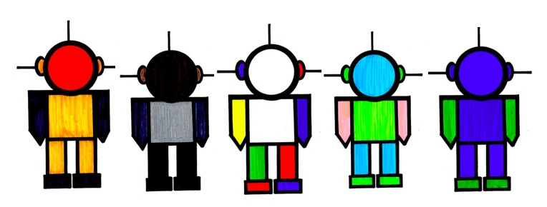
Exploring Concepts: (Robotic Color Study)

Summary: Students will research images of color using “Google” and identify robotic objects that meet the different color terminology.

Outline:
- Research color terminology using Google
- Locate robotic images on Google or create original robotic images that match the different color terminology
- Research color terminology using Google to understand the meaning of color “value in relation to robotics

Activity: Students will research images of color using “Google” and identify robotic objects that meet the different color terminology. As an example, students will find a collection of primary colored robots. They will collect blue, red, and yellow robots. The students will do the same for secondary, warm, cool, tints, shades, and neutrals. Students can also explore Google images that demonstrate their understanding of color value (lightness and brightness of colors). To conclude the images and what students learned should be compiled into a PowerPoint presentation or printed out using a color copier.
Instructing Concepts: (Robotic Color Study)

Color

Color is the element of art that is produced when light, striking an object, is reflected back to the eye. Color can be formed from light where “white” is all colors mixed and “dark” is the absense of light. When mixing pigments to paint or use some other medium, “dark” colors are found by mixing many colors, and light colors are created by using less color. NOTE: Mixing light and mixing pigments are exactly the opposite process to accomplish the same result.

Color Terminology:
Color is the element of art that is produced when light, striking an object, is reflected back to the eye.

Hue is the name we give to a color.

Intensity is the strength and vividness of the color.

Value means the lightness or brightness of the color.

Primary colors are those that cannot be made from mixing other colors. Instead, primary colors are the source of other colors. These colors include red, yellow, and blue.

Secondary colors are made by mixing equal parts of primary colors. These colors include: orange, green, and purple.

Warm colors are reds, yellows and oranges.

Cool colors are greens, purples, and blues.

Tints are a lighter variety of a color made by adding white. This creates a color of less than maximum purity, chromo, or saturation.

Shades are a darker variety of color made by adding black. This creates a color of less
Than maximum purity, chromo, or saturation.

Neutral usually means without color. Neutral colors such as beige, ivory, taupe, black,
Gray, white, brown, and metallic colors.

Color wheel is a circular diagram in which primary and usually intermediate colors
arranged sequentially so that related colors are next to each other and complementary
colors are opposite.

Thoughts on Color
Color is a natural part of our environment. Color, or the absence of color, allows us to express our thoughts and feelings. Color allows for emphasis and meaning to be placed in ways more meaningful than when color is not present. The artist uses color to convey mood, texture, movement, etc. Color is an integral part of the human condition that enhances and helps explain who we are.
Organizing Learning: (Robotic Color Study)

Summary: Students will complete a complete set of color worksheets, color wheel, and a comprehensive PowerPoint presentation on robotic color.

Outline:
- Complete a set of color worksheets
- Complete a color wheel
- Complete a PowerPoint presentation on color as it relates to robotics

Activity: In this activity, students will be given a set of color worksheets, including a color wheel to complete. These worksheets will be completed using a variety of medium such as Crayola markers, crayons, watercolor paint, colored pencils, or any combination of these. The students will also complete a robotic color PowerPoint presentation that will be presented to the class. When the worksheets and PowerPoint are complete, each student will present their final products to the class and instructor.

Attachments:
- Color worksheets: T075_SPIRIT_Robotic_Color_O_Color_Worksheet.pdf
- Completed worksheets: T075_SPIRIT_Robotic_Color_O_Color_Worksheet_Completed.pdf
Understanding Learning: (Robotic Color Study)

Summary: Students will discuss and then complete a complete set of color worksheets given prompts from the teacher.

Outline:
- Formative Assessment of Color
- Summative Assessment of Color

Activity: Students will complete project and performance assessments related to symmetry.

Formative Assessment: As students are engaged in the lesson ask these or similar questions:
- Were the students able to understand and complete the complete set of color worksheets and color wheel?
- Can students explain the different color terminology and color wheel.

Summative Assessment: Students will complete the following writing prompts:
- Choose 4 different color terms and explain what they mean and how they are related.
- Explain the different colors as they relate to each other on the color wheel.

Students can complete the following performance assessment:
Students will draw a template of a robot and complete a color study. The study must include the color concepts of :primary and secondary colors, hue, intensity, value, warm and cool colors, tints, shades, neutrals, and complimentary colors.

