SHINE Lesson:
Fresh is Best!
==========================Lesson Header ==========================
Lesson Title: Fresh is Best!
This Teacher was mentored by:


www.cargill.com

In partnership with Project SHINE grant funded through the

National Science Foundation
1st Author (Writer): Jess Eckman
Associated Business: Cargill Meat Solutions
Instructional Component Used: Soft Skills: Organization
Grade Level: 6-8

Content (what is taught):
- Organization
- Creating a system

Context (how it is taught):
- Students will reflect on the benefits of organization like assembly lines
- Students will simulate an assembly line
- Students will create their own system of organization

Activity Description:
Students will view a video or skit that demonstrates spoiled food being eaten on accident. Next, students will discuss the importance of organization. Then, students will race to complete a jigsaw puzzle in groups. The first time students will complete the puzzle without directions. The second time students complete the puzzle, they will set up an “assembly line” and each student will have an assigned task to ensure the puzzle is completed efficiently. Students will be instructed on soft skills like organization. Next, students will create a system of organization for their refrigerator at home. Finally, students will be assessed with a rubric and a self-assessment reflection.

Standards:

Math: ME3 Science: SF2

Technology: TB2, TB3, TD2 Engineering: EC4

Materials List:
- Jigsaw puzzles
- Poster paper (optional)
Asking Questions: (Fresh is Best!)

Summary: Students will view a video or skit that demonstrates spoiled food being eaten on accident. Next, students will discuss the importance of organization.

Outline:
- Students will view a video or skit that demonstrates spoiled food being eaten on accident
- Students will discuss a time they have eaten food that was not good to consume
- Students will discuss the importance of an organized kitchen and being organized in general

Activity: Show or demonstrate (with humorous skit) an example of someone eating something GROSS! Students will then discuss the following questions:

Questions | Sample Answers
What is the grossest thing YOU have ever eaten? | Answers will vary
Have you ever found spoiled food at home in the fridge? How did this happen? | Answers may vary. Spoiled foods results from being forgotten or left past when it is safe to eat.
Why is an organized kitchen important? | It’s important to keep a kitchen organized both for safety reasons and sanitation of the cooking environment!
Why is organization an essential life skill? | Organization helps us achieve our goals! If we are not organized, we cannot prioritize and may miss deadlines.
Exploring Concepts: (Fresh is Best!)

Summary: Students will race to complete a jigsaw puzzle in groups. The first time students will complete the puzzle without directions. The second time students complete the puzzle, they will set up an “assembly line” and each student will have an assigned task to ensure the puzzle is completed efficiently.

Outline:
- Students will complete a jigsaw puzzle with their group with no instructions
- Students will complete the puzzle with assigned tasks simulating an assembly line
- The class will discuss how an organized group or assembly line can greatly improve efficiency.

Activity: Students will form groups of 3-4 members. Each group will be given a jigsaw puzzle to complete (50-100 piece puzzles work best). Groups will compete against each other to complete the puzzle in as short an amount of time as possible. Ready-Set-Go! What usually happens is some arguing and chaos within each group. Students will be told that industries like Cargill Value Added Meats use assembly lines to organize workers and complete tasks in a quicker, more efficient manner. Students will get to simulate this experience within their groups by assigning specific tasks for the completion of the puzzle. Examples of tasks include: flipping all pieces face up, assembling edge pieces, dividing pieces into color or pattern groups etc. Students will then race to complete their puzzles for the second time. The class will then discuss if assigning tasks helped complete the puzzle faster. The class might also note that completing the same task (a puzzle) for the second time can also increase efficiency.
Instructing Concepts: (Fresh is Best!)

Soft Skills

Definition:
Soft skill is a general term for behavioral skills difficult to quantify or measure, but they greatly influences the quality of the work place environment. In sociological terms, soft skills are referred to as the EQ (Emotional Intelligence Quotient) or the individual’s personal attributes often called “interpersonal skills” or “people skills”. Soft skills can be refined and developed within an environment of support, frequent feedback, encouragement and reinforcement.

Types of Soft Skills:
Please note the list below is a sample list of common soft skills, but is not an extensive list.
1. Communication Skills: Communication is the ability of a person to convey and comprehend messages sent by one to another. These messages include not only information, but also a personal tone (i.e. welcoming, affirming, friendly, formal etc.).

2. Flexibility/Adaptability: Flexibility is the willingness (attitude) and adaptability is the ability (aptitude) of a person to adjust, change, or modify when circumstances alter in an environment.

3. Lifelong Learner: Lifelong learning is the willingness of a person to continue seeking growth through developing knowledge and skills.

4. Positive Attitude: A positive attitude is the ability of a person to exude optimism as well as remain cooperative and congenial when circumstances become challenging.

5. Professionalism/Respect: Respect is the ability to personally interact with others in a mature manner that honors another’s dignity, personhood, and/or position. Professionalism is the demonstration of respect within the workplace environment.

6. Punctuality/Reliability: Punctuality is the ability to demonstrate consistency in schedule following behavior, while reliability is the ability to demonstrate consistency in task accomplishing behavior.

7. Self-motivated: Self-motivation is the ability to take initiative without outside monitoring or enforcement.

8. Team Work: Teamwork is the willingness to cooperate and collaborate with others to accomplish a common objective.

9. Time Management: Time management is the ability to prioritize and monitor one’s productive activity.

10. Work Ethic/Integrity: Integrity is high moral character exhibited in principled decision-making and actions. Work ethic is work accomplished with integrity or principled driven ownership in accomplishing a task to meet quality standards.
Organizing Learning: (Fresh is Best!)

Summary: Students will create a system of organization for their refrigerator at home.

Outline:
- Students will determine problems with their current refrigerator (examples: can’t find certain items, food spoils in fridge before consumed, run out of items without being added to grocery list, etc)
- Students will brainstorm possible solutions for problems their refrigerators present
- Students will create and present a system of organization for their refrigerator at home

Activity: The class will spend one day in class where current problems students see in home kitchens will be discussed and learn the importance of organization. Students will first brainstorm current problems that can occur in a refrigerator and possible solutions for those problems. The students will develop an individual system that will help solve problems in their refrigerator and help the family stay organized. They must include:
  - A way the family can communicate about the age of items in the fridge (leftovers)
  - A way the family can track what items need to be picked up at the store
  - A schedule to routinely sort through the refrigerator to discard expired foods
  - A schedule to check the refrigerator temperature to maintain the appropriate temperature at all times
  - Designate shelves and/or drawers for types of items (example, dairy shelf or fruit drawer). Students will create a sketch of the system they develop and given time to practice presentations before they present.
For project guidelines see attached file (T077_SHINE_Fresh_Is_Best_O_Project_Guidelines.docx).

Attachments:
- Project Guidelines: T077_SHINE_Fresh_Is_Best_O_Project_Guidelines.docx
- Project Self -Assessment: T077_SHINE_Fresh_Is_Best_O_Project_Reflection.docx
- Project rubric: T077_SHINE_Fresh_Is_Best_O_Rubric.docx
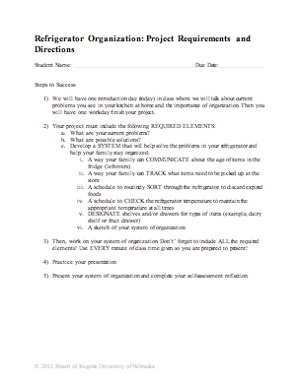
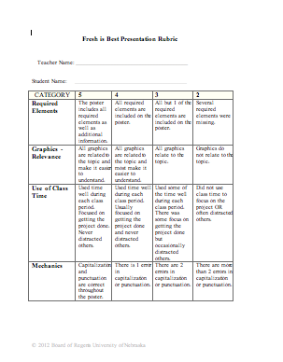
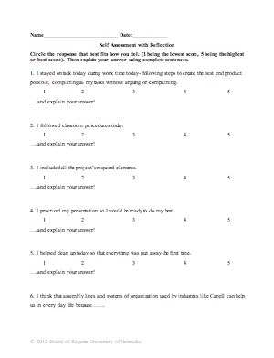
Understanding Learning: (Fresh is Best!)

Summary: Students will demonstrate understanding of the soft skill organization.

Outline:
- Formative Assessment of Soft Skills: Organization
- Summative Assessment of Soft Skills: Organization

Activity: Students will complete written assessments related to organization.

Formative Assessment: As students are engaged in the lesson ask these or similar questions:
- Are students engaged in viewing the video clip or skit?
- Do students understand the cultural reasons behind why an assembly line is more efficient? Why organization is important?
- Are students able to identify problems with organization in their refrigerator?
- Are students actively engaged in completing a new system for organizing their refrigerator?

Summative Assessment: Students can complete one of the following writing prompts:
- Explain why organization is critically important in the kitchen and other places around your house.
- What are some techniques that you can use to be more organized in the kitchen?
- Discuss how a room in your house (garage, storage room, etc.) is currently organized and how it can be improved.

