SPIRIT 2.0 Lesson:
Cruising
==========================Lesson Header ==========================
Lesson Title: Cruising
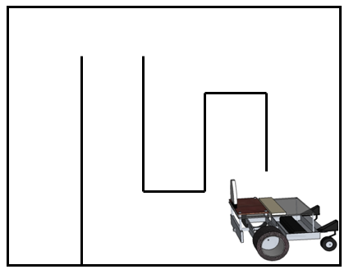
Draft Date: 5-23-12
1st Author (Writer): Pamela Galus
Instructional Component Used: Communication
Grade Level: 2-4

Content (what is taught):
- Define communication
- Discuss the roles of people in communication
- Determine ways to improve communication skills

Context (how it is taught):
- Demonstrate poor communication skills while explaining how to drive a CEENBoT
- Discuss with students proper communication skills and model while explaining how to drive a CEENBoT
- Students provide directions using proper communication to other students to drive the CEENBoT in a simple shape and then through a maze
- Develop both driving and communication skills

Activity Description:
Students will evaluate communication skills by first having the teacher demonstrate poor communication skills when explaining how to drive a CEENBoT. Discussion will follow the demonstration about the two key roles in communication (initiator and receiver) as well as how each one can improve the communication. The teacher will then model the role of initiator using proper communication while explaining how to drive a CEENBoT. Students will develop their communication skills as receivers by clarifying the teacher’s directions. Next, students will themselves become initiators explaining how to drive the CEENBoT to another student in a simple shape and then a maze. Students will switch roles and then evaluate their communication skills with each other.

Standards:

Math: MD1 Science: SB1

Technology: TB1 Engineering: EC1

Materials List:
- 1 CEENBoT per student group
- Masking tape (to create the maze on the floor)
- Paper and pencil
- 1 tri-fold board such as those used for science fair projects per student group
- 1 meter stick per student group

Asking Questions: (Cruising)

Summary: Students learn basic skills about communication while learning different technical skills for controlling the CEENBoT.

Outline:
- Demonstrate poor communication skills while teaching students about CEENBoTs
- Ask students to explain why the communication was done poorly
- Explain to students proper communication when in the role of the “initiator” and “receiver”
- Provide directions on how to operate the CEENBoT, while modeling proper communication

Activity: Students will learn proper communication techniques while learning how to drive a CEENBoT. The teacher will begin by demonstrating poor communication. She or he will hand a student a CEENBoT and tell them to “drive it” without giving any instructions. This will lead into a discussion about proper communication and the roles of the “initiator” as well as the “receiver.” The teacher will also demonstrate different communication techniques such as physically modeling an action to help explain it more clearly. Next, students will be given a controller and CEENBoT. The teacher will give detailed directions modeling proper communication as the “initiator”, while students as the “receivers” must then clarify or ask questions.

Questions | Answers
What is proper or clear communication? | It is a two-way process between an “initiator” and a “receiver.”
How does the initiator know if the receiver understood or has enough knowledge to do what was asked? | Often, an initiator knows when the receiver does the action correctly or incorrectly. Proper communication encourages the initiator to check in with the receiver to make sure the directions are understood.
If the receiver does not understand the directions what should she or he do? | Ask the initiator questions to clarify or draw out more details. The receiver may, also, restate back to the initiator in his or her own words what they understood to check that it is correct with the initiator.
What are some communication techniques that might help the initiator or receiver communicate more clearly? | Draw a picture, physically act out the directions, model a similar action to compare to those being ask to be performed etc.

Attachment:
- Directions for teaching communication and CEENBoT driving components
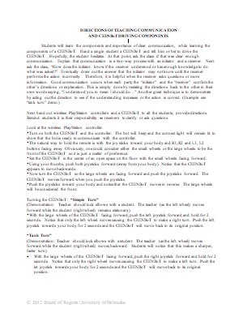
Exploring Concepts: (Cruising)

Summary: Students practice driving the CEENBoT as well as communicating directions to other students to drive.

Outline:
- Teacher will model being the initiator by directing half students how to drive the CEENBoT in particular shape
- The students will practice receiving information and then drive the CEENBoT
- The second half of the students will enter the room, and the students that learned the directions from the teacher will now take on the role of initiator and teach the second group (receivers).
- Discussion will follow about how well students communicated and ways to improve their communication.

Activity: The teacher will direct half the students on how to drive the CEENBoT in a particular shape (possible a different shape for each group). The teacher will model the role of the initiator and the students are the receiver. Those students will then drive the CEENBoT in that particular shape. Next, the other half of the students will enter the room and the students that received the directions will now give the directions they received, so they will now become the initiators communicating to a receiver. The teacher will repeat the activity except the first group will leave the room and the second group will receive directions and then explain them, while the second group will receive. To debrief, students will discuss what went well and poorly during the communication process as well as strategize how to improve their communication when giving and receive directions.
Instructing Concepts: (Cruising)

Communication

Communication is a two-way process related to the transfer of information from one person to another. There has to be an initiator and a receiver for communication to take place. In the most general terms, it can be thought of as the exchange of thoughts, opinions, information, and feelings for the achievement of a common goal.

Communicate Effectively to Multiple Audiences
When communicating information you must be aware of whom your audience is and adapt your methods to fit each unique audience. For instance you would communicate information very differently to a group of business people from the chamber of commerce than a group of middle school students. The content can be very similar but your delivery must be tailored to fit your audience.

Communicate Effectively Using a Variety of Media
Communication in the 21st century is very different than it was even several years ago. When conveying your ideas there are many different technologies available. It could be by e-mail, telephone, web conferencing, texting, blogging, discussion boards, traditional written methods, or verbally. This list is not exhaustive but is presented to show the diversity of communication methods. When choosing the media that you will use to communicate, you should consider the information to be transmitted and your audience very carefully. The reason is to insure that you choose the most efficient and the least likely method to be misunderstood. Remember the goal of communication is the successful transfer of information. If the wrong media type is used it is possible that communication will be ineffective.

Develop Cultural and Global Awareness
In this world with a global economy, rapid travel, instant communication, and instantaneous news it has become critical that we develop a multicultural awareness. The people that we are communicating with may very well have different backgrounds, values, and customs. If we are to understand each other and create quality communication, we must be aware of these differences. This multicultural awareness is a critical component for effective communication. With it communication flows freely in both directions and common goals can be easily achieved. Without multicultural awareness misinterpretations and poor communication will be commonplace.
Organizing Learning: (Cruising)

Summary: Students create a maze for a second student and provide directions, while the driving student is unable to view the maze.

Outline:
- Students develop a drawing of a possible driving course using a scaled drawing
- After instructor approval, students use masking tape to create the driving course on the floor
- Students practice driving through the course
- With the student driver behind the tri-fold board so that their view of the driving course is blocked, one student provides verbal instructions to help the blind driver navigate the course

Activity: Students will continue to practice driving skills by creating a drawing of a driving course that is approximately 6 meters by 6 meters in size. Students should plan their course by making a schematic drawing. The students should have the scaled drawing approved by the instructor before using the masking tape to create their driving course on the classroom floor. First, each student should practice driving through the course. Next, they should then take a turn behind the tri-fold board barrier to practice following their teammates instructions to navigate the CEENBoT through the course.

As a class, students should discuss some of the problems and successes they had while trying to communicate instructions to each other. Students should share ideas and strategies for improving communication.

Students should be able to navigate the CEENBoT through the maze the teacher has constructed in two minutes or less without going outside of the track.

Students will take turns giving instructions to a student driver (the driver is behind a tri-fold board and cannot see the track).
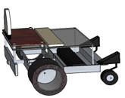
Understanding Learning: (Cruising)

Summary: Students will identify the two main roles in communication as well as explain different strategies to improve communication.

Outline:
- Formative Assessment of Communication Skills
- Summative Assessment of Communication Skills

Activity: Students will complete written assessments related to communication.

Formative Assessment: As students are engaged in the lesson ask these or similar questions:
- Are students able to explain the roles of the “initiator” and “receiver” during communication?
- Do students ask clarifying questions when they are in the receiver role?
- Are students able to communicate instructions clearly to another student?
- Can students strategize ways to improve their communication?

Summative Assessment: Students can complete one of the following writing prompts:
- Explain what the two roles people play in communication. Also, what can each role do to improve communication?
- Jeffery is giving directions to his house for a friend. Besides giving street names and turns, what else could Jeffery do to help improve or clarify his directions for his friend? (List 3 possible ways to help.)

