SPIRIT 2.0 Lesson:
Watching the Watchers - Browser Security
==========================Lesson Header ===================================


Lesson Title: Watching the Watchers - Browser Security
Draft Date: July 8, 2013
1st Author (Writer): Melanie Nuffer
Instructional Component Used: Browser Security/Online Privacy
Grade Level: 11-12

Content (what is taught):
- Basic concepts of browser hardening.
- Basic concepts of online privacy.

Context (how it is taught):
- Students will utilize and analyze the results of software tool Collusion.
- Students will create a video tutorial to show users how to harder their browsers.
- Students will create a game app to teach players about browser security and online privacy.

Activity Description:
Students apply concepts of browser security and online privacy issues. Students will utilize a software program called Collusion to visually show the hidden connections that result from online browsing. They will analyze and compare these results for each of the four major browsers. Students will demonstrate their knowledge of browser hardening by creating a video tutorial to be distributed to the school community. Students will collect data, record and organize the data, utilize web tools to create a game, test the game and finally, disseminate the game to other students’ mobile devices.

Standards:

Science Engineering
SE2, SF5 ED2, ED3
Technology Computer Science
TA1, TC1, TC2, TC3, TD2, TE1, TE4 CT:L2: 1,6-8 CL:L2: 2,3
CL:L3:MW:1 CCP:L2:1-3, 6
CCP:L3:MW:2,3 CCP:L3:CP:1
CI:L2: 3 CI:L3:MW:4, 5, 8, 10
CI:L3:CP:2, 6
Materials List:
- Computer with Internet access
- Collusion downloads
- Presentation tools
- Game development tools
- Browsers: Safari, Firefox, Chrome
- Mobile device (optional)

Asking Questions (Watching the Watchers - Browser Security)
Summary: Students consider and discuss how private/secure they think their interactions through web browsers are.
Outline:
- Lead discussion asking questions about students’ thoughts and feelings about the privacy and security of online interactions through web browsers.
Activity:
Lead a discussion to get students thinking about privacy and security online. Ask students about their expectations of privacy and security in their online interactions. The questions below can help guide the discussion. After the discussion, show 6 minute 40 second video of “Gary Kovacs: Tracking the trackers” TED Talk at http://www.ted.com/talks/gary_kovacs_tracking_the_trackers.html. Discuss students’ thoughts on the video and the Collusion tool. Kovacs ends the video with this statement “Privacy is not an option, and it shouldn’t be the price we accept for just getting on the Internet.” Get students’ thoughts on what this statement means to them.
Questions | Answers
How private are your online interactions? | It depends. If it is encrypted, it’s private. If it is not encrypted, not at all.
What are some ways you know your info is being collected or tracked? | Pop up ads
Who is watching me? Why? | The Government, Google, Amazon, etc. To learn about your habits and interests in order to market products, etc.
When you “like” something on Facebook or retweet something, what happens? Who notices? Who cares? | It depends on your settings. It could be just your friends or it could be anyone. Depending on the content it could be noticed by a lot of different groups not all with your best interests in mind.
What positive results come from tracking users’ online activities? | Somd see no positives. On the other hand, sites like Amazon are able to customize ads and recommendations that you might very well be interested in.
What are potential negative outcomes of privacy loss? | Identity theft.
What can be done to tighten security settings? | Add a firewall, antivirus software, software settings.
Can tightening security settings be disadvantageous? | Not sure
Resources:
Kovacs, G. (Feb 2012). Gary Kovacs: Tracking the trackers | Video on TED.com. TED: Ideas worth spreading. Retrieved June 19, 2013, from http://www.ted.com/talks/gary_kovacs_tracking_the_trackers.html
Exploring Concepts (Watching the Watchers - Browser Security)
Summary: Students will explore the web connections that are made without the user’s knowledge when connecting to websites.

Outline:
- Students will use the Collusion tool to analyze their online interactions with social networking sites and explore the ramifications of using unsecured browsers.

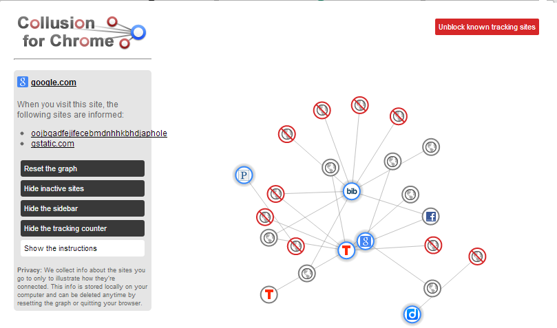
Activity:
Students will be assigned one of the major browsers, Safari, Chrome, and Firefox. They will run Collusion on that browser while visiting a few of their online social networks (if your school doesn’t have access to social networks, then any online shopping site will do, or they can run this at home for homework). They will then take a screen shot of the graph and write an analysis of the graph. Students will make an informal presentation of their finds with the class, comparing the differences in browsers. Teacher will then lead a discussion on patterns and commonalities in students’ discoveries.

Resources:
Collusion for Firefox http://www.mozilla.org/en-US/collusion/
Collusion for Chrome https://chrome.google.com/webstore/detail/collusion-for-chrome/ganlifbpkcplnldliibcbegplfmcfigp?hl=en
Collusion for Safari https://disconnect.me/tools

Instructing Concepts (Watching the Watchers-Browser Security)

Web Browser Security
Web browsers are software applications used to locate, retrieve and display content from the Internet, including web pages, videos, images and other files. The four most common web browsers are Internet Explorer, Google Chrome, Apple Safari, and Mozilla Firefox. The web browser is the primary connection to the rest of the Internet. Many applications may rely on the browser. This leaves users susceptible to attack. Browsers have become a major target for illegal and intrusive attacks.
Currently more than 2.5 billion people can connect to the Internet at any given time. The amount of time each person spends online is increasing rapidly. The increased connectedness has opened the world to individuals but has also opened the individual to the world. Each time a user clicks he or she leaves a trail of where they have been. This trail is used to create profiles on individual users. Businesses use these profiles to provide a more customized online experience. Hackers, however, can use this as a means of infiltrating the user’s computer for illegal activities including distribution of malware, identity theft, click fraud, and numerous other illicit activities.
In most cases, the default configuration of a user’s web browser is set for the greatest functionality, not the greatest level of security. Using an unsecured browser can leave a user’s computer vulnerable to a hacker’s attack. Too much security, however, cuts down on functionality. Users should make informed decisions about the pros and cons of the various computer settings to determine the appropriate settings for them. The pros of online profiling are varied. Areas that benefit include recalls, marketing, legal issues, law enforcement, fraud detection, and risk management. Consumer safety can be improved because of the ability to track products for recall purposes. Businesses are better able to make informed decisions about marketing budgets. Law enforcement and Homeland Security can use this technology to electronically track individuals and activities. Fraud can be detected in the same way. Purchase behaviors can be used to predict credit worthiness and can be used as a basis for increasing or decreasing credit limits.
The risks associated with online activities include stealing personal information, destroying files, fraudulent activities, installation and distribution of malware. Browsers are a means for many malware attacks as they provide a direct route to the user’s computer often bypassing operating system security, anti-malware, and other security measures.
Users have the ability to make choices on the level of security that their browsers provide. Increasing browser security can decrease functionality. The user must decide how much functionality he or she is willing to sacrifice for the sake of security. Profiling is so sophisticated that it even affects the results of Internet searches. Once a profile is established two people using the same search engine and the same search parameters will be presented with different results, results skewed to their personal interests. Each user must decide: is this good or bad?

Key Vocabulary
Cross site scripting (XSS) – hacking technique that uses vulnerabilities in the code of a web application to allow an attacker to send malicious content
Cookies – data generated by a website and saved to the user’s browser. Its purpose to remember information about the user.
Cache – stores recently used information for faster retrieval.
Malware – malicious software designed to do damage to the computer or steal information from users.
Hackers – person who gains unauthorized access to computer systems.
Browsers – translates HTML code into readable pages to provide user access to the Internet

Organizing Learning (Watching the Watchers - Browser Security)
Summary: Students apply their knowledge to explore the various security settings for each of the four most popular web browsers.

Outline:
- Explore various security settings in each browser.
- Harden each browser.
- Compare Collusion graphs from pre-hardened and hardened browser activities.
- Present findings to the group.

Activity:
Divide students into three groups. Assign each group a different browser (Safari, Chrome, or Firefox) and have them run Collusion on three different sites. They should record the sites and take a screenshot of the graph the Collusion generates. Next, have them explore the various settings available to increase security and privacy. They should address questions like: What settings are available? How does each setting affect your browser’s functionality? What additional questions do this raise for you concerning security and privacy? Based on what students have learned about their individual browsers and security/privacy options, make the changes necessary to maximize the security for their browser. Run Collusion again with the same browser and same sites as before. Take a screen shot of the graph and write an analysis of the graph. To conclude, students should do a side-by-side comparison of the new Collusion graph with the pre-hardening graph. The comparison should note the differences and address what each security setting appears to do. Students will then present their findings to the class.

Resources:
Collusion for Firefox http://www.mozilla.org/en-US/collusion/
Collusion for Chrome https://chrome.google.com/webstore/detail/collusion-for-chrome/ganlifbpkcplnldliibcbegplfmcfigp?hl=en
Collusion for Safari https://disconnect.me/tools

Understanding Learning (Watching the Watchers-Browser Security)

Summary:
Students will demonstrate their understanding of browser security and online privacy.

Outline:
- Formative assessment of browser security and online privacy.
- Summative assessment of browser security and online privacy.

Activity:
Students will complete the lesson activities while the instructor makes formative assessment observations. Summative assessments will be made through the project activities listed below.

Formative Assessment
As students are engaged in the lesson ask these or similar questions:
- Can students apply the basic vocabulary of browser security and online privacy?
- Can students analyze the pros and cons of each browser security setting option?
- Do students know how to apply the settings for the four main browsers to provide for the greatest levels of security and privacy?
- Do students understand the risks associated with using an unsecured browser?
- Are the risks different with different browsers?

Summative Assessment
Students can complete the following writing prompts.
- Describe what browser security means and how it can be improved. Your discussion should include different settings and their affect on browser security.
- Elaborate on the difficulty with on-line privacy and explain how on-line privacy can be enhanced.

Students can complete the following performance assessments.
- Students will be divided into groups and create a video tutorial to show how to change browser setting to maximize security and privacy for their assigned browser. Videos should include what effect the various settings will have on functionality and the pros and cons of increased security vs. functionality. Completed videos will be posted on the school website and made available to the school community to increase their awareness of the need for browser security.
- Students will create a game app appropriate for mobile devices that teaches the player about browser security and online privacy. They will work in pairs to create their games. To best accommodate different levels of programming skills, students will be given choices as to which tool they would like to use to create their app. Recommendations for app development are Apps Volcano, App Inventor and PhoneGap. See attachment for details on these tool choices. Completed games will be made available for download from the school website to increase community awareness of the need for browser security and greater privacy.

Attachments:
App development tools : T085_RET_Watching_Watchers_U_App_Development.doc

